



**A database design for Bakri’s Big Burgers restaurant management system**

By

**Mahmoud Chaer (Team Leader)** (mmc55@mail.aub.edu)

**Hussein Moukalled** (ham69@mail.aub.edu)

**Omar Chehab** (oac05@mail.aub.edu)

A REPORT

submitted to Dr. Hussein Bakri in partial fulfillment of the requirements of phase 3 of the database project for the course EECE433 – Database Systems (Group 6)

October 2024

Table of Contents

1. Introduction 1

2. References/Copyright Section 2

3. Tools Used to Draw the ER 2

4. System Description & Requirements 2

5. Legend of ER Diagram and Symbols 6

6. Complete ER Diagram for the BBB Database Management System 7

7. New Complete ER 8

7.1 Entity Types & their Attributes 9

7.1.1 Customer 9

7.1.2 Review (weak entity) 10

7.1.3 Ingredient 10

7.1.4 Supplier 11

7.1.5 Meal 12

7.1.6 Menu 13

7.1.7 Order 14

7.1.8 Table 15

7.1.9 Chef 15

7.1.10 Waiter 16

7.1.12 HR 18

7.1.13 Administration 19

7.1.14 Kitchen_Station 20

7.1.15 Emergency Contact (Driver/Waiter/Chef) (Weak entity) 20

7.2 Relationships and their Explanations 21

7.2.1 WRITES (between REVIEW, CUSTOMER) 21

7.2.2 PAYS (between CUSTOMER and Order) 22

7.2.3 CONTAINS (between ORDER, MEAL) 22

7.2.4 DELIVERS (between ORDER, DELIVERY_DRIVER) 23

7.2.5 IS_MADE_OF (between INGREDIENT, MEAL) 23

7.2.6 IS_SITTING (between CUSTOMER, TABLE) 24

7.2.8 CONTACTS (between WAITER, DELIVERY DRIVER) 25

7.2.9 HIRES (between HR, WAITER/DELIVERY_DRIVER/CHEF) 25

7.2.10 COOKS (between CHEF, MEAL) 26

7.2.11 MANAGES (between CHEF, KITCHEN_STATION) 26

7.2.12 CONTAINS (between MENU, MEAL) 27

7.2.13 SUPERVISION (between CHEF, SOUS-CHEF) 27

7.2.14 IS_ASSIGNED (between TABLE, WAITER) 27

7.2.15 DEPENDS_ON (between EMERGENCY_CONTACT_ CHEF/WAITER/DELIVERY_DRIVER and CHEF/WAITER/DELIVERY_DRIVER) 28

7.2.16 WORKS_IN (between CHEF, KITCHEN_STATION) 28

7.2.17 CONTACTS (between ADMINISTRATION, SUPPLIER) 29

7.2.18 SUPPLIES (between SUPPLIER, INGREDIENTS) 29

7.2.19 SUPERVISION (between SUPERVISOR, SUPERVISEE) 30

7.2.20 CREATES (between CHEF, MENU) 30

7.2.21 SHIFT (between Administration, waiter/chef) 30

8. ER to Relational Mapping 31

8.1 Step 1 – Mapping Strong Entity Types 31

8.1.1 Relation: HR 31

8.1.2 Relation: Administration 32

8.1.3 Relation: Menu 32

8.1.4 Relation: Meal 33

8.1.5 Relation: Supplier 33

8.1.6 Relation: Ingredient 34

8.1.7 Relation: Chef 34

8.1.8 Relation: Delivery_Driver 35

8.1.9 Customer 35

8.1.10 Table 36

8.1.11 Waiter 36

8.1.12 Order 37

8.1.13 Kitchen_Station 37

8.2 Step 2 - Mapping of Weaking Entity Types 38

8.2.1 Review 38

8.2.2 Emergency_Contact 39

8.3 Step 3 – Mapping of Binary 1:1 Relationship Types 40

8.3.1 MANAGES 40

8.4 Step 4 – Mapping of Binary 1:N Relationship Types 40

8.4.1 WORKS IN 40

8.4.2 SUPERVISION 41

8.4.3 DEPENDS ON 42

8.4.4 Contacts 43

8.4.5 SUPERVISION 43

8.4.6 IS_SITTING 44

8.4.7 IS_ASSIGNED 44

8.4.8 WRITES 45

8.4.9 PAYS 45

8.4.10 DELIVERS 46

8.5 Step 5 – Mapping of Binary M:N Relationship Types 46

8.5.1 Contacts 46

8.5.2 Contains 47

8.5.3 Cooks 47

8.5.4 Composed_Of 47

8.5.5 Creates 48

8.5.6 Hires 48

8.5.7 Supplies 49

8.6 Mapping of Multivalued Attributes 50

8.6.1 Assigned_Location 50

8.6.2 Payment Method 50

8.6.3 Image 51

8.6.4 Image 51

8.6.5 Product 52

8.6.6 Day 52

8.7 Mapping of N-Ary Attributes 53

8.7.1 Places 53

8.8 Step 8- Mapping Aggregation, Specialization Relationships 53

9. Final Display - All Tables 54

10. Tables’ States 55

10.1 HR 55

10.2 Administration 56

10.3 Menu 57

10.4 Meal 58

10.5 Supplier 59

10.6 Ingredient 59

10.7 Chef 60

10.8 Delivery_Driver 60

10.9 Customer 61

10.10 Table 62

10.11 Waiter 62

10.12 Order 63

10.13 Kitchen_Station 64

10.14 Review 64

10.15 Emergency_Contact 65

10.16 Payment_Method 65

10.17 Image_Meal 66

10.18 Image_Review 66

10.19 Product 67

10.20 Day 67

10.21 Assigned_Location 68

10.22 Supplies 68

10.23 Creates 69

10.24 Composed_Of 69

10.25 Cooks 70

10.26 Contacts 70

10.27 Places 71

10.28 Hires 71

10.29 Shift 72

10.30 Contains 72

11. SQL – Implementation 73

11.1. Domains 73

11.2. Create Tables 73

11.2.1. t 73

11.2.1. t 73

11.2.1. t 73

11.2.1. t 73

11.2.1. t 73

11.2.1. t 73

11.2.1. t 73

11.2.1. t 73

11.2.1. t 73

11.2.1. t 73

11.2.1. t 73

11.2.1. t 73

11.2.1. t 73

11.2.1. t 73

11.2.1. t 73

11.2.1. t 73

11.2.1. t 73

11.2.1. t 74

11.2.1. t 74

11.2.1. t 74

11.2.1. t 74

11.2.1. t 74

11.2.1. t 74

11.2.1. t 74

11.2.1. t 74

11.3. Alter Tables (for FKs) 74

11.3.1. t 74

11.3.1. t 74

11.3.1. t 74

11.3.1. t 74

11.3.1. t 74

11.3.1. t 74

11.3.1. t 74

11.3.1. t 74

11.3.1. t 74

11.3.1. t 74

11.3.1. t 74

11.3.1. t 75

11.3.1. t 75

11.3.1. t 75

11.3.1. t 75

11.3.1. t 75

11.3.1. t 75

11.3.1. t 75

11.3.1. t 75

11.3.1. t 75

11.3.1. t 75

11.3.1. t 75

11.3.1. t 75

11.3.1. t 75

11.3.1. t 75

11.3.1. t 75

11.3.1. t 75

11.3.1. t 75

11.3.1. t 75

11.3.1. t 75

11.3.1. t 75

11.3.1. t 76

11.4. Relationships 76

11.4.1. t 76

11.4.1. t 76

11.4.1. t 76

11.4.1. t 76

11.4.1. t 76

11.4.1. t 76

11.4.1. t 76

11.4.1. t 76

11.4.1. t 76

11.4.1. t 76

11.4.1. t 76

11.4.1. t 76

11.4.1. t 76

11.4.1. t 76

11.4.1. t 76

11.4.1. t 76

11.4.1. t 76

11.4.1. t 76

11.5. Populate Tables 77

11.5.1. t 77

11.5.1. t 77

11.5.1. t 77

11.5.1. t 77

11.5.1. t 77

11.5.1. t 77

11.5.1. t 77

11.5.1. t 77

11.5.1. t 77

11.5.1. t 77

11.5.1. t 77

11.5.1. t 77

11.5.1. t 77

11.5.1. t 77

11.5.1. t 77

11.5.1. t 77

11.5.1. t 77

11.5.1. t 77

11.5.1. t 77

11.5.1. t 78

11.5.1. t 78

11.5.1. t 78

11.5.1. t 78

11.5.1. t 78

11.5.1. t 78

11.5.1. t 78

11.5.1. t 78

11.5.1. t 78

11.5.1. t 78

11.5.1. t 78

11.5.1. t 78

11.5.1. t 78

11.5.1. t 78

11.5.1. t 78

11.5.1. t 78

11.5.1. t 78

11.5.1. t 78

11.5.1. t 78

11.5.1. t 78

11.5.1. t 79

11.5.1. t 79

11.5.1. t 79

11.5.1. t 79

11.6. Triggers, Functions and Procedures 79

11.6.1. Triggers & Functions 79

11.6.2. Procedures 79

11.7 Complex Queries 79

11.7.1. t 79

11.7.1. t 79

11.7.1. t 79

11.7.1. t 79

11.7.1. t 79

11.7.1. t 79

11.7.1. t 79

11.7.1. t 79

11.7.1. t 79

11.7.1. t 79

11.7.1. t 79

11.7.1. t 79

11.7.1. t 80

11.7.1. t 80

11.7.1. t 80

11.7.1. t 80

11.7.1. t 80

11.7.1. t 80

11.7.1. t 80

11.7.1. t 80

11.8. (BONUS) Security 80

12. Conclusion 80

13. Instructor’s Feedback 80

# Introduction

A restaurant management system database is a crucial element of such a company that could very well be the difference between branching and bankruptcy. The importance of such a database system from the need for efficient and streamlined operations in the fast-paced restaurant environment. The proper functioning of a restaurant relies on a complex interconnection of operations such as order management, inventory tracking, employee management, and customer service which are all time consuming and error prone tasks. A robust database system addresses these challenges by providing a centralized platform that organizes and manages all the critical components mentioned above ensuring seamless communication and organization between all different departments, roles and components of the company. By opting for a performant, strongly built database, the business avoids frequent complications such as overbooking, stock shortages and miscommunication to list a few.

Such a database would represent the restaurant itself as a mini world; its day-to-day activities including customers, employees’ menus and administrative tasks. It would be of great importance to the owner(s) of the restaurant as it would allow them easy access to any information of value such as reviews, employees, stocks etc… making it easier to evaluate performance and make decisions to ensure maximum profitability. It would also assist the Human Resources department in making informed decisions about who to promote, demote or fire based on performance reviews and readily available stats. As for the staff, they require the system to efficiently track customer orders, follow table assignments and bookings, access data of interest such as recipes, review customer preferences and check customer feedback. Finally, customers' expectations from such a system would be smooth order deliveries, prompt service through seeming less communication between the kitchen staff and the waiters, easy reservation systems and an overall excellent dining experience.

Specific requirements for the database differ between stakeholders. Owners and managers would expect quick and easy access to key performance indicators such as customer reviews, shift assignments, number of orders and stock levels. Staff such as waiters and chefs would expect this system to facilitate quick and precise order management, table reservations and order deliveries to always ensure efficiency. As for customers, an inviting user interface that makes it easy to check menus, book tables, order food and leave reviews is essential. By addressing all these diverse needs, a database system would promote operational efficiency and consequently drive the restaurant’s profitability.

This report describes the Bakri’s Big Burgers restaurant main database design using the Entity-Relationship diagram approach. Section 2 lists the sources and references used in the making of this project, section 3 shows the tool(s) used to draw the ER, section 4 describes the system and it’s requirements, section 5 is a legend of the ER diagram symbols, section 6 describes the complete ER diagram by explaining all entities with their respective attributes (6.1) and all relationships with their attributes (6.2), finally section 7 is the conclusion.

# References/Copyright Section

* Elmasri, R., & Navathe, S. B. (2016). Fundamentals of database systems (7th ed.). Pearson.
* Silberschatz, A., Korth, H. F., & Sudarshan, S. (2019). Database system concepts (7th ed.). McGraw-Hill.
* Ramakrishnan, R., & Gehrke, J. (2002). Database management systems (3rd ed.). McGraw-Hill.
* Boardmix. (n.d.). ER diagrams: The complete guide to database modeling.
* W3School
* TutorialPoint

# Tools Used to Draw the ER

For this project, we only used the software draw.io (<https://draw.io>) to draw our ER.

# System Description & Requirements

The proposed restaurant database design promotes easy and coordinated data storage and tracking to facilitate the overall operations of the business. The following are the system requirements:

* Each staff member is registered in the database as a waiter along with all of its attributes. To differentiate between staff, we look at the attribute role of the waiter. The Avg_Rating attribute is derived from the avg rating that this specific waiter got during the reviews as reviews are made to specific waiters. The Hire_Date is the date when the waiter was hired. The salary is the waiter’s current salary. The CV is the current CV of the waiter. The Employee_ID is just a primary key assigned to each waiter in order to identify them.
* All the tables of the restaurant are registered in the database. The Availability is whether the table is empty. Seat_Capacity is how many people can sit on this Table. The Table_ID is just an identifier for the table. Each waiter is assigned specific tables that he must take care of.
* Every Order that is placed by a Customer and Waiter in the restaurant is stored in the database. To identify each unique Order, we use the Order_ID which is the primary key. Status is used to know whether the Order is pending, in progress or done. The priority is to rank the orders in terms of importance, this helps the chefs in knowing what orders to start preparing first. Finally, we have the derived attribute Price, which indicates the price of a certain Order, it is derived from the Meal entity. At the end, this Order in paid by the Customer that placed the Order, using a payment method of his choice.
* Every Meal that is cooked by a Chef in the restaurant is stored in the database. To identify each unique Meal, we use a Meal name, which serves as the primary key. The Recipe indicates the ingredients used to make the Meal along with the amount used. We have two similar attributes that are Price and Total_Cost, Price represents the amount of money that the Customer has to pay in order to get this Meal, while Total_Cost represents the amount of money used to make this Meal, both are derived. The Image attribute represents a visual representation of every Meal, it is multivalued since we can have several photos for a single Meal. Category represents the type of the Meal, whether it is an appetizer, a salad, a main dish… The description attribute describes the Meal and how it is served in a sentence.
* Every Customer that Places an order is stored in the database. In order to identify every unique Customer, a Customer_ID is used, which is the primary key. The customer’s Name is stored in the database. Address simply represents the location of the Customer’s home. The contact_Info of the Customer is also stored in the database, it represents the Customer’s phone number and email address, it is a composite attribute. The Payment_Methods usually used by the Customer are stored in the database, it is a multivalued attribute that can include cash or/and cards. A Customer can gain Points by coming to the restaurant frequently, these points are stored in the database and can get you a discount when they reach a certain amount.
* Every Chef employed at the restaurant is stored in the database which can be identified by an Employee_ID. His Name is stored in the database with many other attributes. The CV represents the Chef’s past experiences and his level of education. The date on which the Chef was hired is stored in the database as Hire_Date. The Chef’s Salary is stored in the database, which represents the amount of money that he gets by working at the restaurant. Finally, the Role attributes represent the occupation of the Chef inside the kitchen (baker, fry chef…).
* Every Delivery_Driver that works for the restaurant is stored in the database which can be identified by an Employee_ID. The Driver’s Name is stored in the database. The contact_Info of the driver is stored in the database, it represents the Driver’s phone number. The regions/locations that are covered by every driver are stored in the database as assigned_locations, it is a multivalued attribute since a driver can cover several locations. Vehicule_Type represents the vehicle used by the driver whether it is a motorcycle, a sedan or a truck for large deliveries.
* Every Ingredient that is Supplied to the restaurant by a Supplier is stored in the database along with an Inventory_ID, which helps in identifying every unique ingredient. The Stock_Qty represents the available quantity of a certain Ingredient in stock, while Minimum_Qty represents the minimum quantity that should be available for a certain Ingredient in stock. if the Stock_Qty is less than Minimun_Qty, Ingredients should be supplied by the Supplier. The Price of Ingredients is stored as a derived attribute, which simply represents the Price of a certain Ingredient, it is derived from the attribute Cost in the SUPPLIES relationship between Ingredients and Supplier. The Name of Ingredients is stored in the database as well.
* Every Supplier that worked with the restaurant is stored in the database along with a Supplier_ID used to identify him. The Supplier’s Name is stored in the database, it represents the company’s Name. The contact_Info of the Supplier is stored in the database, it represents the Supplier’s phone number and email address. Address simply represents the location of the Supplier’s factory. The Products that are supplied by him are stored in the database as a multivalued attribute since a Supplier can supply more than one product.
* Every Kitchen_Station that has chefs working in it is stored in the database along with its name Station_Name to identify each station. The number of chefs that are working in a certain station is stored in the database and represented as Number_Of_Chefs (derived attribute as its data is already stored in the database from the relationship works, between Chef and Kitchen_Station). Finally, the Specialization of every station is stored in the database, a station can be specialized in desserts, seafood, and so on.
* Every Review that was written by a customer is stored in the database along with a Review_Number to identify each Review. The presence of a Review depends on the presence of a Customer since a Review cannot be written without a Customer. The Rating that the Customer left reflects his overall experience in the restaurant, this is usually followed by a Description where the Customer describes his experience in a couple of sentences. Both of these attributes are stored in the database. Finally, the multivalued attribute Images represents the photos that the Customer took during his stay at the restaurant.
* An administration is responsible for overseeing the overall operations in the restaurant and each administrator is identified by a unique Employee_ID. The name of an administrator is stored in the database along with his contact info which is composed of an email and a phone number for easy and quick reachability at any time. We also keep track of the address of the administrators for live correspondence. Finally, each administrator is assigned different roles and therefore earns different salaries. The Administration also sets a Shift for every employee, in which the start and the end time of the Shift are included.
* The HR department oversees the recruitment and hiring process of every employee in the restaurant. Each HR employee has a unique Employee_ID that helps identify it as well as a name. HR members also have their contact info stored as a phone number and email as well as their address for easier correspondence. Roles vary between HR employees and so do their salaries.
* A menu contains the served meals at any given time, each menu is identified by a unique Menu_ID. Different menus are given at different times of the day i.e. breakfast, lunch, dinner there for each menu has a start and end time as well as a category section, and image. Finally, the Days during which a particular menu is served is recorded to know when to serve what menu.
* Every Emergency_Contact that is linked to an employee (Chef/Waiter/Delivery_Driver) is stored in the database along with the employee_ID (chef_ID, Driver_ID, Waiter_ID) and the Name of the contact which is used for identification purposes. The attribute Relation simply represents the relation between the employee and his Emergency_Contact, such as friends or family. The contact’s Phone_number is stored in the database, it allows the restaurant to reach the Emergency_Contact. Finally, the priority attribute ranks the Emergecy_Contacts of a certain employee from most to least important. The emergency contact is splitted into three, one for the waiters, one for the chefs and one for the drivers.

# Legend of ER Diagram and Symbols

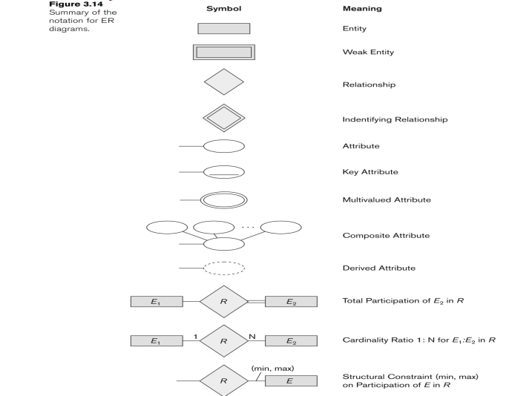

Source : Elmasri, R., & Navathe, S. B. (2016). *Fundamentals of database systems* (7th ed.). Pearson

# Complete ER Diagram for the BBB Database Management System

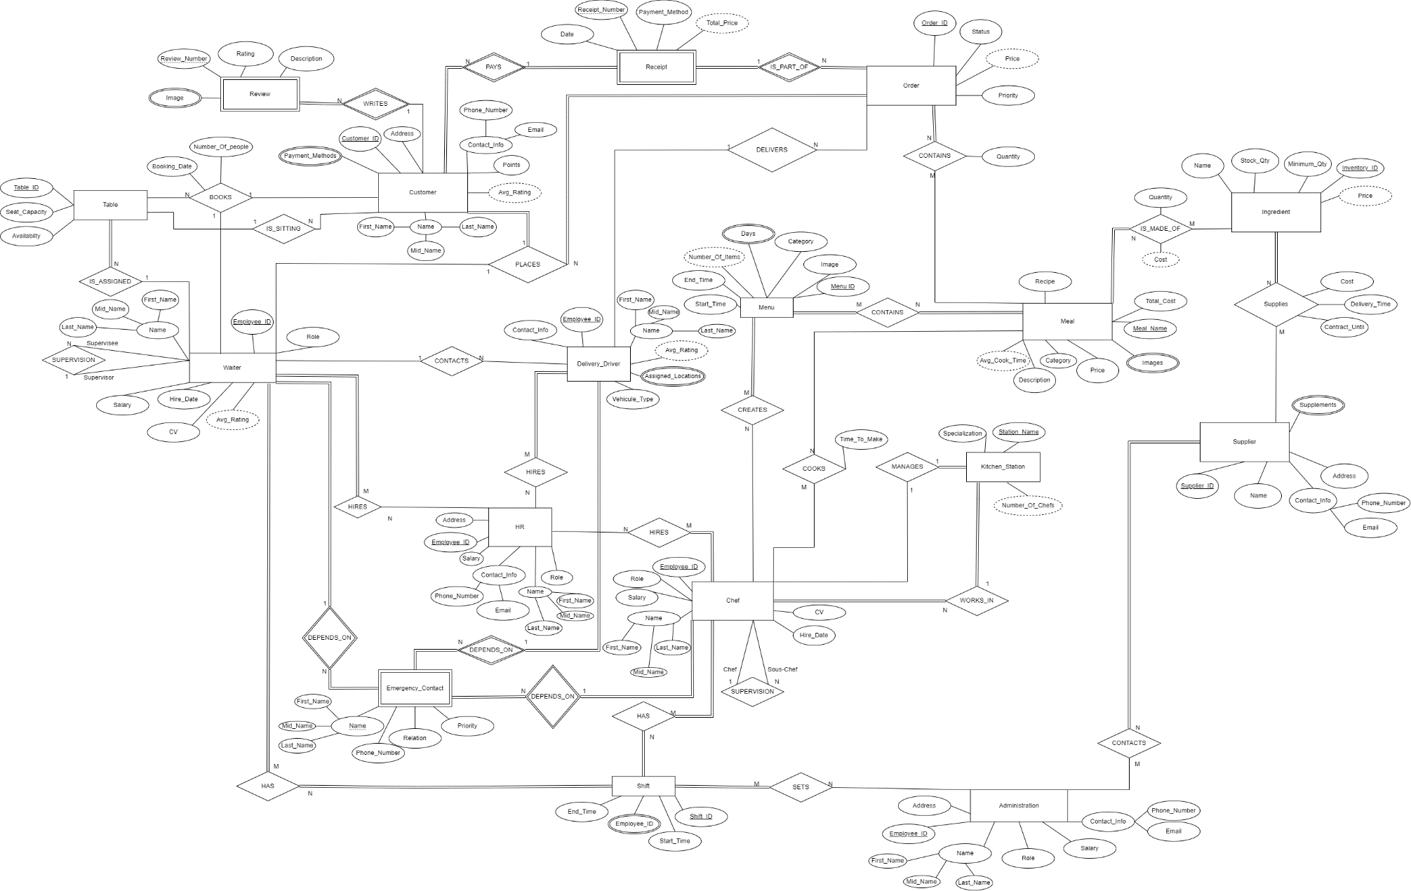

# New Complete ER

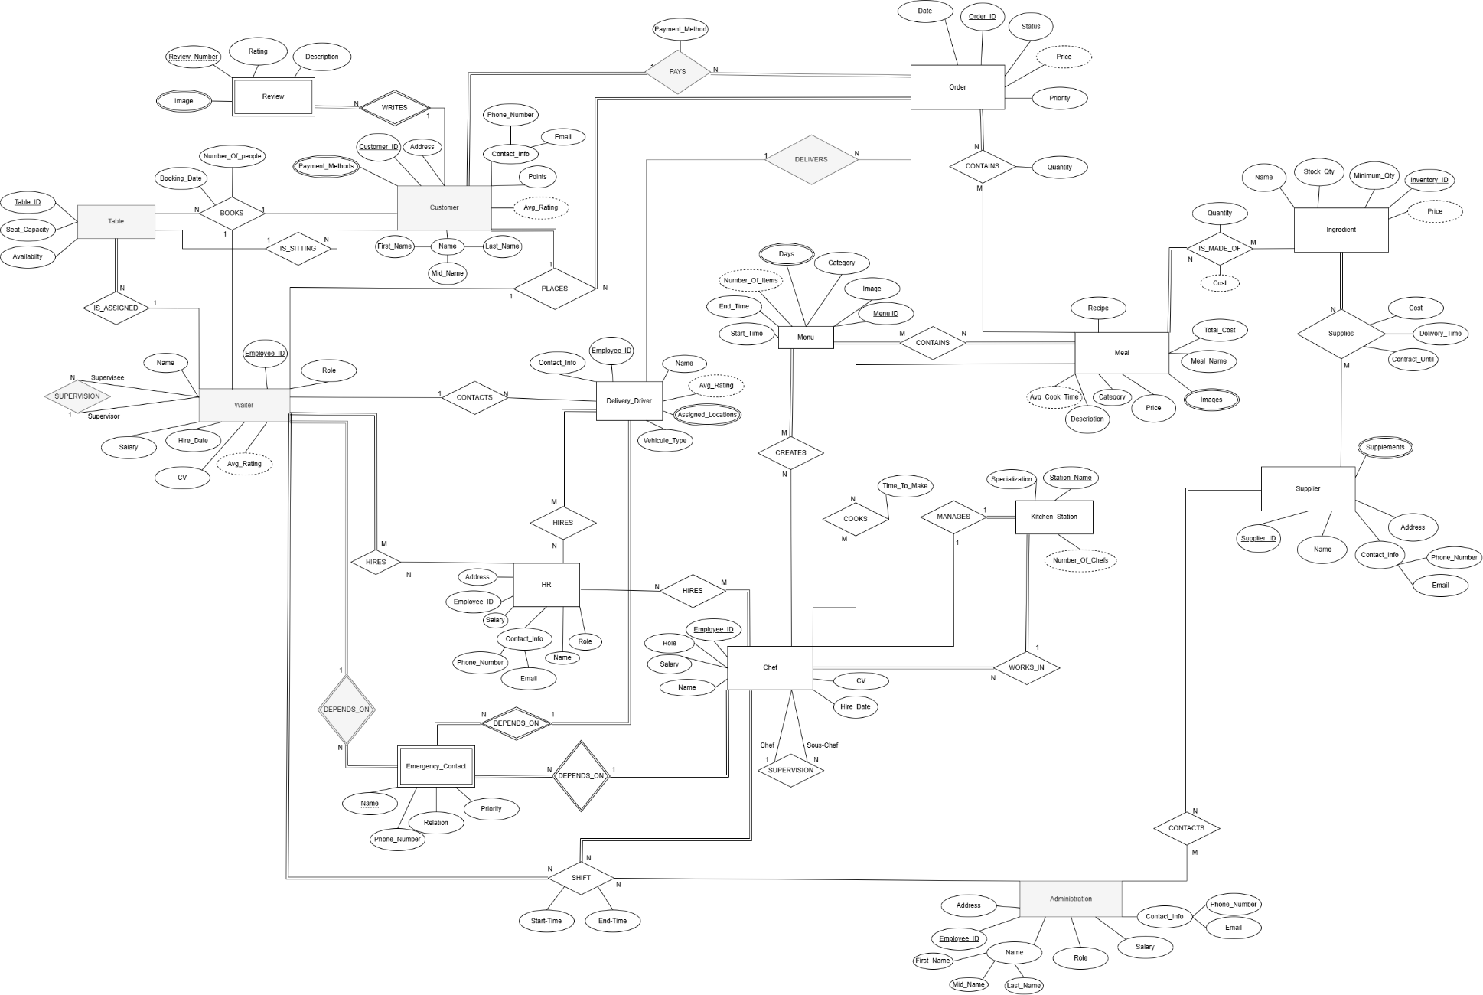

## Entity Types & their Attributes

### Customer

The Customer is any person in the restaurant that is ordering Meals. A restaurant must have important information about its customers to know how to work with them in the future. This information are saved in the attributes:

* Customer_ID (primary key):

It is the primary key of the Customer entity. It is used to target a specific Customer in case of a database query.

* Name:

The attribute Name is needed for communication and differentiating between the different employees and customers. Also used to print the name tags of the employees.

* Contact_Info (composite Phone_Number, Email):

This info is needed so that the restaurant can contact each customer whenever they wish to. It might be used in the event of a reservation or a special offer, or just generally for advertising. Email is more for formal messages. Phone_Number is for faster responses (in case the Customer is late for a reservation for example).

* Points:

The Points are saved for each Customer. This is a reward system were based on the amount of Points a Customer has, the restaurant can know if they should give them a discount or special treatment (high points shows that the Customer comes a lot to the restaurant).

* Address:

The Address of a Customer is needed in case future deliveries might occur or in case the restaurant wants to send a gift or reward for the Customer.

* Payment_Methods (multivalued attribute):

This info contains the payment methods that the Customer has used previously. The attribute is multivalued because a Customer might have used several payment methods in the past (ex: Credit Card, Cash, Crypto, ect…). This attribute is needed because for example, if a Customer places a delivery order, the restaurant might need to know if the delivery person must have additional cash on him or for credit card payments, the credit card device.

### Review (weak entity)

The Review entity is used for storing the reviews that the customers leave. Each restaurant wants to be able to view the different reviews they got to improve the areas where they are performing poorly or not enough.

* Review_Number (partial key):

This is used as a key (along with the customer that left it) in order to be stored in the database.

* Rating:

This is the rating left by the Customer, the rating is over 5 (/5). Each review should have a rating to be able to visualize a numerical value that reflects the customer’s feedback.

* Image (multivalued attribute):

This attribute is needed so that the Customer leaves images of his review (showing proof). The images must be stored for future analysis. It needs to be multivalued, as a user might leave several images in one Review.

* Description:

This is the text describing the Review that the Customer left. It contains the Customer’s feedback, message, or any other text that the Customer might want to leave. It is important as images and ratings are most of the time not enough to show the Customer's true feedback.

### Ingredient

This entity is for the ingredients that are used to produce meals. Each ingredient has its own info that is saved in the database.

* Inventory_ID (primary key):

This is just an ID that is used to track the ingredients in the inventory.

* Name:

Name of the Ingredient. It is not the primary key, as some ingredients might have the same name but are different.

* Stock_Qty:

Used to track the stock quantity left of a specific ingredient in the inventory.

* Minimun_Qty:

This attribute is needed so that the restaurant knows what the minimum quantity is needed in stock of a specific ingredient so that they can order a restock when they reach this quantity.

* Price (derived attribute):

It is a derived attribute as it can be directly taken from the other attribute (Cost in the Supplies (Ingredient/Supplier) relationship). It reflects the cost of this ingredient. This attribute might be needed here so that whenever a user needs to get the cost of an Ingredient, he can directly get it from the entity. In this way, the ingredient entity has all the info needed about the ingredients.

### Supplier

The Supplier entity contains the info related to a supplier that the restaurant gets items from.

* Supplier_ID (primary key):

This is just the primary key of the Supplier as other attributes are not always unique.

* Name:

This attribute is the name of the company that acts as a supplier. It is needed so that the restaurant can contact them.

* Contact_Info (composite Phone_Number, Email):

This attribute contains the contact info of the Supplier. This info is needed so that the restaurant can contact the Supplier in case they need a restock or any other emergency demand. Sometimes Email is not enough, for faster response Phone_Number might be needed.

* Address:

Address of the Supplier. Needed in case the restaurant wants to send an employee to pick up some items or in case a meeting is happening.

* Products (multivalued):

This attribute stores the item that the Supplier supplies to the restaurant. It is a multivalued attribute because a Supplier might supply multiple items.

### Meal

The Meal entity is storing info related to one meal. For example, a Meal can be a pizza, burger, ect…

* Meal_Name (primary key):

The Meal_Name is used as a primary key to distinguish between the other meals.

* Recipe:

The actual recipe needed to prepare a Meal. A recipe is needed so that the chefs can know how to prepare a specific Meal.

* Price (derived attribute):

It is the price that the Meal is selling for in the restaurant. The price is needed so that the customers know how much each Meal is going for. It is derived from the cost.

* Category:

The Category of a Meal is its type (ex: side, main course, drink…). It is important as it helps in dividing the meals into different categories so that they can be distinguished.

* Description:

Describes what the Meal is about. It can contain what ingredients are used, how it is prepared and what to expect from it. This describes to the Customer the Meal that he will be ordering.

* Images (multivalued attribute):

These are the images that are stored for a Meal. A Meal can have several Images, this is why this attribute is multivalued. The images need to be stored so that they can be displayed to the Customer for a better vision of the Meal.

* Total_Cost (derived attribute):

This attribute is the total cost that is needed to prepare the meal. This attribute is derived, it adds a specific % to the cost of the ingredients of the meal to account for additional expenses.

### Menu

This is the set of meals that are given in a specific period. For example, during breakfast time, a different menu might be used compared to during lunch time.

* Menu_ID (primary key):

Primary key, used to identify menus. The Menu Category might not be enough because, for example, we might have a breakfast Menu Monday different from the breakfast Menu Sunday.

* Image:

An image that is the cover of the Menu. It can be seen as a main image for the Menu.

* Category:

This attribute is the type of Menu. Some examples are breakfast and lunch. This is important to distinguish between different types of menus.

* End_Time:

The time when the Menu is no longer available.

* Start_Time:

The time the Menu starts being available at.

* Days (multivalued):

The days for which the Menu is being used. It is a multivalued attribute because a Menu can be used for several days.

### Order

This entity represents the details of a Customer’s request for food, each time the Customer requests something, an Order is made. At the end of each sitting, all the Customer’s orders are added in one Receipt for him to pay. It contains several attributes stored in the database such as:

* Order_ID:

This attribute is the Primary Key of the Order entity, it is used as an identifier for each unique order in the database.

* Status:

This attribute tracks the current state of the order, it helps the restaurant in tracking each order and knows whether it is facing a delay or not, which could help in identifying a problem and improving efficiency. This is a great addition to keeping the Customer updated on the Status of his Order.

* Priority:

This attribute ranks Orders that are placed at around the same time by priority. This could help the restaurant in keeping every Customer satisfied by not having to wait.

* Price (derived):

This attribute represents the sum of every Meal in our Order, it helps the Restaurant in getting the total price in the Receipt. It is derived from the Meal entity by adding the price of every Meal in the Order.

### Table

This entity represents seating arrangements in the restaurant, it helps the restaurant in managing seating plans for Customers and tracking Orders associated with each Table. It contains several attributes stored in the database such as:

* Table_ID:

This attribute is the primary key for the Table entity, it helps the restaurant in identifying each unique Table.

* Seat_Capacity:

This attribute represents the number of people that can be seated on a table, this helps the restaurant in the reservation process.

* Availability:

This attribute represents the status of the table, whether it is occupied or available. This helps the restaurant in organizing everything related seating.

### Chef

This entity represents the individual that is responsible for preparing meals, creating menus and managing kitchens. A restaurant cannot run properly without chefs. It contains several attributes stored in its database such as:

* Employee_ID:

This attribute represents the primary key of the Chef entity, it helps in identifying each unique chef.

* Name:

Each chef has a name which is shown on the tag pinned on his cloth.

* Role:

This attribute represents the different roles that a chef can have such as baker, fry chef and so on. This helps the restaurant to know how many chefs of each kind are available in the restaurant to know whether we have a shortage or not.

* Salary:

Each Chef is paid a salary at the end of the month, the salary varies between a Chef and another depending on his Role. This attribute helps the restaurant in keeping track of their financial records.

* CV:

Each Chef submits his CV which is thoroughly studied by the HR to hire only the finest applicants.

* Hire_Date:

The restaurant keeps track of the Hiring date of each Chef, it makes it easier to promote him later or give him a raise based on his years of service for the restaurant.

### Waiter

This entity represents a staff member in the restaurant who interacts with customers and takes orders. No restaurant is complete without the smooth dining experience offered by a competent waiter staff.

* Employee ID (Primary key):

Primary key, used to identify the waiter; each waiter has a uniquely assigned Employee ID to help better identify him when he’s hired.

* Role:

Each waiter is assigned a different role which makes it easier to identify the speciality and job of each waiter; some waiters are bar waiters and fix drinks for the customers, others are responsible for taking orders and serving the food and some are responsible for taking calls and booking tables.

* Name:

Each waiter has a name which shows on the tag pinned to his cloth.

* Salary:

Each waiter is paid a salary at the end of the month, the salary varies between a waiter and another.

* Hire_Date:

We keep track of the Hiring date of each waiter, it makes it easier to promote him later or give him a raise based on his years of service for our restaurant.

* CV:

Each waiter submits his CV, which is thoroughly studied by the HR to hire only the finest applicants.

* + 1. Delivery Driver:

This entity represents an employee who delivers food orders from the restaurant to the customer. In case the customer lives far away from the restaurant or just feels like staying at home, he can have his food delivered to his doorstep with timely and accurate order fulfillments.

* Employee ID (Primary Key):

Primary key used to identify the waiter; each delivery driver has a uniquely assigned Employee ID when he’s hired to help better identify him.

* Contact_Info:

A delivery driver provides his phone number so that the restaurant and the customers can contact him, making the overall experience smoother.

* Vehicle_Type:

The vehicle used varies between a driver and another, for far away distances the order would most likely be assigned to a driver who uses a car while shorter distance orders will be taken by drivers on motorcycles or bikes.

* Salary:

Each delivery driver is paid a salary at the end of the month, the salary varies between a delivery driver and another depending on how many areas he covers and his rating.

* Name:

Each delivery driver has a name which is given to the customer when he places an order so that he can familiarize himself with the person responsible for the delivery of his order and allow both the waiter and the customer to contact him.

* Assigned_Locations (Multivalued):

The covered locations by the restaurant are divided on the delivery drivers to make the process more efficient and ensure timely delivery of the orders, each driver can be responsible for more than 1 area.

### HR

The HR (Human resources) is the department responsible for managing the employee-related aspect of the restaurant, its main role is to interview and hire the most competent participants to ensure an excellent restaurant staff.

* Employee ID (Primary Key):

Primary key used to identify the HR employee; each HR employee has a uniquely assigned Employee ID to help better identify him.

* Name:

Each HR employee has a name divided into First name, Middle name and Last name to help identify and contact him.

* Address:

The address of each member of the HR department could come in handy for official correspondence through documents like letters or tax forms.

* Salary:

Each HR employee is paid a salary at the end of the month, the salary varies between an HR employee, and another based on his role

* Contact info (Composite):

Each HR member has contact info which comes in the form of his email and his phone number so that employees can contact him for referrals, ideas or complaints.

* Role:

Each HR member has a different role, some could be responsible for the hiring decisions and the recruitment, others could be responsible for handling complaints. Giving a role to each HR employee makes the department more structured and efficient.

### Administration

The administration is a crucial department responsible for overseeing the overall operations and management of the restaurant. It takes care of the higher business details and ensures the smooth functioning of all the fractions of the restaurant.

* Employee ID (Primary Key):

Primary key used to identify the administrators; each member of the administration has a uniquely assigned Employee ID to help better identify him.

* Name:

Each member of the administration has a name to help identify and contact him.

* Address:

The address of each member of the administration is given, which could come in handy for official correspondence through documents like letters or tax forms.

* Role:

Each administrator has a different role, some could be responsible for overseeing the operations of the HR department, some could be responsible for the business decisions ensuring a smooth functioning of the administration.

* Salary:

Each member of the administration is paid a salary at the end of the month, the salary varies between an administrator, and another based on his role

* Contact_Info:

Each member of the administration has contact info which comes in the form of his email and his phone number to facilitate access to him and make it easier to be in contact with brands, make deals or talk to others.

### Kitchen_Station

This entity is used to monitor the division of the kitchen between chefs and different tasks. Each kitchen station has a different purpose and is assigned one or more chefs. This helps the restaurant divide the work and follow up with any issue by targeting the specific station where the issue came from.

* Station_Name (primary key):

This is the name of the station which can also help identify the Kitchen_Station in the database.

* Number_Of_Chefs (derived attribute):

This attribute shows how many chefs work in a targeted Kitchen_Station. This can be beneficial the restaurant to keep track of the number of employees in each station compared to the amount of work that it produces.

* Specialization:

This attribute shows the restaurant what each Kitchen_Station specifically does (ex: meat station, dough preparation, ect…). This can help the staff quickly send the tasks to the needed station.

### Emergency Contact (Driver/Waiter/Chef) (Weak entity)

An emergency contact is crucial for every employee in any company, this person will be contacted in case of an emergency. Many emergency contacts should be given with an order of priority to ensure the highest chance of at least one of them answering.

* Name (Partial Key):

The name of the emergency contact is provided to better identify him and make contacting him easier, it is stored as partial key because it might not be unique.

* Phone_Number:

Each emergency contact has a phone number so that he can be contacted as quickly and easily as possible in case of an emergency.

* Relation:

The relation of the emergency contact to the employee, is he a family member, a friend, a coworker… to make the interaction smoother.

* Priority:

The priority of an emergency contact describes in what order should he be contacted; a higher priority means this emergency contact will be contacted first.

* Employee_ID (Waiter,Driver and Chef):

Plays a role in being part of a composite primary key for the weak entity emergency_contact, while also helping identify the employee related to this contact.

This entity is available three times, once for each type of employee (Driver/Chef/Waiter).

## Relationships and their Explanations

### WRITES (between REVIEW, CUSTOMER)

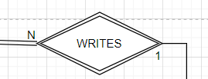

Total participation from Review, partial participation from Customer. This is a binary relationship where each Customer can write one or more reviews. But a Review must be written by a Customer. A Review can only be written by one Customer. This is how reviews work in general. A user can write several reviews, and each review has only one author.

This relationship helps the restaurant know which Customer has written a Review in order to help them fix a bad Review.

### PAYS (between CUSTOMER and Order)

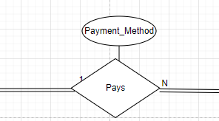

Total participation from both Customer and Order. This is a binary relationship where a Customer must pay for one or more orders and an order must be paid for by a customer. An order must be paid by only one Customer, if several customers paid for an order only one Customer is saved as the one who paid.

The Payment_Method attribute is used to save which payment technique the customer uses, i.e. cash, card, vouchers.

### CONTAINS (between ORDER, MEAL)

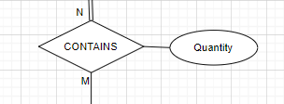

Total participation from Order, partial participation from Meal. This is a binary relationship where each Order needs to contain one or more meals. But it is not necessary that all meals are part of an Order. A Meal can be part of no Order. A Meal can be part of many orders. Each relationship between these two is characterized by a quantity. Because an Order has many meals, but the quantity shows the restaurant the quantity of a specific Order.

This relationship is important as it helps the restaurant know each Order is made of what meals to directly give it to the chefs to prepare it.

### DELIVERS (between ORDER, DELIVERY_DRIVER)

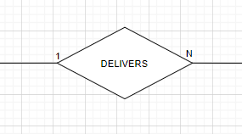

Partial participation from both Order and Delivery_Driver. This is a binary relation between Delivery driver and order where a Delivery_Driver can deliver one or more orders. And an Order is delivered by only one driver. An Order is not necessarily delivered since the Order might be for the restaurant locally not to an address outside. And the Delivery_Driver doesn’t necessarily deliver an Order all the time.

This relationship is important as it helps the restaurant know which Order each Delivery_Driver has delivered and follow up with them in case of an issue.

### IS_MADE_OF (between INGREDIENT, MEAL)

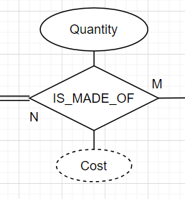

Total participation from Meal, partial participation from ingredients. This is a binary relationship where each Meal is made of one or more ingredients. Each Ingredient is part of one or more meals. A Meal must be made of ingredients, but not all ingredients are necessarily part of a Meal (maybe some ingredients are only for the staff to eat from). Each relationship between Meal and Ingredient is characterized by a Quantity and Cost. Because a Meal can have different quantities of different ingredients. And a Cost can be useful to directly get the cost of the ingredients of this Meal. It is a derived attribute since we can directly get it by summing the costs of the ingredients used.

This relationship is important as we can see directly what each Meal is made of, as well as its ingredients’ cost.

### IS_SITTING (between CUSTOMER, TABLE)

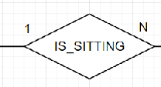

Partial participation from Customer, parietal participation from Table. This is a binary relationship where one customer sits on one table and one table can have many customers sitting on it. Not all customers sit on a table, they could have their food to go or order it. Not all tables need to have customers sitting on them, some could be empty.

This relationship shows that the customers have a dine in option where they can sit on a table and eat their food in the restaurant.

* + 1. PLACES (between WAITER, CUSTOMER, ORDER)

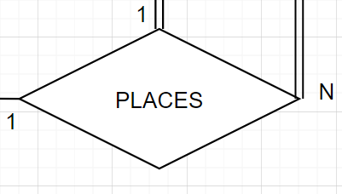

Total participation Customer and Order, partial participation from Waiter. This is a ternary relationship where one customer contacting one waiter can place many orders, one waiter takes one order from one customer and one customer placing one order talks to one waiter. All customers must place an order, and all orders must be placed, but not all waiters take orders.

This relationship shows that to get the food, whether for dine in or delivery, a customer has to order it via a waiter.

### CONTACTS (between WAITER, DELIVERY DRIVER)

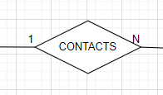

Partial participation from Waiter and Delivery_Driver. This is a binary relationship between waiter and driver where 1 waiter can contact many drivers, and a driver is contacted by 1 waiter who tells him to pick up the order and give him the location. Not all delivery drivers are contacted and not all waiters contact delivery drivers.

The relationship is needed to allow waiters to ask delivery drivers to come and give them the drop off location and know which Waiter contacted the Delivery Driver in case of a mistake.

### HIRES (between HR, WAITER/DELIVERY_DRIVER/CHEF)

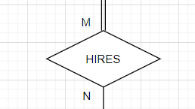

Total participation from Waiter/Delivery_Driver/Chef, partial participation from HR. This is a binary relation between HR and Waiter, HR and Delivery_Driver and HR and Chef respectively. One HR employee can hire many chefs/waiters/drivers and one chef/waiter/driver can be hired by many HR employees as a group decision. Each chef/waiter/driver must be hired but not all HR members hire employees.

This relationship shows that each employee of the restaurant is hired by the HR department ensuring that the employees are competent enough to join the team.

This exists three times, once for every type of employee (HR to chef/driver/waiter)

### COOKS (between CHEF, MEAL)

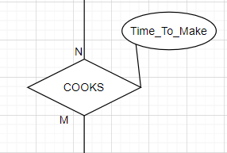

Partial participation from both Chef and Meal. This is a binary relationship where each Chef cooks one or more meals. A Meal is cooked by one or more chefs. A Meal is not necessarily always being cooked by a Chef (not all meals are being cooked all the time in the kitchen). Therefore, a Chef also isn’t always cooking a Meal (sometimes maybe there are no orders, or he’s at home, or at a break). The attribute Time_To_Make is a real time info that shows us how much time the Chef took to make the Meal.

This relationship is important to know which Chef has cooked which Meal in case of an issue with the Meal.

### MANAGES (between CHEF, KITCHEN_STATION)

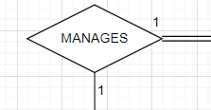

Total participation from Kitchen_Station, partial participation from Chef. This is a binary relationship where each Kitchen_Station must be managed by exactly one Chef. And where one Chef manages exactly one Kitchen_Station. A Chef cannot manage multiple kitchen stations. A Kitchen_Station can’t be managed by more than one Chef.

This relationship is important because it helps the restaurant see directly which chefs manage which kitchen stations to directly talk with the managers if needed.

### CONTAINS (between MENU, MEAL)

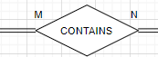

Total participation from Menu and Meal. This is a binary relationship between Menu and Meal where each Menu must contain one or more meals. And each Meal must be part of one or more Menu (otherwise why is the Meal there).

This relationship is important as it shows what are the present meals in each Menu so that the restaurant can directly use menus that contain predefined meals.

### SUPERVISION (between CHEF, SOUS-CHEF)

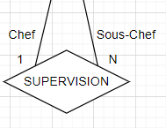

Partial participation from Chef from both sides. This is a binary relationship between Chef and Chef (same entity, relationship with itself). Each Chef (called then Sous-Chef) can be supervised by exactly one Chef (called Chef). Each Chef can supervise many other sous-chefs. A Chef doesn’t necessarily supervise another Chef. And a Chef isn’t necessarily supervised by another Chef.  
This relationship is important as it helps the restaurant in maintaining the hierarchy of the chefs.

This relationship helps the restaurant in organizing its Dine-in facility

### IS_ASSIGNED (between TABLE, WAITER)

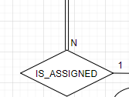

Total participation from Table, partial participation from Waiter. This is a binary relationship between Table and Waiter, where a waiter can be assigned to many Tables, but every Table is assigned to one waiter.

This relationship helps the Restaurant in the seating process by allowing the Customer to book a Table to avoid capacity issues upon arrival.

### DEPENDS_ON (between EMERGENCY_CONTACT_ CHEF/WAITER/DELIVERY_DRIVER and CHEF/WAITER/DELIVERY_DRIVER)

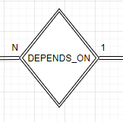

Total participation from both Emergency_Contact_Chef/Waiter/Delivery_Driver and Chef/Waiter/Delivery_Driver. This is a binary relationship where every Emergency_Contact depends on one Waiter/Chef/Delivery_Driver, and every Waiter/Chef/Delivery_Driver has many Emergency_Contacts to depend on him.

This relationship helps the restaurant in keeping track of every employee’s emergency contact so they can contact him in case of emergency.

This relationship exists three times, once for every time of employee.

### WORKS_IN (between CHEF, KITCHEN_STATION)

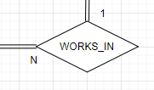

Total participation from both Chef and Kitchen_Station. This is a binary relationship where every Chef works in one Kitchen_Station, and every Kitchen_Station has many chefs working in it.

This relationship helps the restaurant by linking every Chef to a Kitchen_Station to make work clearer and improve efficiency.

### CONTACTS (between ADMINISTRATION, SUPPLIER)

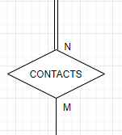

Total participation from Supplier, partial participation from Administration. This is a binary relationship where one member of the Administration contacts many suppliers, and every supplier can be contacted by many members of the administration.

This relationship facilitates the process of getting supplies for the restaurant by making a member of the administration contact a supplier.

### SUPPLIES (between SUPPLIER, INGREDIENTS)

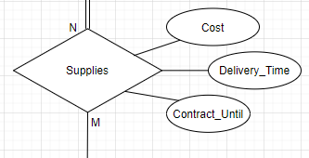

Total participation from Ingredients, partial participation from supplies. This is a binary relationship where a Supplier supplies many Ingredients, but every Ingredient can be supplied by many Suppliers. The attribute cost represents the financial cost of the supplied Ingredient by a certain Supplier. The attribute Delivery_Time represents the time needed for a certain Supplier to deliver a certain Ingredient. The attribute Contract_Until represents the date on which the contract made with a certain supplier ends.

This relationship helps the restaurant in keeping track of every Ingredient supplied by every Supplier alongside the Cost and Delivery_Time to fix the financials and the inventory.

### SUPERVISION (between SUPERVISOR, SUPERVISEE)

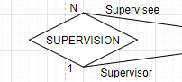

Partial participation from both sides. This is a binary relationship between the same entity (Waiter), where a Supervisor supervises many Supervisees, but a Supervisee is supervised by one supervisor.

This relationship helps the restaurant in keeping track of the hierarchy between Waiter.

### CREATES (between CHEF, MENU)

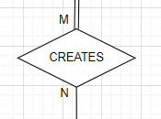

Total participation from Menu, partial participation from Chef. This is a binary relationship where a Chef creates one or more Menu. Not all chefs necessarily create a Menu. But a Menu must be created by one or more chefs.

### SHIFT (between Administration, waiter/chef)

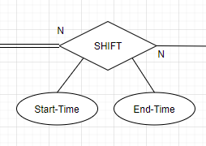

Total participation from chef/waiter but partial participation from administration. It is a binary relationship, an administration member may or may not be part of the ones who set the shift times but each and every waiter/chef must be assigned to a shift. One administration member can assign shift(s) to many waiters/chef and one chef/waiter can be assigned a shift by many administration members.

This relationship occurs twice (Administration to Chef/waiter)

# ER to Relational Mapping

## Step 1 – Mapping Strong Entity Types

### Relation: HR

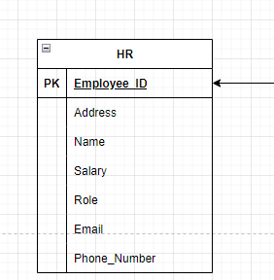

Seven columns each represent an attribute with Employee_ID being the Primary Key. The other attributes are Address, Name, Salary, Role, Email, Phone_Number.

### Relation: Administration

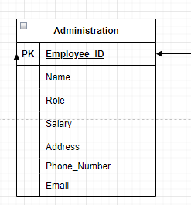

Seven columns each represent an attribute with Employee_ID being the Primary Key. The other attributes are Address, Name, Salary, Role, Email, Phone_Number.

### Relation: Menu

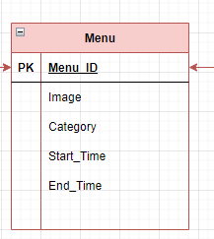

Five Columns each representing an attribute with Menu_ID being the primary key. The other attributes are Image, Category, Start_Time, End_Time.

### Relation: Meal

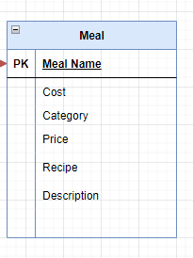

Six columns each representing an attribute with Meal_Name being the primary key. The other attributes are Cost, Category, Price, Recipe, Description.

### Relation: Supplier

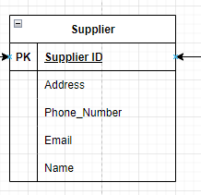

Five columns each representing an attribute with Supplier_ID being the Primary Key. The other attributes are Address, Phone_Number, Email, Name.

### Relation: Ingredient

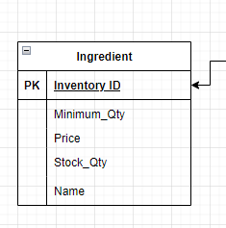

Five columns each representing an attribute with Inventory_ID being the primary key. The other attributes are Minimun_Qty, Price, Stck_Qty, Name.

### Relation: Chef

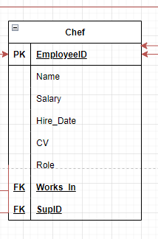

Eight columns each representing an attribute with EmployeeID being the Primary Key. The other attributes are Name, Role, Salary, Hire_Date, CV. We also have Works_In which is a Foreign Key that links this relation to the relation Kitchen station. Finally, we have SupID which is a Foreign Key that links the relation Chef to itself (Recursive relationship).

### Relation: Delivery_Driver

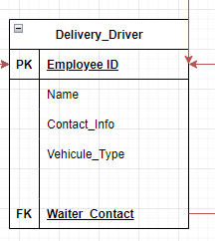

Five columns each representing an attribute with EmployeeID being the Primary Key. The other attributes are Name, Contact_Info, Vehicule_Type. We also have Waiter_Contact which is a Foreign_Key that links this relation to the relation Waiter.

### Customer

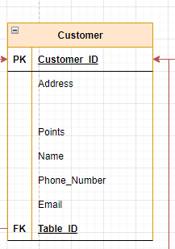

This relation has seven columns. CustomerID (Primary Key), address, points, name, phone_number and Email. Table ID (Foreign Key) is used to link relation Customer to relation Table.

### Table

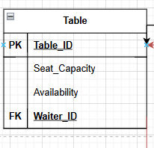

This relation has 4 columns. Table ID (Primary key), Seat capacity and Availability. Waiter ID (Foreign key) links the relation Table to the Relation Waiter.

### Waiter

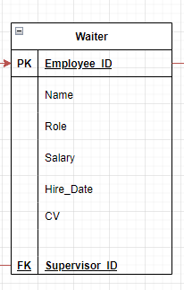

This relation has seven columns. Employee ID (Primary Key), name, role, salary, hire date, cv. Supervisor ID (Foreign key) links the relation Waiter to itself (recursive relationship).

### Order

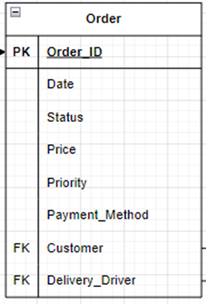

This relation has 8 columns. Order ID (Primary Key), date, status, price, priority, payment method. Customer ID (Foreign Key) links relation Order to relation Customer and Delivery Driver links the relation Order and the relation Delivery Driver.

### Kitchen_Station

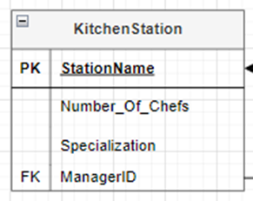

This relation has 4 columns. Station Name (Primary Key), Number of chefs, specialization. Manager ID (Foreign Key) links relation Kitchen Station to relation Chef.

## Step 2 - Mapping of Weaking Entity Types

### Review

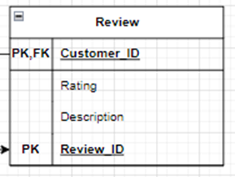

This relation has 4 columns. Review ID (Primary Key), Customer ID (Primary Key), rating, description. Customer ID (Foreign Key) links relation Review to relation Customer.

### Emergency_Contact

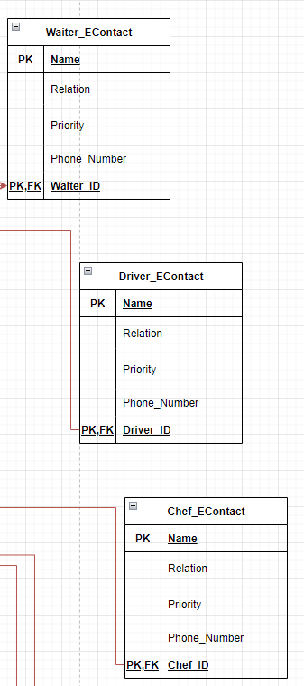

This relation is repeated three times (waiter/driver/chef), it has 5 columns. Name (Primary Key), chef/waiter/driver_ID(Primary Key) , relation, priority, phone number. the ID (Foreign Key) links relation Emergency Contact to relations Waiter/Delivery Driver/Chef.

## Step 3 – Mapping of Binary 1:1 Relationship Types

### MANAGES

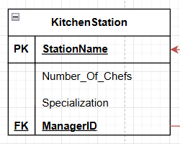

The relationship MANAGES is a 1:1 relationship between chef and kitchen station. One chef manages one station and is managed by one chef. Since we have the choice between which relation to hold the FK, we chose to set the FK ManagerID in the relation KitchenStation which points to the PK EmployeeID in chef.

## Step 4 – Mapping of Binary 1:N Relationship Types

### WORKS IN

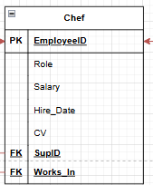

The relationship WORKS IN is a 1:N relationship between Chef and KitchenStation.

The FK Works_In set on the N side of the relationship is in the relation Chef and points to the PK Station Name in the relation KitchenStation

### SUPERVISION

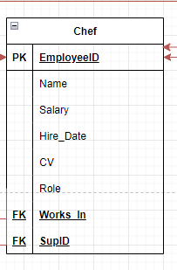

The relationship SUPERVISION is a 1:N recursive relationship. The FK SupID set in the Chef relation points to the PK EmployeeID in the relation itself.

### DEPENDS ON

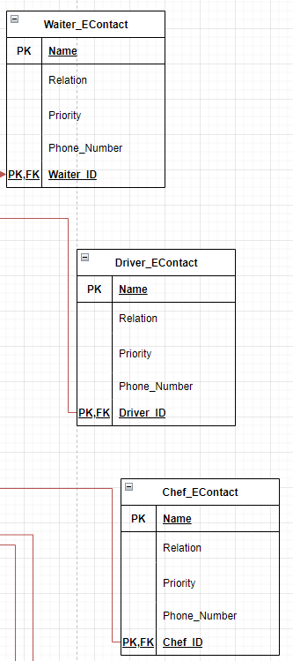

The relationship DEPENDS_ON is a 1:N used between 2 relations: Chef/Waiter/Delivery driver with Emergency_Contact_chef/waiter/driver. The FK chef/waiter/driver_ID set in the N side of the relationship in the relation Emergency_Contact and points to the PK Employee_ID in relations Chef/Waiter/Delivery Driver.

It is repeated three times (emergency_contact_chef/waiter/driver to chef/waiter/driver)

### Contacts

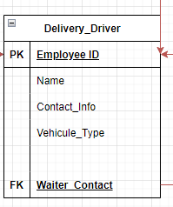

The relationship CONTACTS is a 1:N relationship between Waiter and Delivery driver. The FK Waiter_Contact is set on the N side of the relationship in the relation Delivery_Driver and points to the PK Employee_ID in the relation waiter.

### SUPERVISION

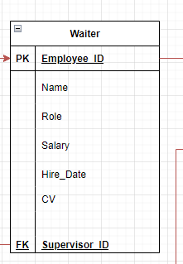

The relationship SUPERVISION is a 1:N recursive relationship. The FK Supervisor_ID set in the Waiter relation points to the PK EmployeeID in the relation itself.

### IS_SITTING

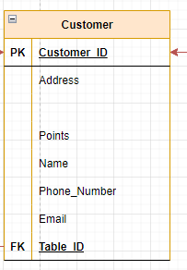

The relationship IS_SITTING is a 1:N relationship between Customer and Table. The FK Table_ID is set on the N side of the relationship in the relation Customer and points to the PK Table_ID in the relation Table.

### IS_ASSIGNED

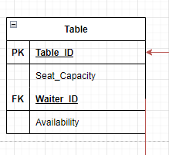

The relationship IS_ASSIGNED is a 1:N relationship between Table and Waiter. The FK Waiter_ID set in the N side of the relationship in the Table relation points to the PK Waiter_ID in the relation Waiter.

### WRITES

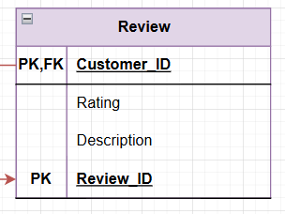

The relationship WRITES is a 1:N relationship between Review and Customer. The FK Customer_ID is set in the N side of the relationship in the relation Review an points to the PK Customer_ID in the relation Customer.

### PAYS

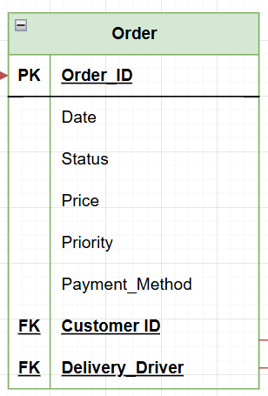

The relationship PAYS is a 1:N relationship between Customer and Order. The FK Customer_ID is set in the N side of the relationship in the relation Order and points to the PK Customer_ID in the relation Customer.

### DELIVERS



The relationship DELIVERS is a 1:N relationship between Order and Delivery driver. The FK Delivery_Driver is set in the N side of the relationship in the relation Order and points to the PK Employee_ID in the relation Delivery_Driver.

## Step 5 – Mapping of Binary M:N Relationship Types

### Contacts

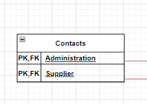

This is a relationship between Administration and Supplier. Since it is Many-to-Many, we’ve created a new relation for it with foreign keys from the Administration and Supplier relations, together they form the composite key for this relation.

### Contains

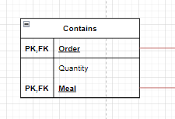

This is a relationship between Order and Meal. Since it is Many-to-Many, we’ve created a new relation for it with foreign keys from the Order and Meal relations, together they form the composite key for this relation. It also has an attribute Quantity added to it

### Cooks

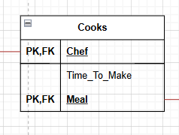

This is a relationship between Meal and Chef. Since it is Many-to-Many, we’ve created a new relation for it with foreign keys from the Chef and Meal relations, together they form the composite key for this relation.

### Composed_Of

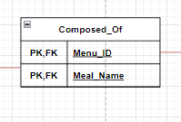

This is a relationship between Meal and Menu. Since it is Many-to-Many, we’ve created a new relation for it with foreign keys from the Menu and Meal relations, together they form the composite key for this relation.

### Creates

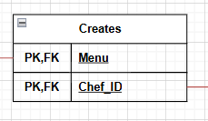

This is a relationship between Menu and Chef. Since it is Many-to-Many, we’ve created a new relation for it with foreign keys from the Menu and Chef relations, together they form the composite key for this relation.

### Hires

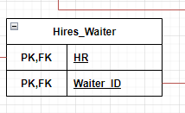

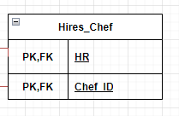

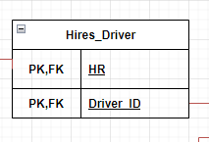

This is a relationship between HR and Driver/chef/waiter_ID. Since it is Many-to-Many, we’ve created a new relation for it with foreign keys from the HR driver/chef/waiter relation. Together they form the composite key for this relation. Driver/chef/waiter_ID points to employee_ID in driver/chef/waiter relation.

### Supplies

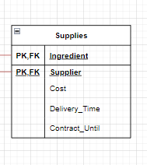

This is a relationship between Ingredient and Supplier. Since it is Many-to-Many, we’ve created a new relation for it with foreign keys from the Ingredient and Supplier relations, together they form the composite key for this relation. It also has three attributes added to it, which are Cost, Delivery_Time, Contract_Until.

### 8.5.8 Is_Made_Of

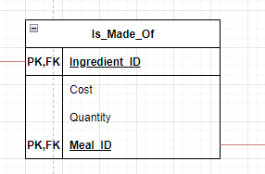

This is a relationship between ingredient and meal. Since it’s many-to-many we have created a new relation for it with foreign keys from the ingredient and meal relations, together they form the composite key for this relation. It also has attributes quantity and cost (derived attribute).

### 8.5.9 Shift

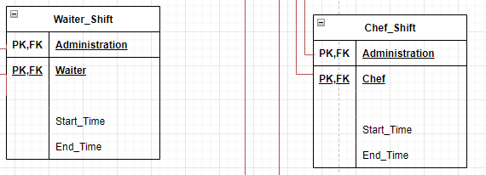

This is a relationship between Waiter/Chef and Administration. Since it is Many-to-Many, we’ve created a new relation for it with foreign keys from the Waiter/Chef and Administration relations, together they form the composite key for this relation. It also has attributes Start_Time and End_Time. This relation occurs twice.

## Mapping of Multivalued Attributes

### Assigned_Location

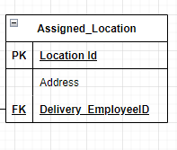

This is a Multivalued Attribute of the relation Delivery_Driver. It has 3 columns: Location_ID (Primary Key), Address. Delivery_EmployeeID (Foreign Key) links the multivalued attribute to the relation Delivery_Driver.

### Payment Method

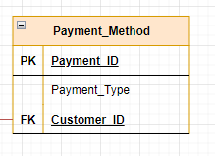

This is a multivalued attribute of the relation Customer. It has 3 columns: Payment ID (Primary Key), payment type. Customer ID (Foreign key) links the multivalued attribute Payment method to relation Customer.

### Image

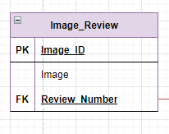

This is a multivalued attribute of the relation Review. It has 3 columns: Image ID (Primary Key), image. Review Number (Foreign Key) links the multivalued attribute Image to the relation Review.

### Image

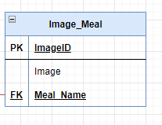

This is a multivalued attribute of the relation Meal. It has 3 columns: Image ID (Primary Key), image. mael_name (Foreign Key) links the multivalued attribute Image to the relation Meal.

### Product

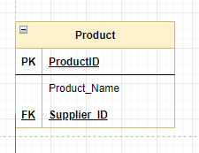

This is a multivalued attribute of the relation Product. It has 3 columns: Product ID (Primary Key), product name. Supplier ID (Foreign Key) links the multivalued attribute Product to the relation Supplier.

### Day

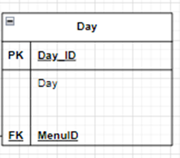

This is a multivalued attribute of the relation Menu. It has 3 columns: Day ID (Primary Key), Day. Menu ID (Foreign Key) links the multivalued attribute day to the relation Menu.

## Mapping of N-Ary Attributes

### Places

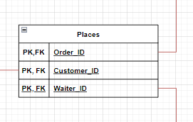

This is a relationship between Order, Customer and Waiter (ternary). Since it is Many-to-Many-to-Many, we’ve created a new relation for it with foreign keys from Waiter, Order and Customer relations, together they form the composite key for this relation.

## Step 8- Mapping Aggregation, Specialization Relationships

We do not have any special relationships from outside the course’s scope.

# Final Display - All Tables

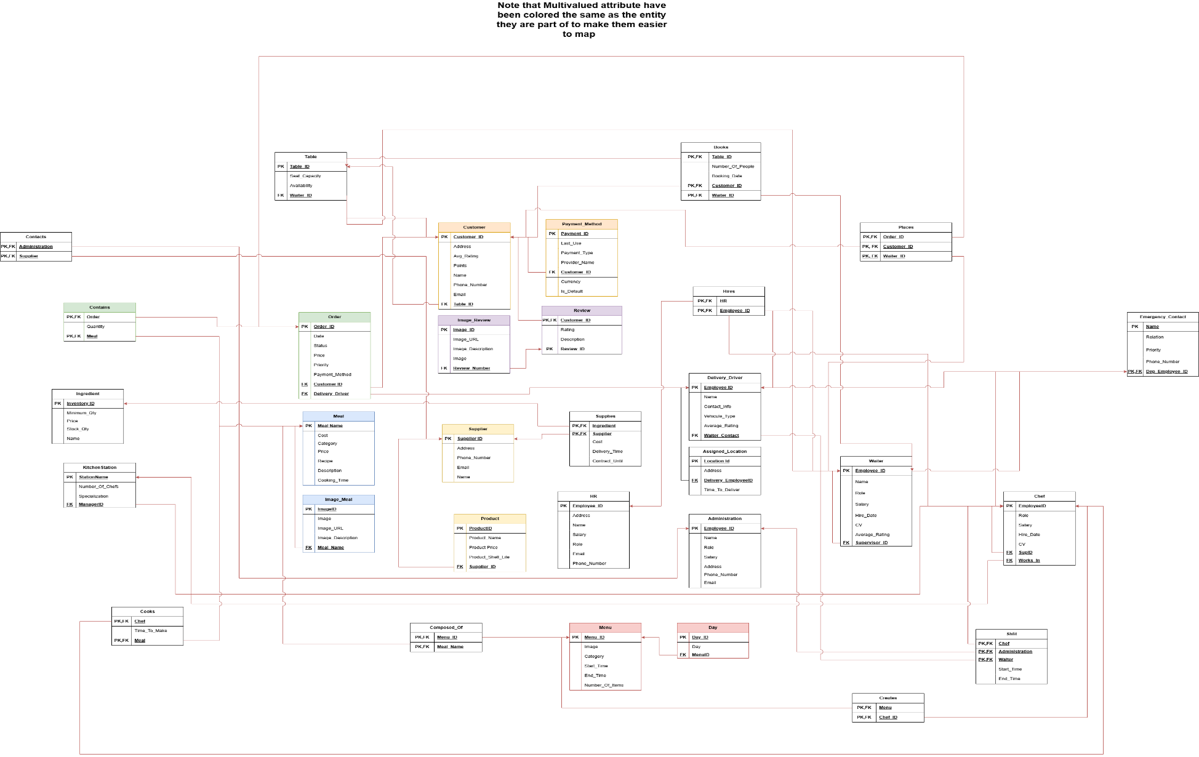

# Tables’ States

## HR

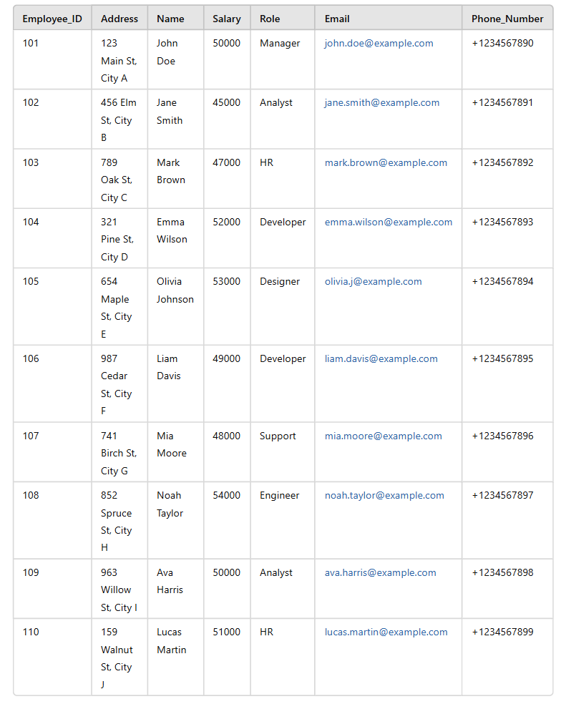

## Administration

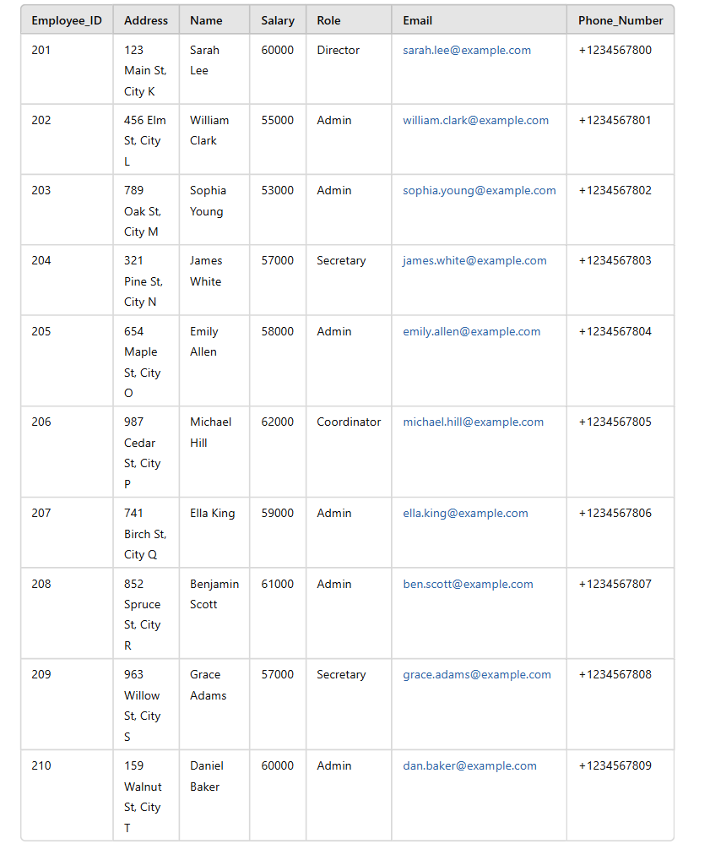

## Menu

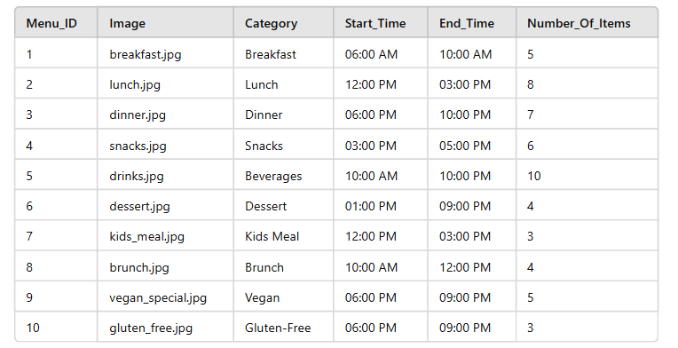

## Meal

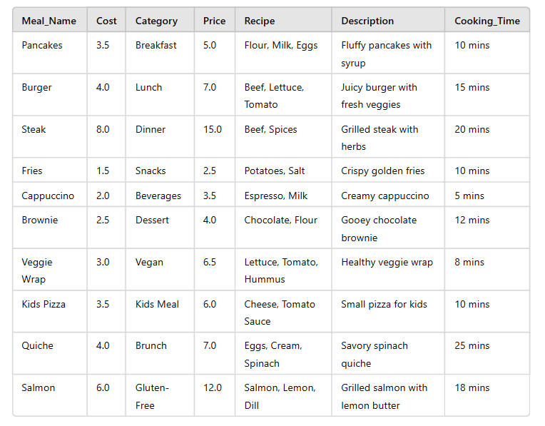

## Supplier

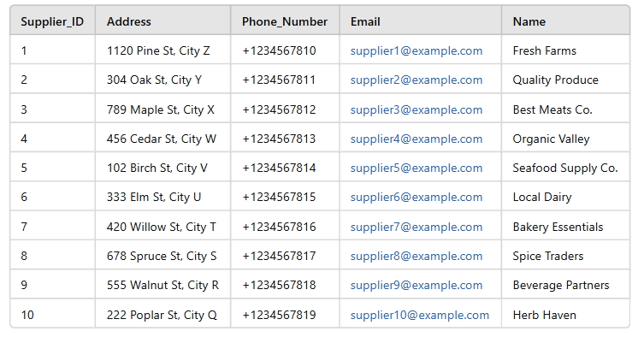

## Ingredient

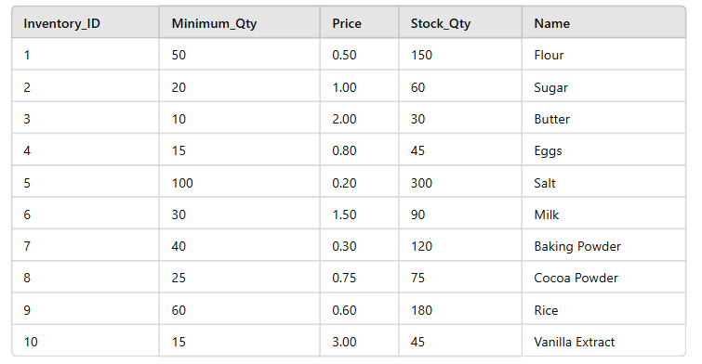

## Chef

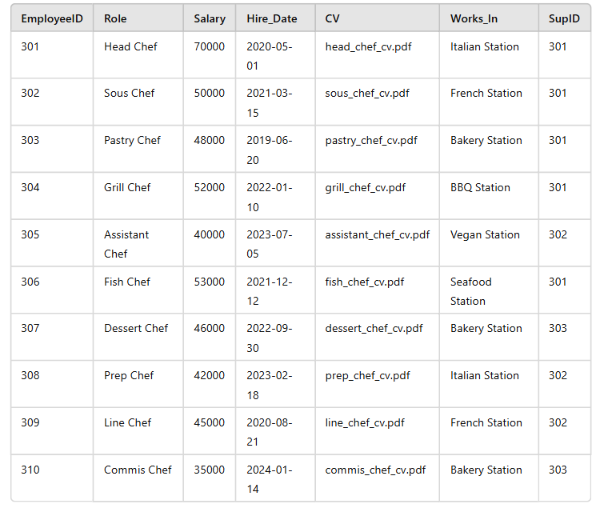

## Delivery_Driver

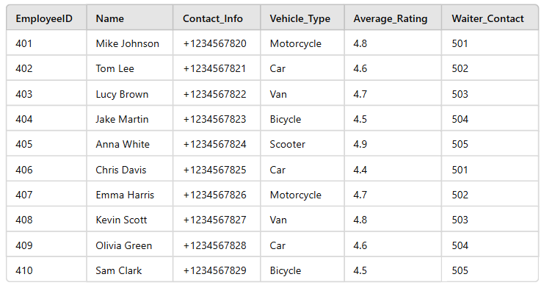

## Customer

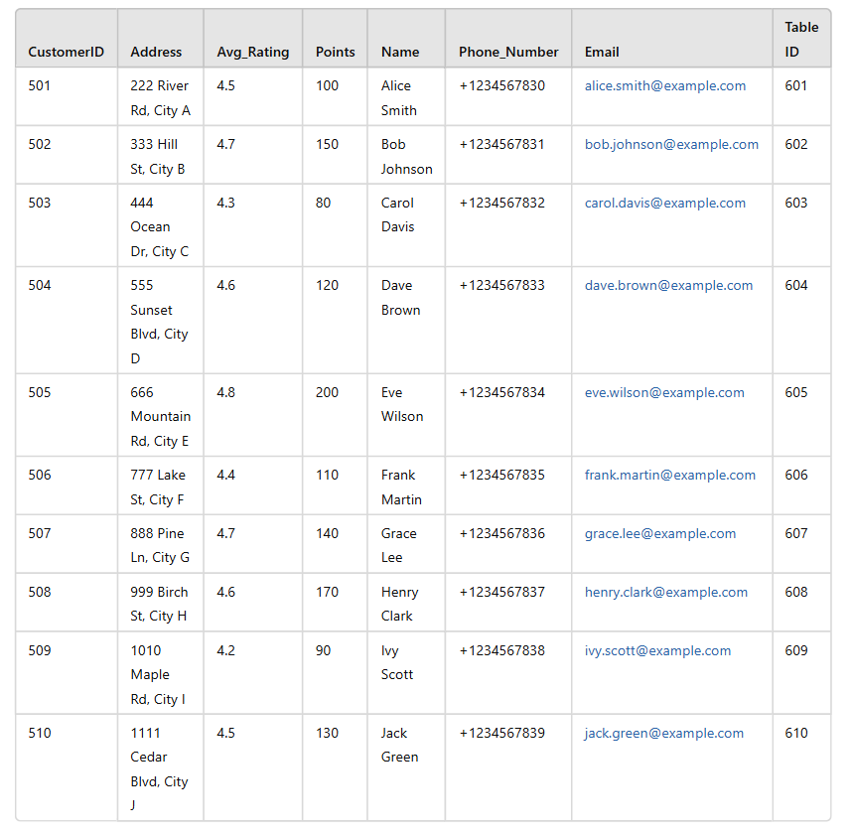

## Table

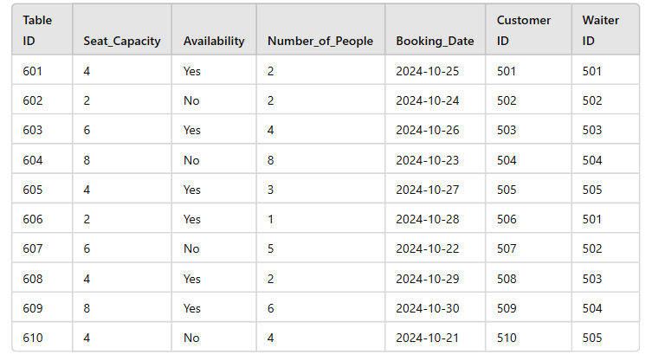

## Waiter

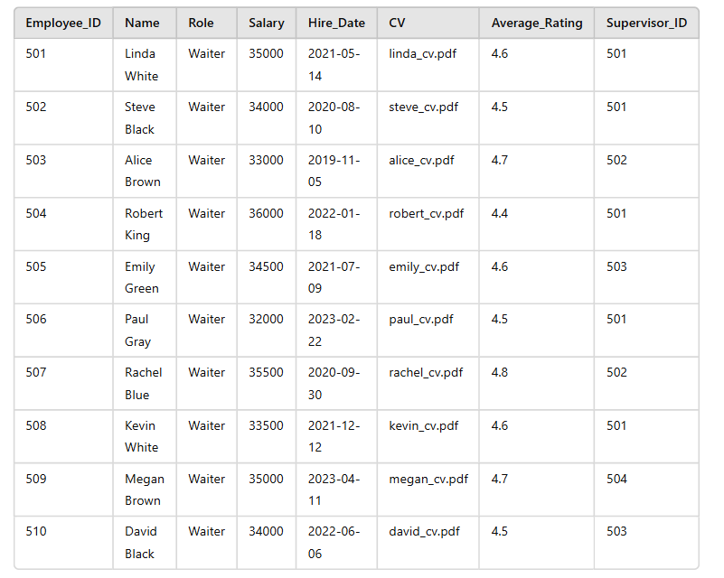

## Order

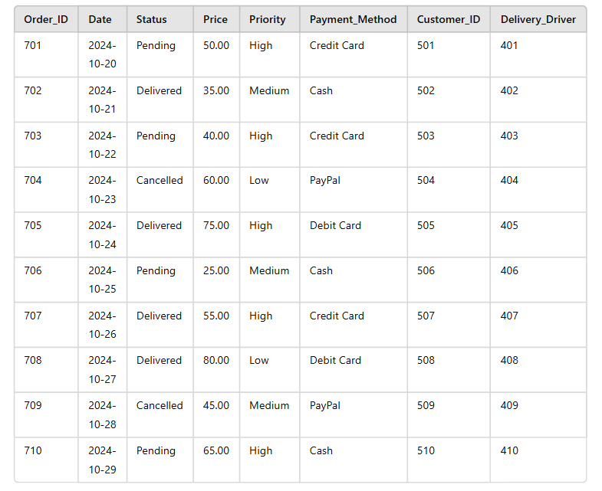

## Kitchen_Station

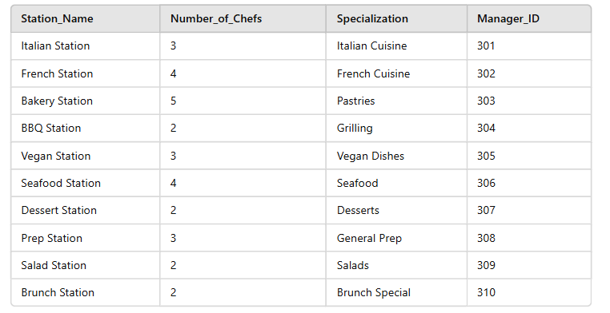

## Review

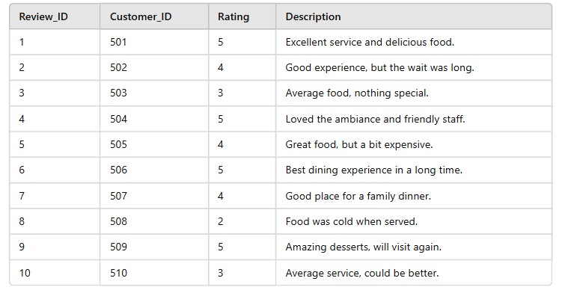

## Emergency_Contact

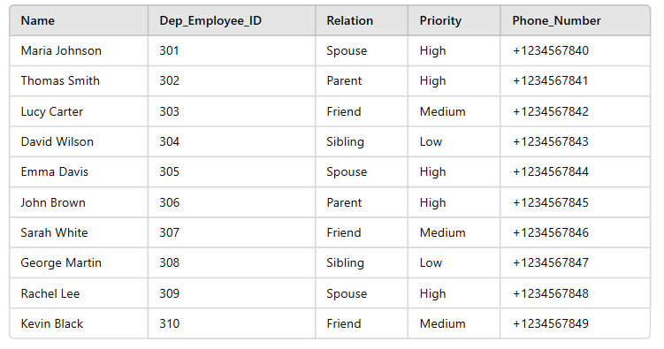

## Payment_Method

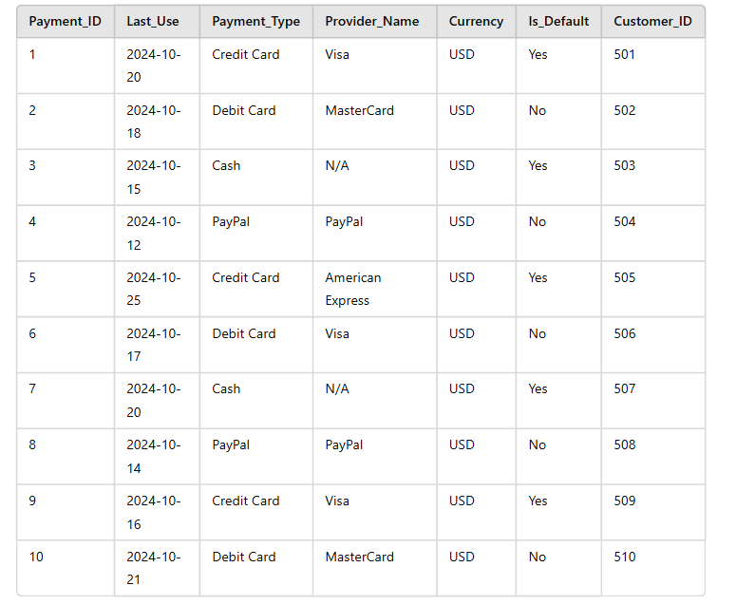

## Image_Meal

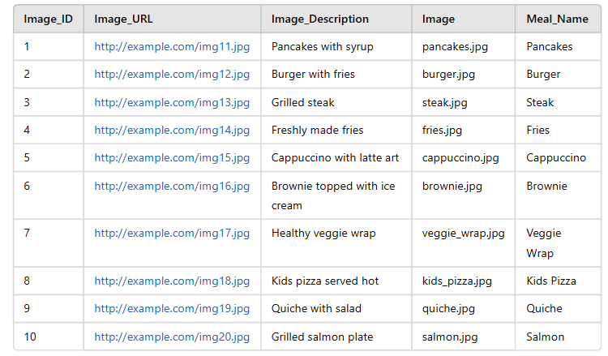

## Image_Review

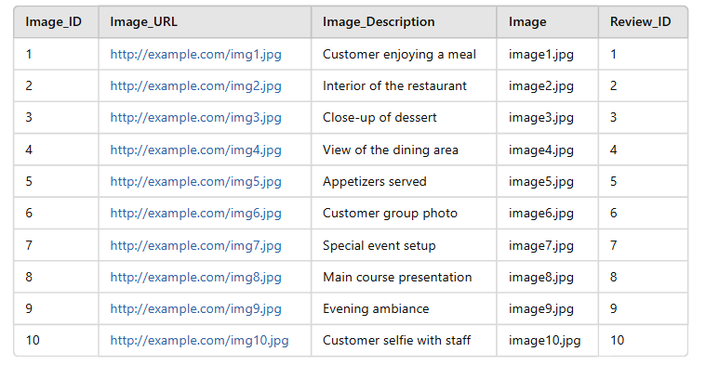

## Product

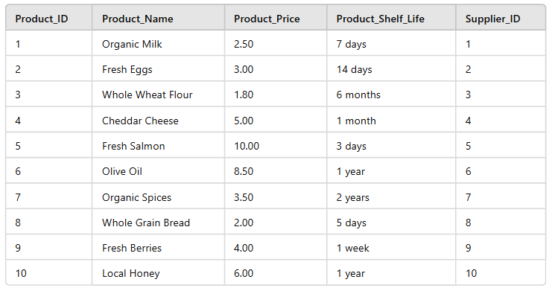

## Day

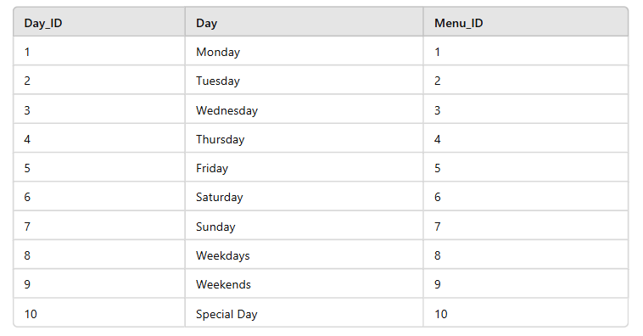

## Assigned_Location

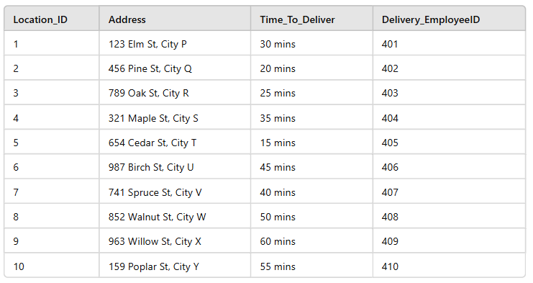

## Supplies

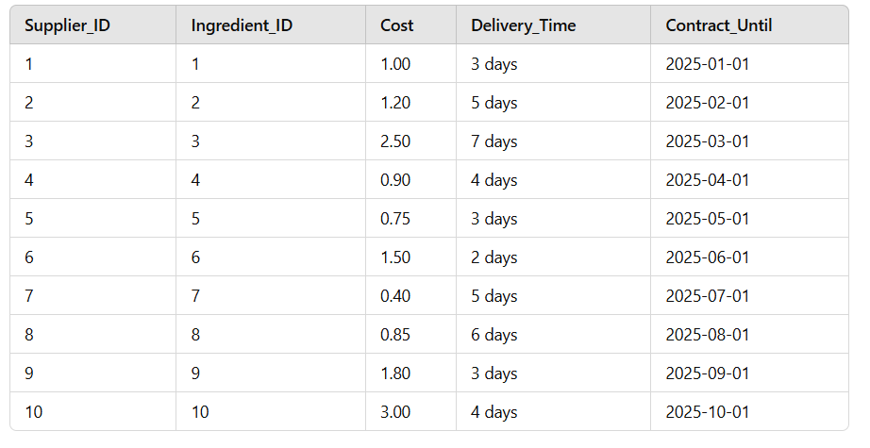

## Creates

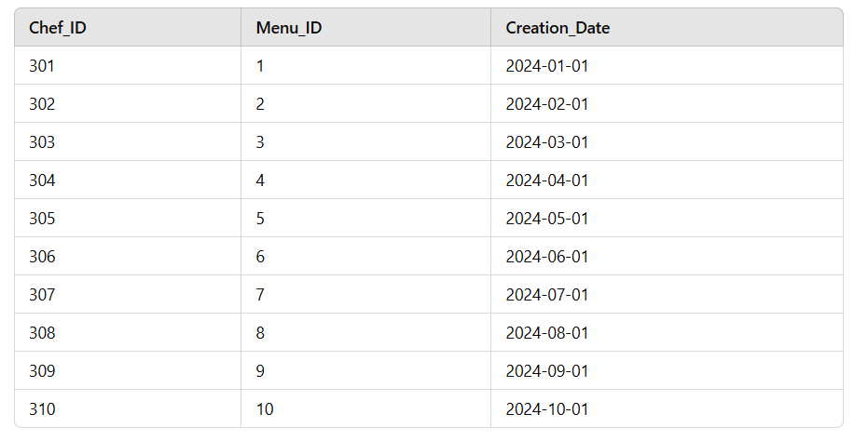

## Composed_Of

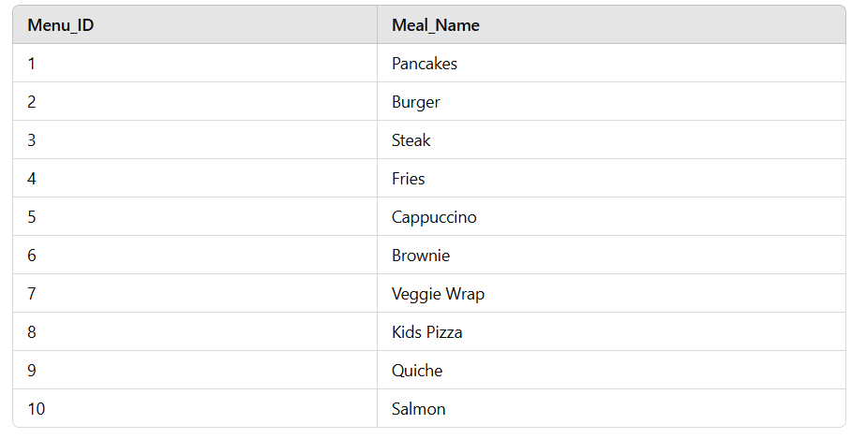

## Cooks

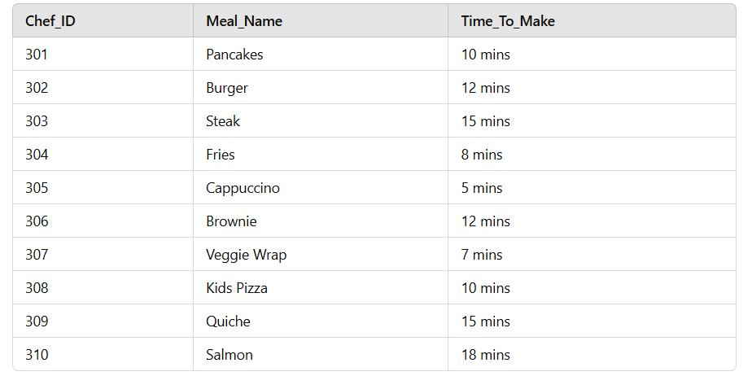

## Contacts

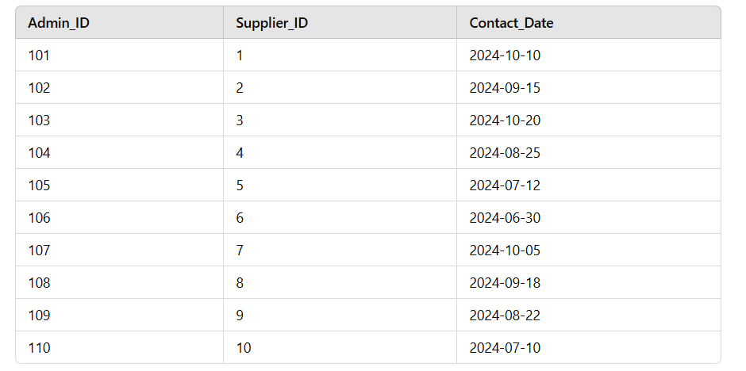

## Places

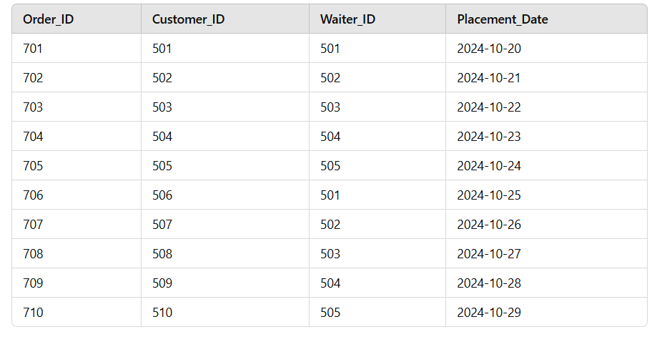

## Hires

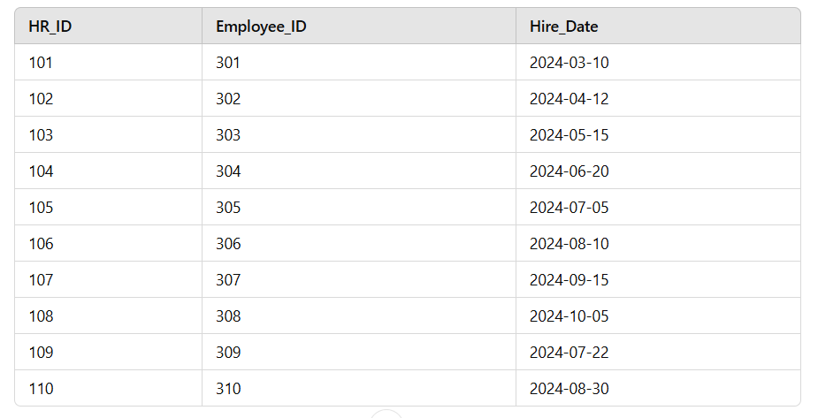

## Shift

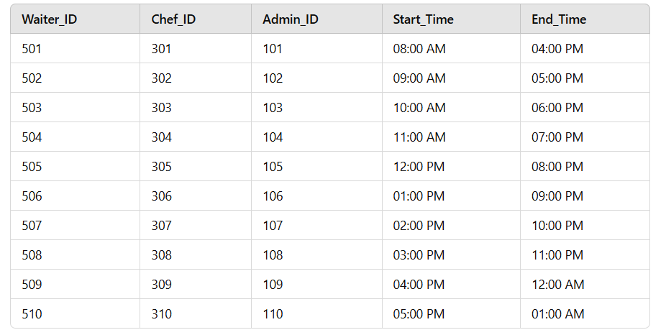

## Contains

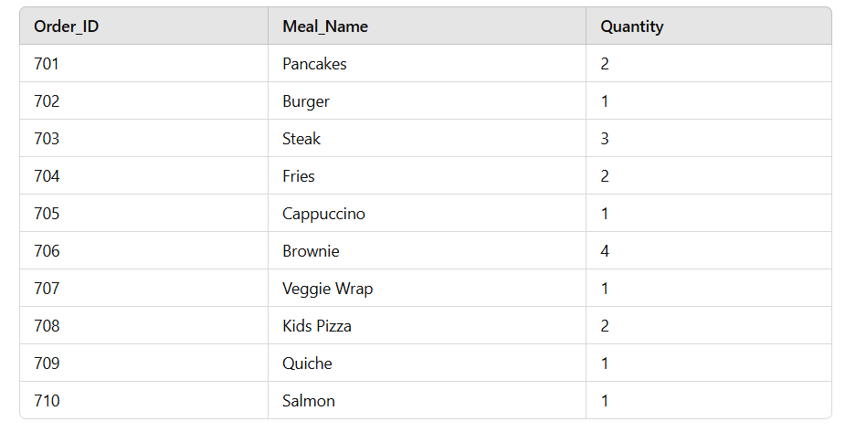

# SQL – Implementation

## 11.1. Domains

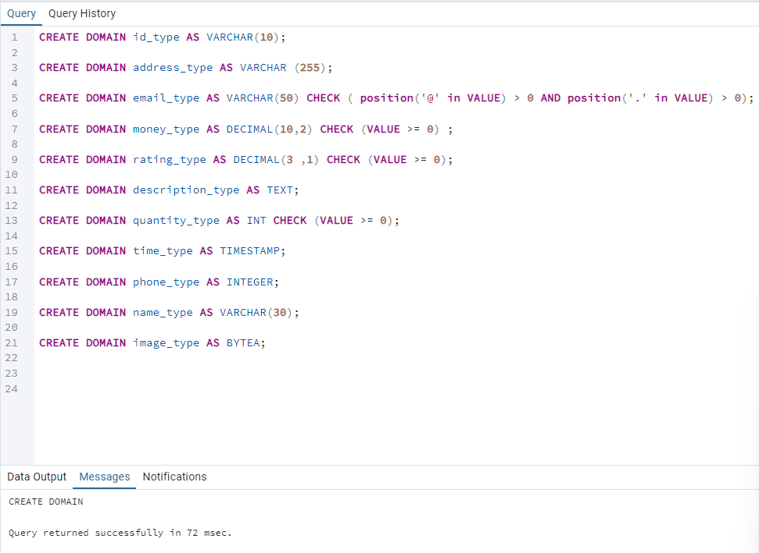

This is the list of domains used, since many of our attributes share common domains (Ex: employeeID, image etc…) we decided to create domain constraints for the most repetitive ones.

* Id_type is VARCHAR(10) and is mainly used for employee IDS i.e. the chef ID will be C (for chef) followed by a number; C1,C2,C3… Waiters will be W1,W2,W3… and drivers will be D1,D2,D3,D4…
* address_type is VARCHAR(255) to accommodate all types of addresses with street numbers and names, buildings floors etc…
* email_type is VARCHAR(50), The CHECK ensures an ‘@’ and a ‘.’ is included in the given address as otherwise it would be invalid.
* money_type is DECIMAL with 10 significant two of which are decimal points and is used for all monetary transactions in the DB such as prices, costs, salaries… The CHECK ensures the value to be >=0 as we can’t have negative transactions. Note: 0 stands for a customer that left without paying, got a full discount…
* rating_type is DECIMALl with 3 significant one of which is decimal points and is used for employee ratings. The CHECK ensures no negative rating is allowed.
* description_type is TEXT to allow long paragraphs to describe the meals.
* quantity_type is INTEGER, the CHECK ensures we can’t have a negative quantity.
* time_type is TIMESTAMP and is used to specifically tag the orders with not only the time of the order but also the date.
* phone_type is INTEGER and is used for all phone numbers in the database.
* name_type is VARCHAR(30) to accommodate longer names.
* image_type is BYTEA as images are stored in binary/hex and then decoded.

## 11.2. Create Tables

### 11.2.1 Customer

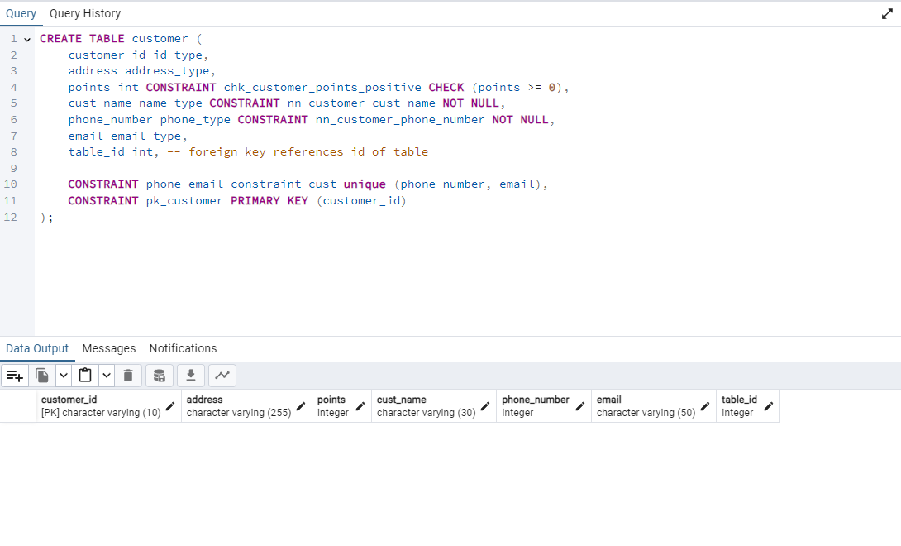

This table will hold all the information of every customer that came or ordered from the restaurant, the constraint phone_email_constraint_cust ensures the phone numbers and emails are unique amongst all tuples of the tables.

### 11.2.2 HR

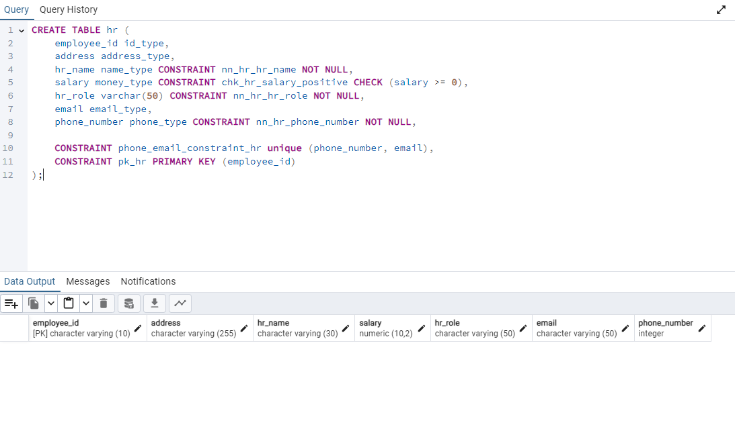

This table holds the information of every HR employee in the restaurant, the constraint phone_email_constraint_hr ensures phone numbers and emails are unique amongst all tuples in the table.

### 11.2.3 Payment method

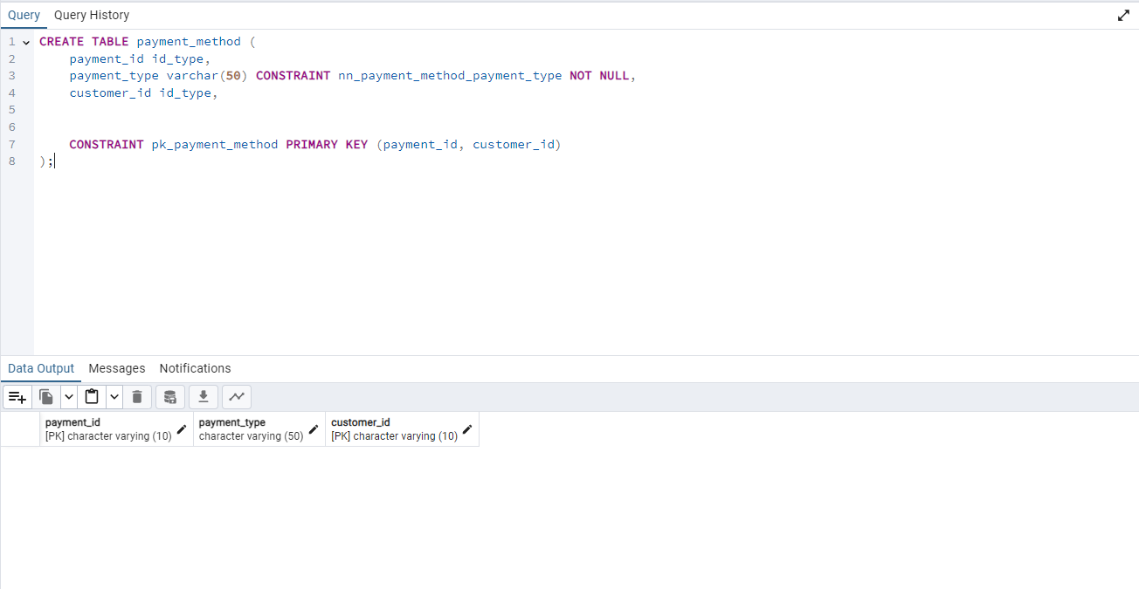

This table holds the payment methods used by the customers.

### 11.2.4 Review

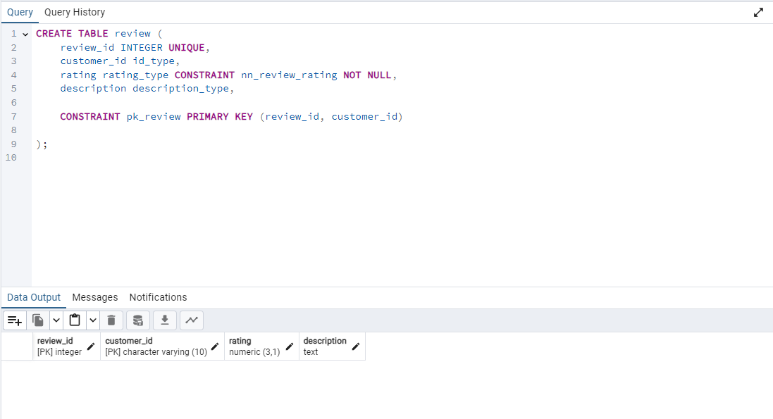

This table holds every review left by the customers that visited or ordered from the restaurant.

### 11.2.5 image review

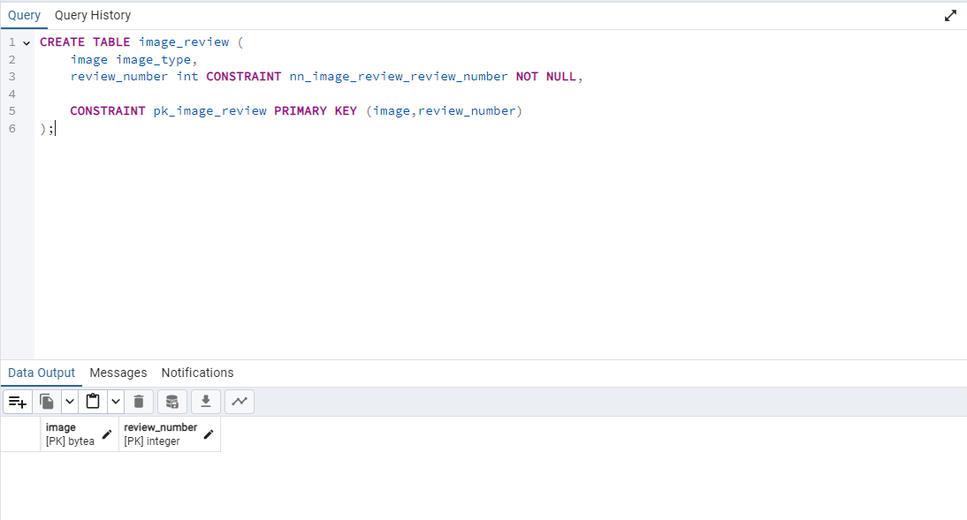

This table is a multivalued attribute of the table review that holds the image left along with the review.

### 11.2.6 Ingredient

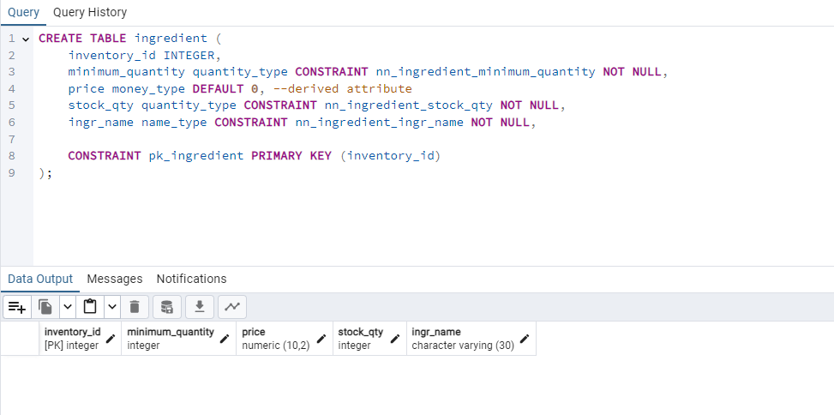

This table holds the stock every ingredient that is supplied to our restaurant. Note the price attribute is set to be 0 by default as it is a derived attribute that will be automatically calculated using a trigger later.

### 11.2.7 Meal

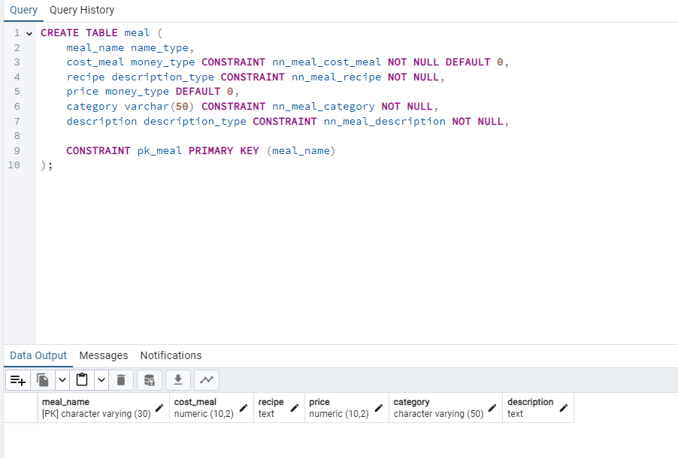

This table stores every meal served in our restaurant, notice price and cost_meal are set to be default 0 as they are derived attributes that will be calculated automatically later.

### 11.2.8 Image meal

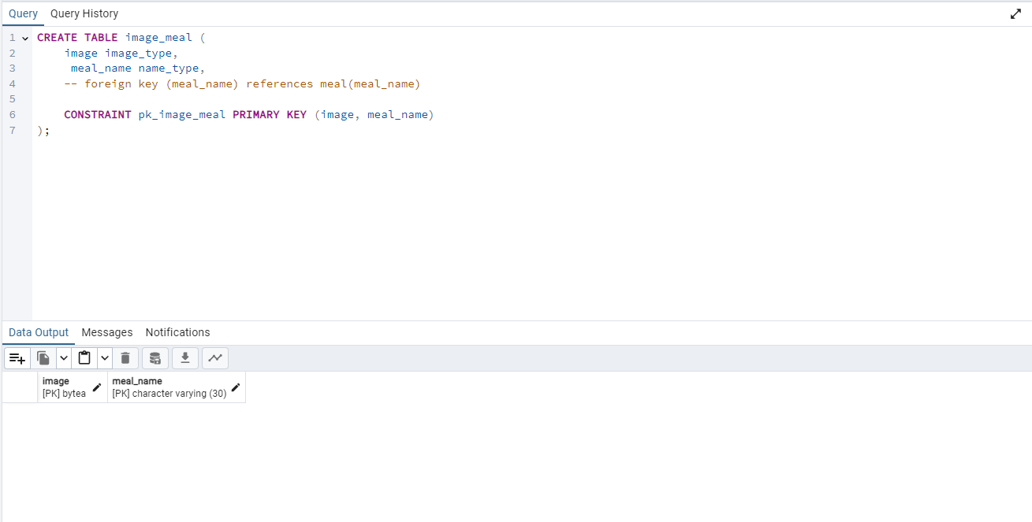

This Table stores the images of every meal served in our restaurant, it is a multivalued attribute of the meal table.

### 11.2.9 Table

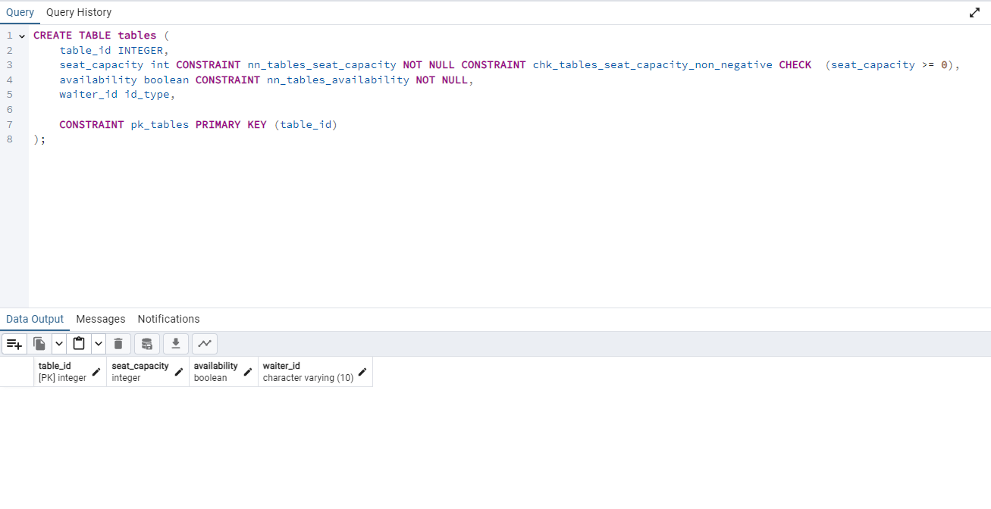

This table stores information about every table in our restaurant.

### 11.2.10 Menu

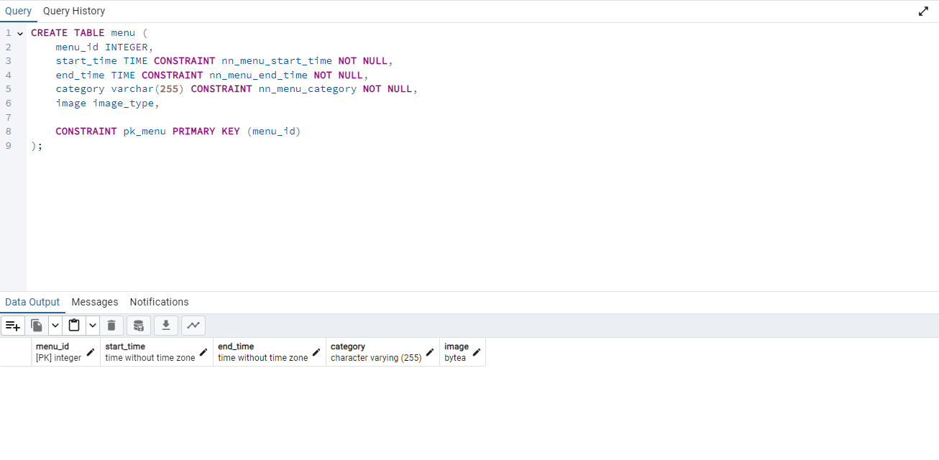

This table stores information about every menu in our restaurant.

### 11.2.11 Menu Day

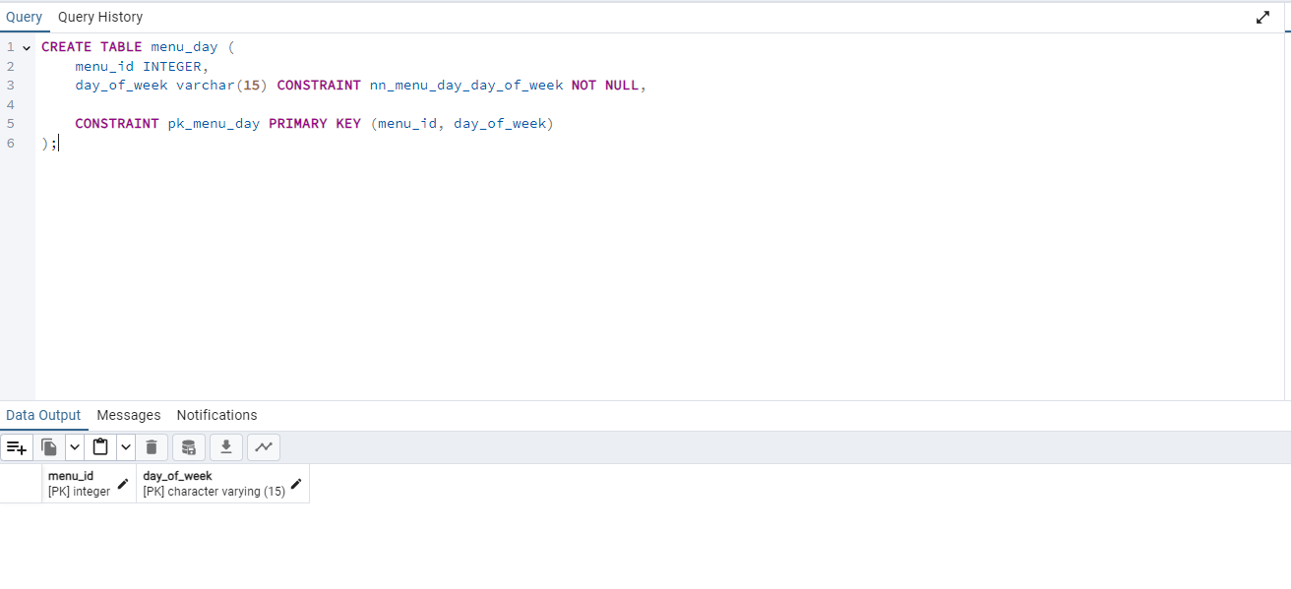

This table stores the day of availability of every menu, it is a multivalued attribute inside the menu table.

### 11.2.12 Customer Order

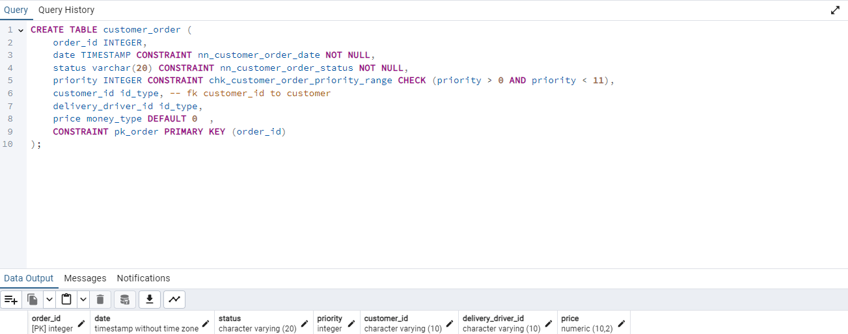

This table stores every order placed by a customer in our restaurant. We set the price equal to zero by default since it is a derived attribute. The price will be derived from the contain table by multiplying quantity by the price from meal

### 11.2.13 Chef

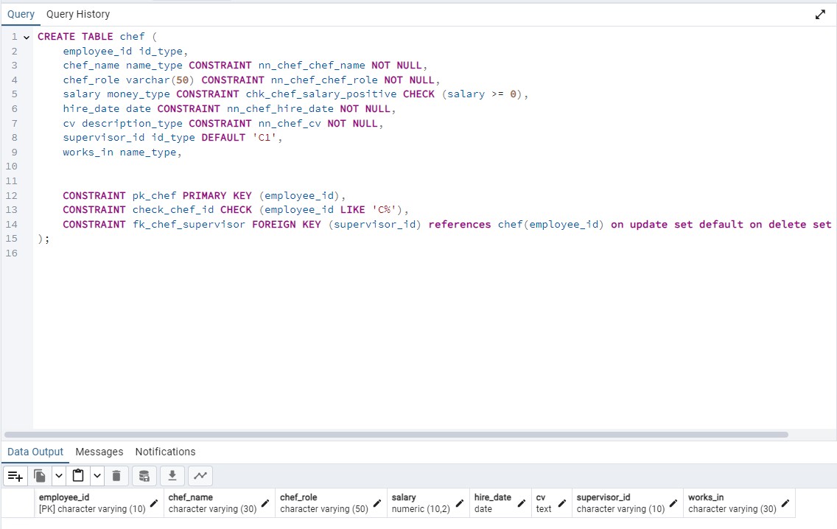

This table contains information about all chefs, the constraint check_chef_id ensures the entered ID is of the form C followed by an integer as that’s the chosen chef identifier in this DB. The constraint fk_chef_supervisor is used to assign to the chefs a supervisor that is himself a chef and has a default value of C1 in case no supervisor

### 11.2.14 Waiter

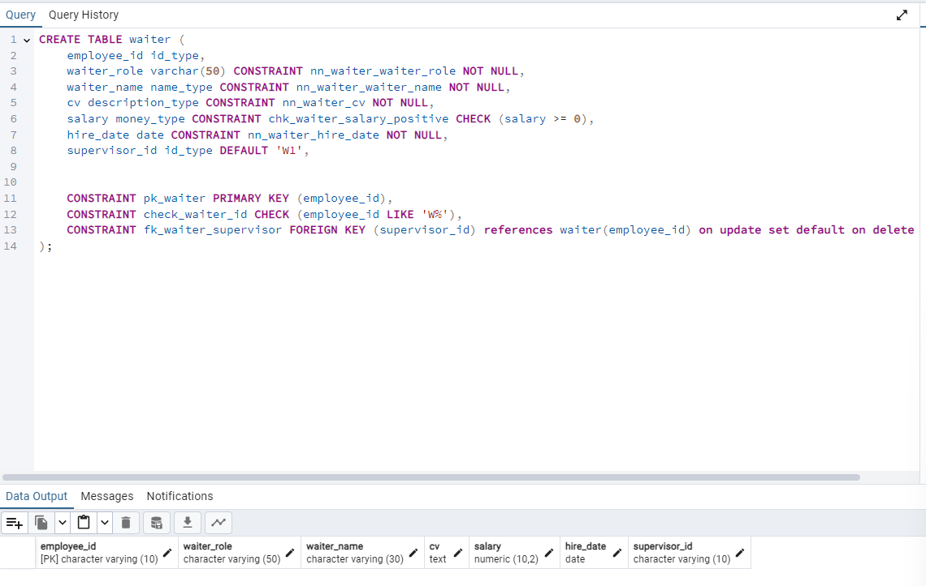

This table contains information about all waiters, the constraint check_waiter_id ensures the assigned waiter ID is of the form W followed by a number as that’s the chosen waiter identification in this DB. The constraint fk_waiter_supervisor is used to assign the waiters a supervisor that is himself a waiter and has a default value of W1 in case so supervisor was assigned to a waiter or the supervisor is not available anymore.

### 11.2.15 Supplier

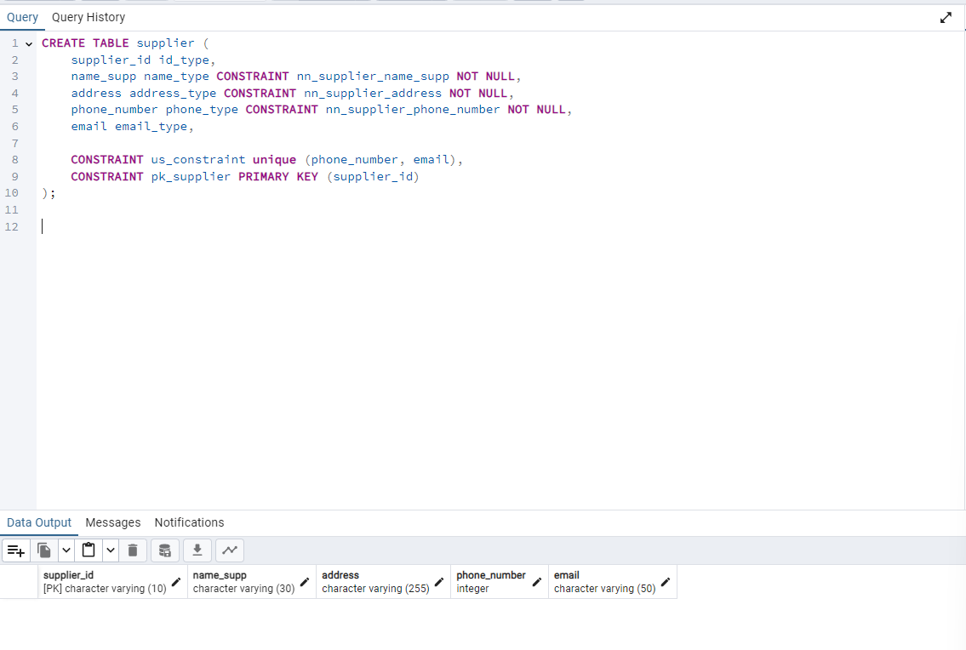

This table contains information about all suppliers, the constraint us_constraint stands for Unique supplier constraint and is used to ensure emails and phone numbers are unique amongst all tuples of the table.

### 11.2.16 Product

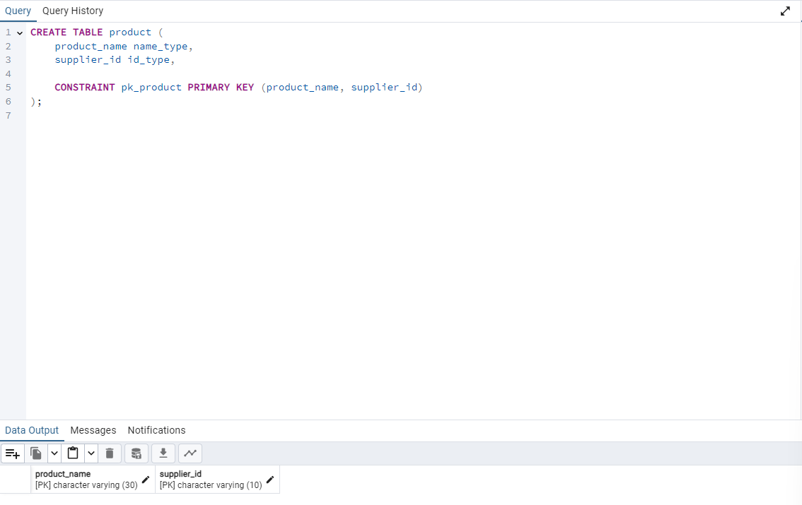

This table is a multivalued attribute of the table supplier and contains information about all products supplied by the suppliers.

### 11.2.17 Delivery Driver

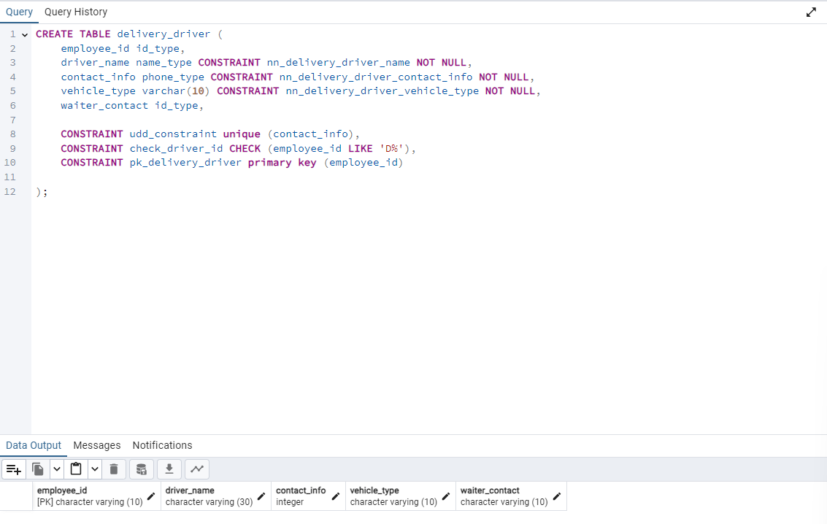

This table contains information about all delivery drivers, the constraint udd_constraint stands for Unique Delivery Driver constraint and ensures the contact_info is unique amongst all tuples of the table. The constraint check_driver_id ensures the ID is of the form D followed by a number as that’s the adopted driver identification in this DB.

### 11.2.18 Assigned Location

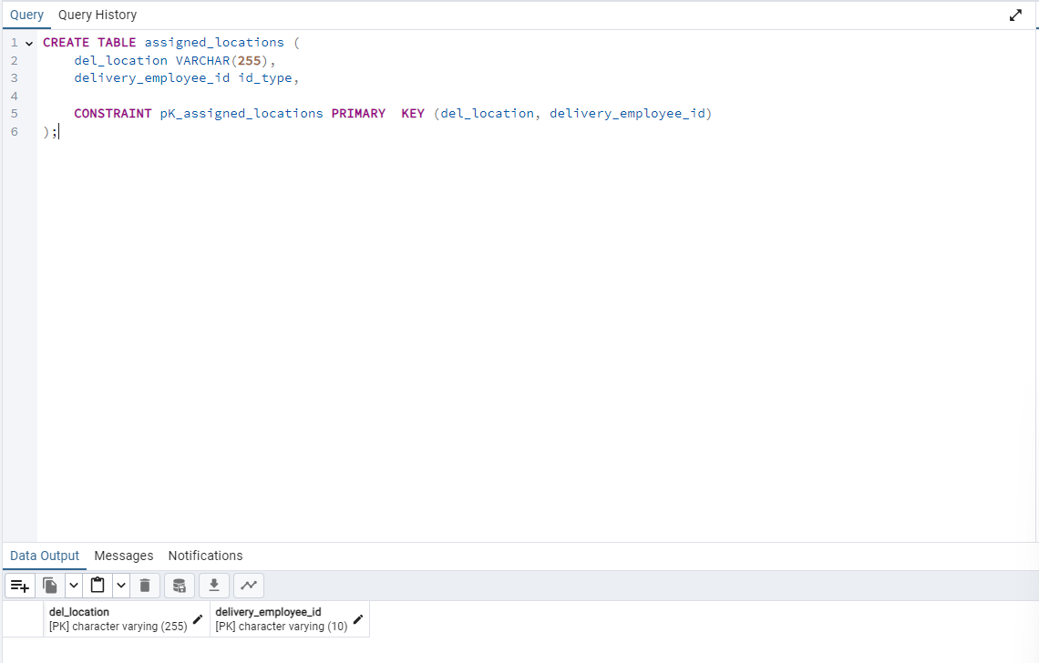

This table is a multivalued attribute of the table delivery driver and contains the locations that each delivery driver is responsible for.

### 11.2.19 Administration

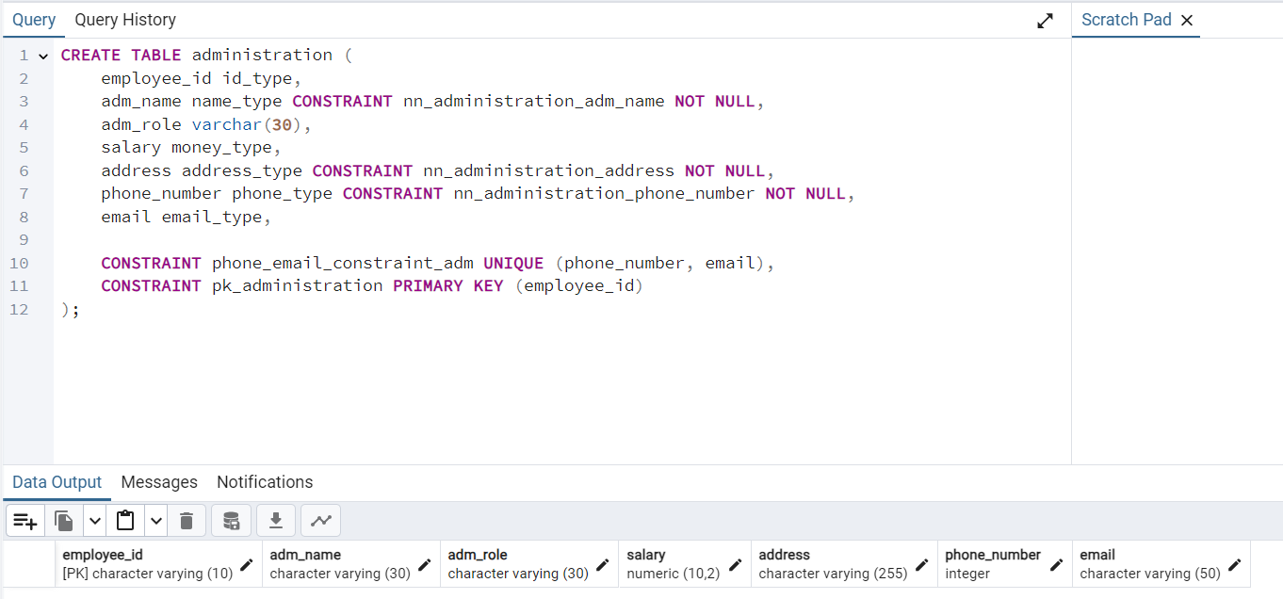

This table is a relation that holds the administrations’ info. We have some constraints like the administration name should not be null. Address is also not null. And the phone number of the administration should not be null too. The phone numbers and emails should be unique as we do not want many employees in the administration to have the same email.

### 11.2.20 Kitchen Station

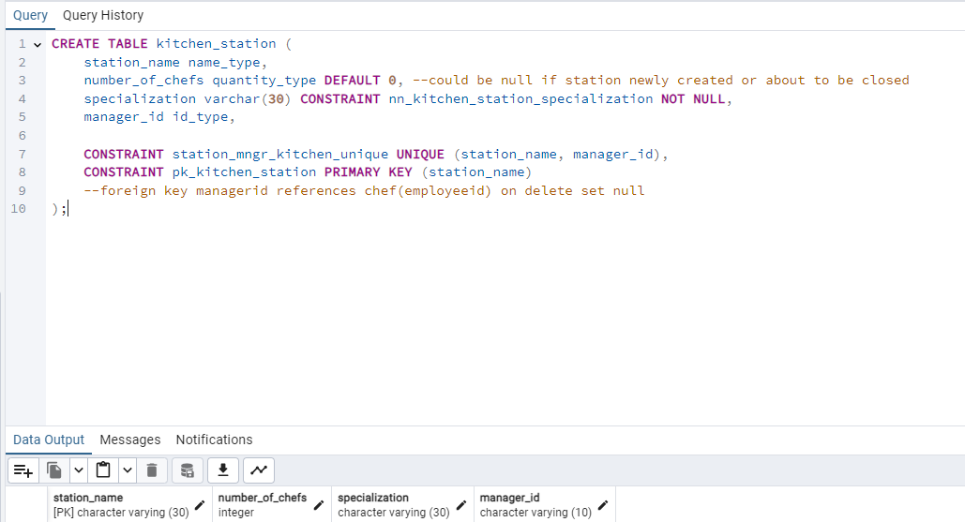

This table is a relation that holds the different kitchen stations in the restaurant. We have some constraints like the specialization cannot be null as a kitchen station must be specialized in something. The manager should be unique as each station has exactly 1 manager. Note: the number of chefs is set to be 0 by default as it’s a multivalued attribute that will be calculated later using a trigger.

### 11.2.21 Emergency Contact Waiter

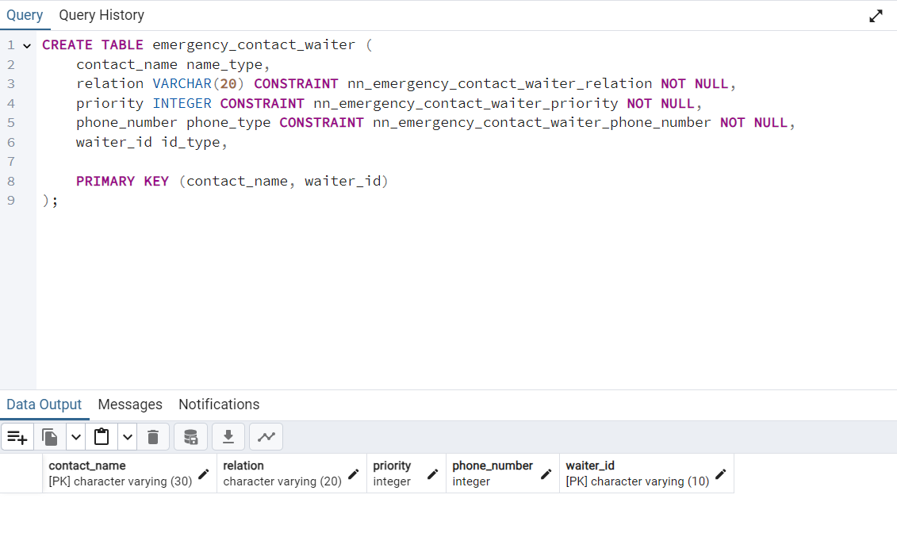

This table holds information about the relationship between the waiter and the person needed as an emergency contact. Some info must not be null like the relation between them, the priority of the contact and the phone number of the emergency contact.

### 11.2.22 Emergency Contact Chef

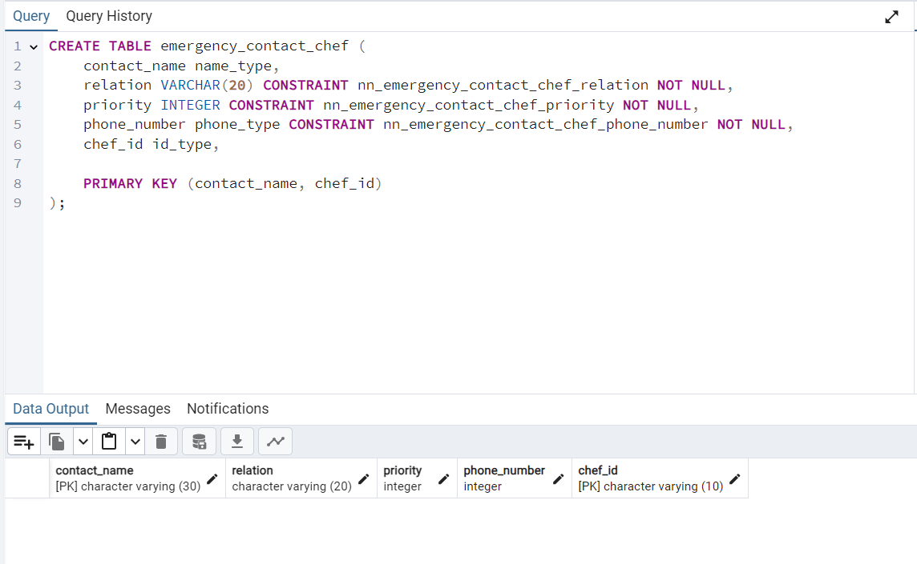

This table holds information about the relationship between the chef and the person needed as an emergency contact. Some info must not be null like the relation between them, the priority of the contact and the phone number of the emergency contact.

### 11.2.23 Emergency Contact Delivery Driver

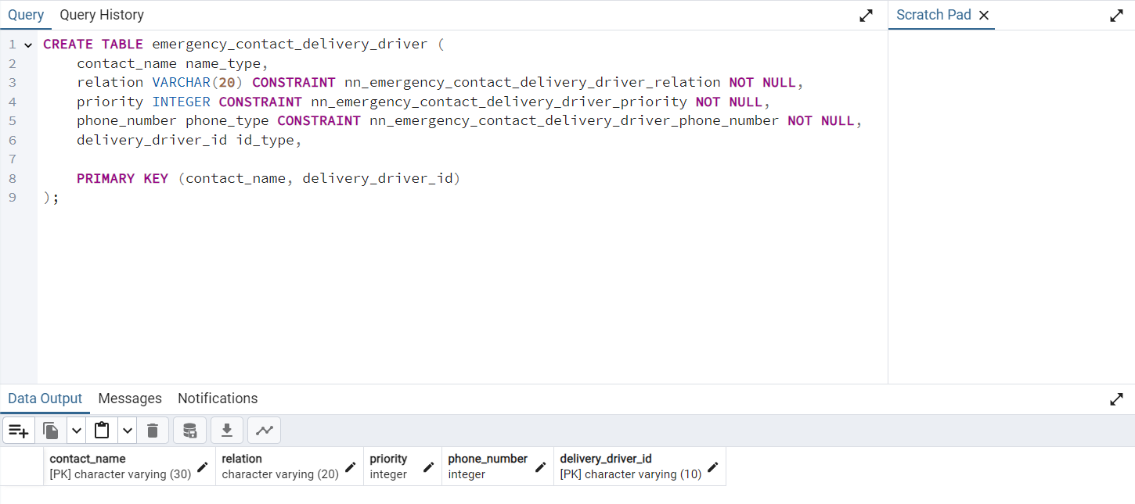

This table holds information about the relationship between the delivery driver and the person needed as an emergency contact. Some info must not be null like the relation between them, the priority of the contact and the phone number of the emergency contact.

## 11.3. Alter Tables (for FKs)

### 11.3.1 FK_Payment_Method

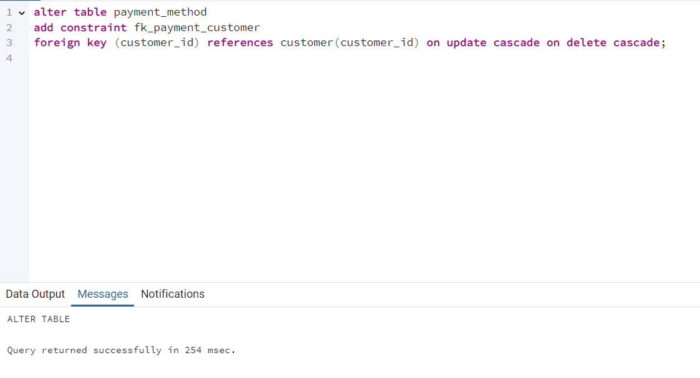

When updating the primary key that the foreign key references, the foreign key will be updated too. When deleting the primary key that the foreign key references, the foreign key will be deleted too.

### 11.3.2 FK_Review_Customer

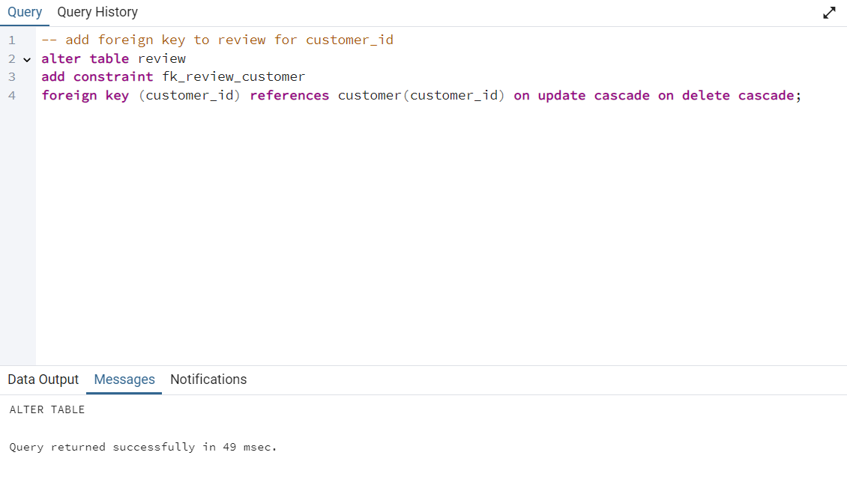

When updating the primary key that the foreign key references, the foreign key will be updated too. When deleting the primary key that the foreign key references, the foreign key will be deleted too.

### 11.3.3 FK_Image_Review

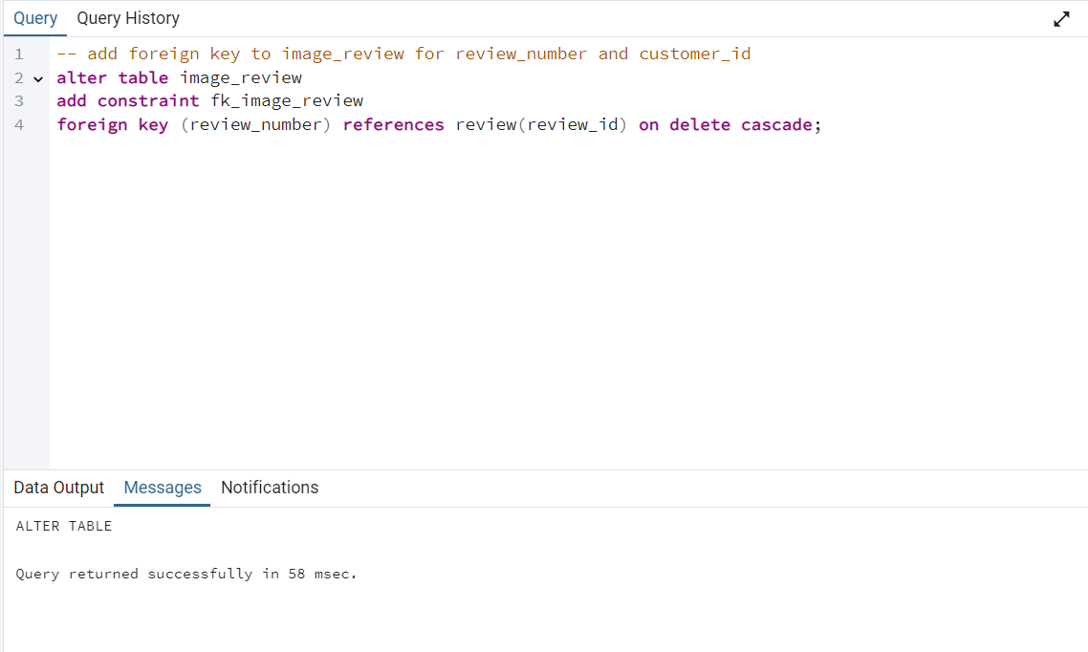

When deleting the primary key that the foreign key references, the foreign key will be deleted too.

### 11.3.4 FK_Image_Meal

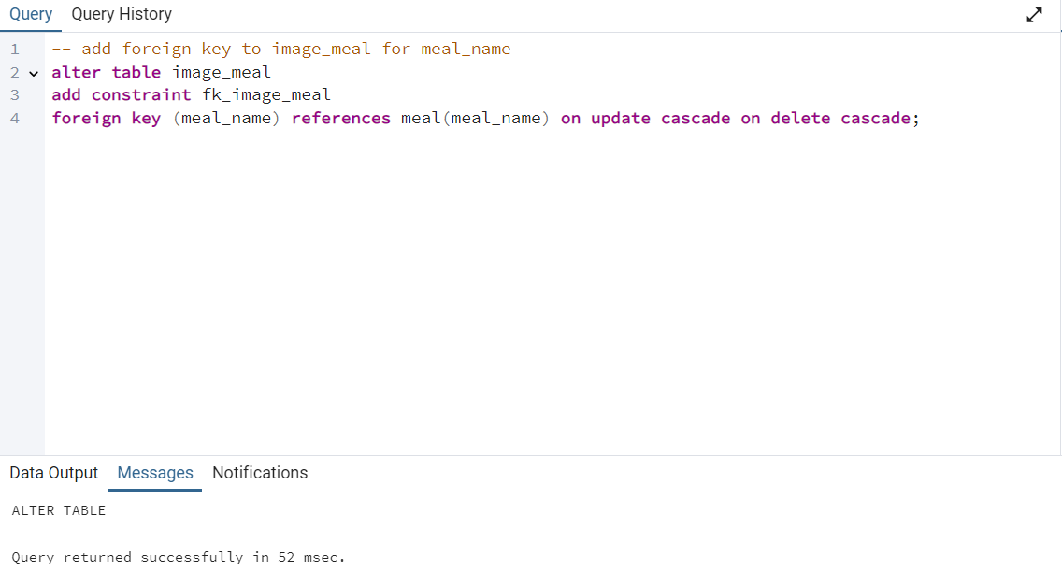

When updating the primary key that the foreign key references, the foreign key will be updated too. When deleting the primary key that the foreign key references, the foreign key will be deleted too.

### 11.3.5 FK_Menu_Day

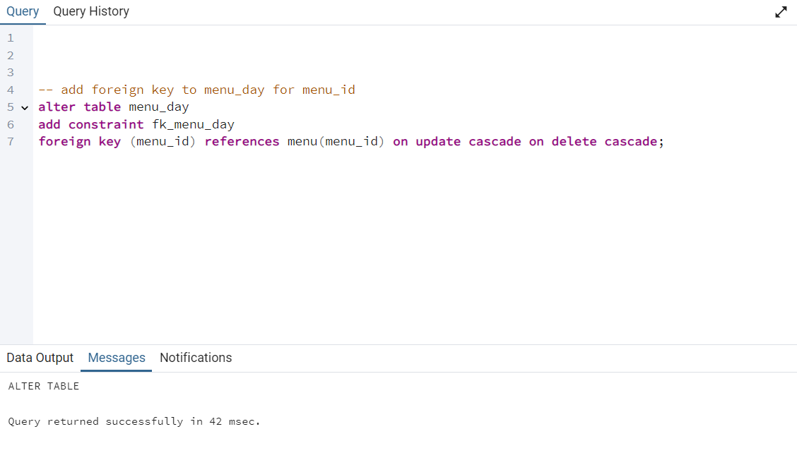

When updating the primary key that the foreign key references, the foreign key will be updated too. When deleting the primary key that the foreign key references, the foreign key will be deleted too.

### 11.3.6 FK_Orders_Customer

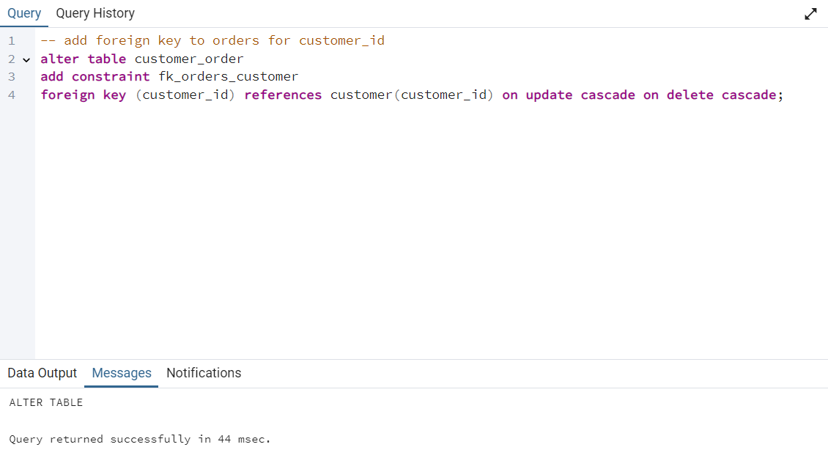

When updating the primary key that the foreign key references, the foreign key will be updated too. When deleting the primary key that the foreign key references, the foreign key will be deleted too.

### 11.3.7 FK_Order_Driver

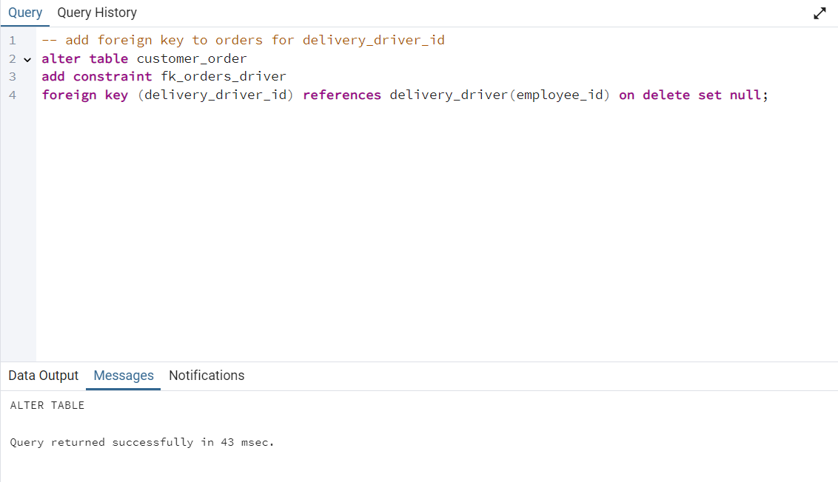

When deleting the primary key that the foreign key references, the foreign key will be set to null (as no order). If only changed, it will be kept as it is.

### 11.3.8 FK_Chef_Kitchen

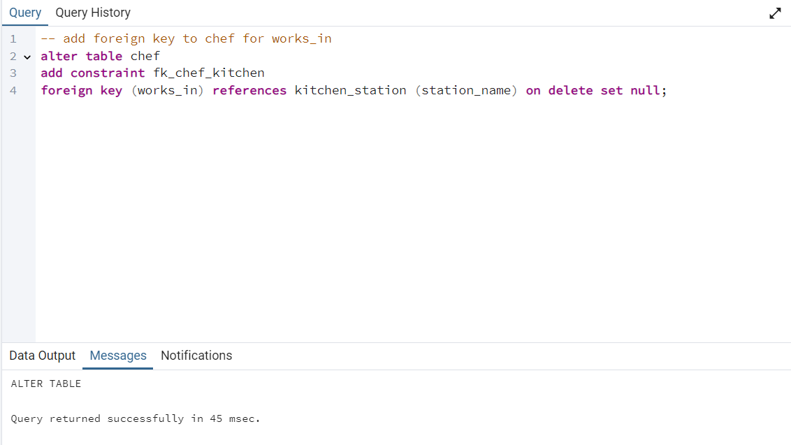

When deleting the primary key that the foreign key references, the foreign key will be set to null (as no order). If it is only updated, it will be kept as it is.

### 11.3.9 FK_Product_Supplier

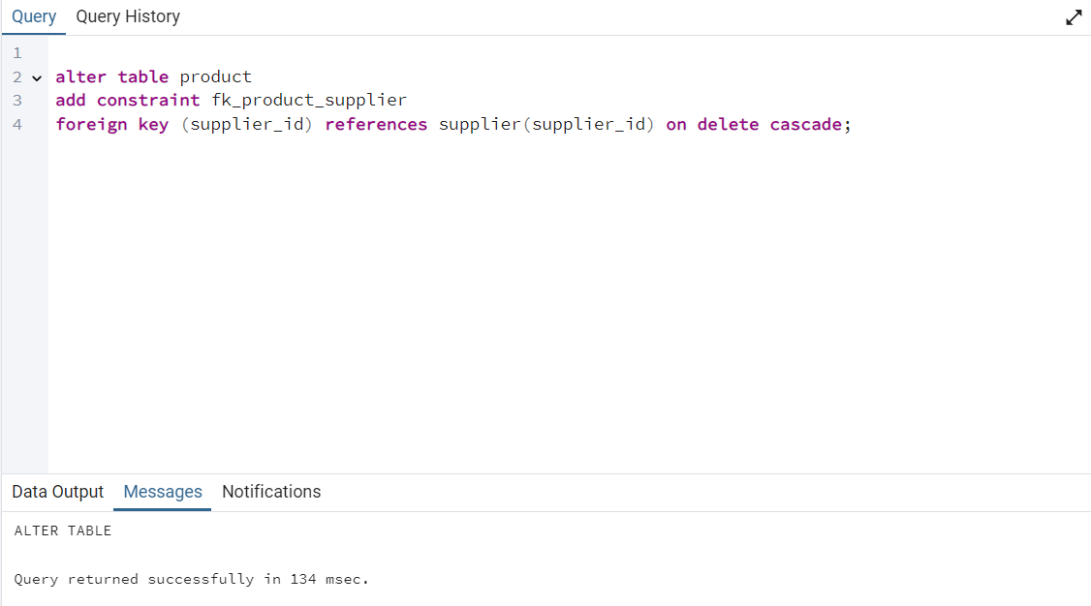

When deleting the primary key that the foreign key references, the row of the foreign key will be deleted as well. If it is only updated, it will be kept as it is.

### 11.3.10 FK_Tables_Waiter

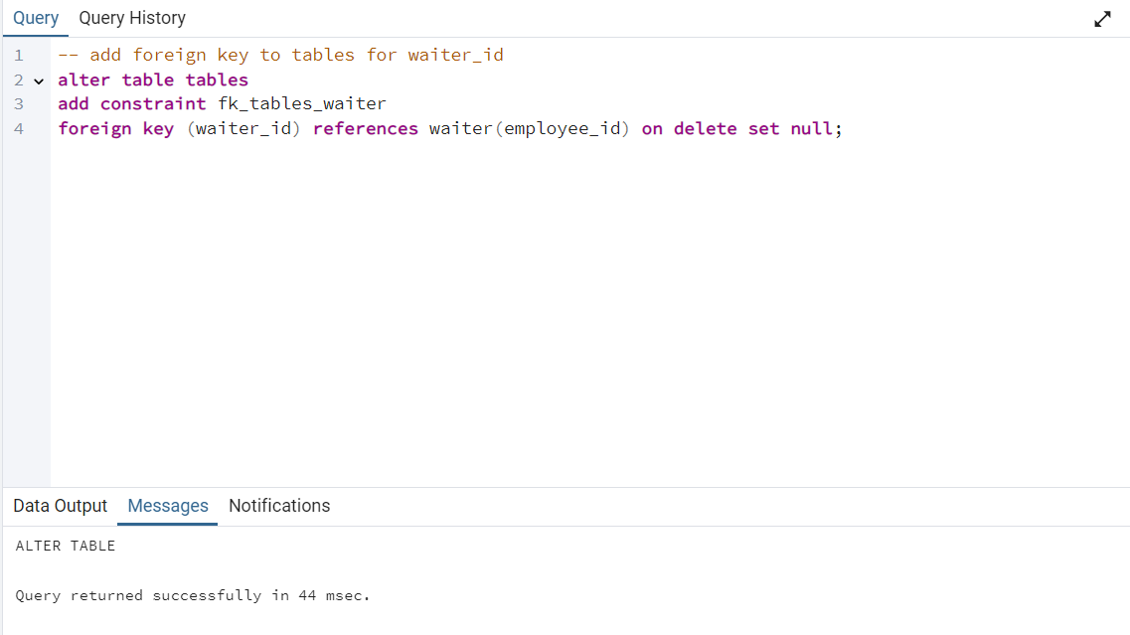

When deleting the primary key that the foreign key references, the row of the foreign key will be deleted as well. If it is only updated, it will be kept as it is.

### 11.3.11 FK_Assigned_Location_Driver

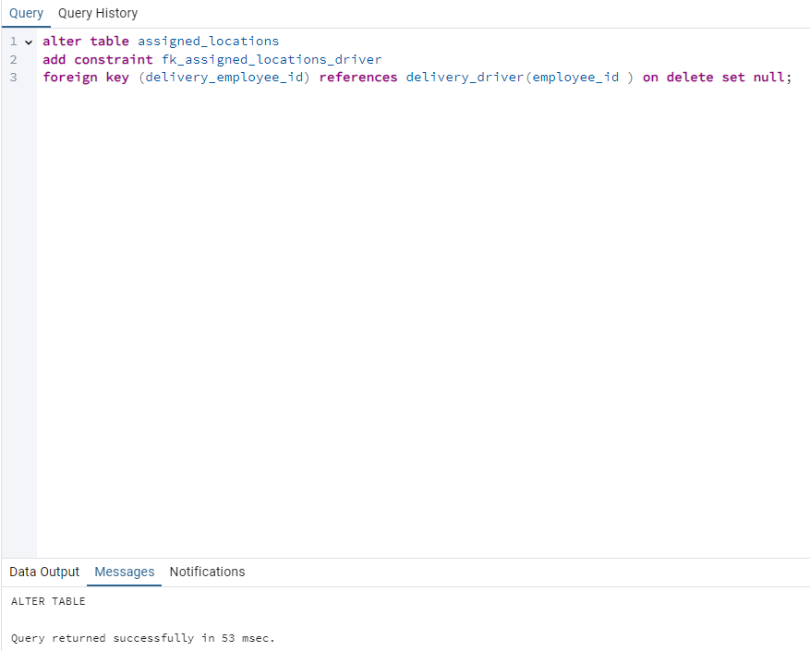

When deleting the primary key that the foreign key references, the foreign key will be set to null.

### 11.3.12 FK_Driver_Waiter

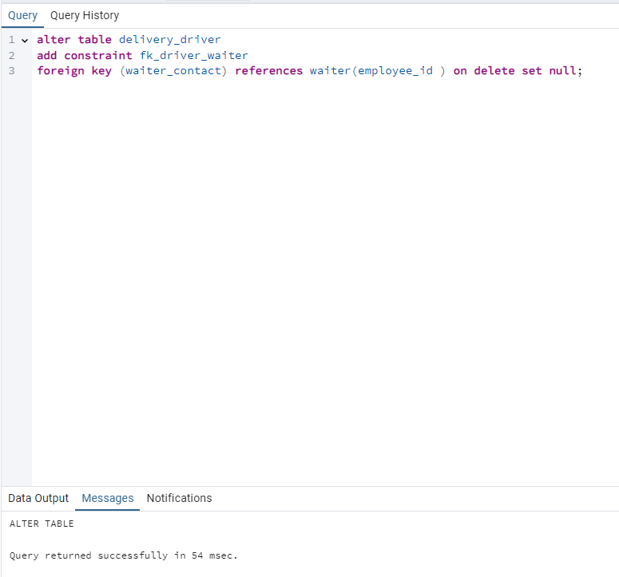

When deleting the primary key that the foreign key references, the foreign key will be set to null.

### 11.3.13 FK_Kitchen_Chef

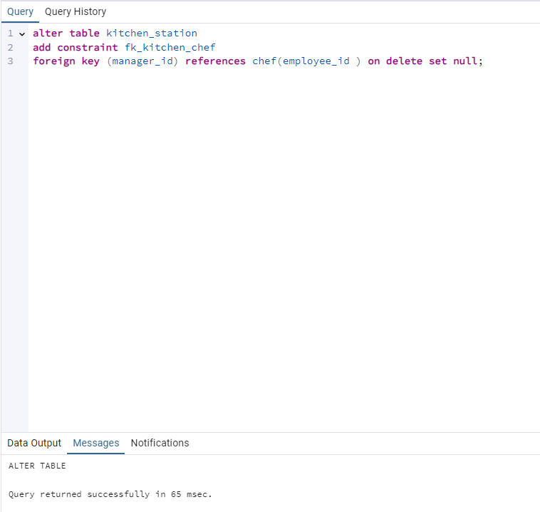

When deleting the primary key that the foreign key references, the foreign key will be set to null.

### 11.3.14 FK_Customer

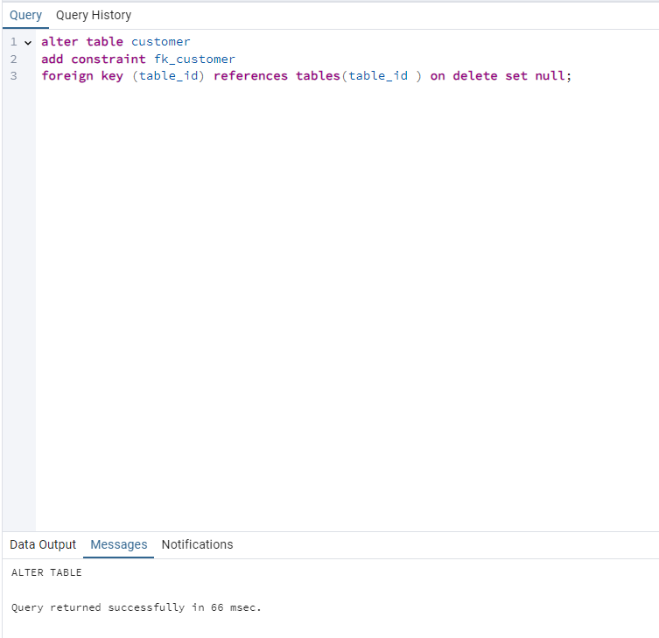

When deleting the primary key that the foreign key references, the foreign key will be set to null.

### 11.3.15 FK_Emergency_Contact_Waiter

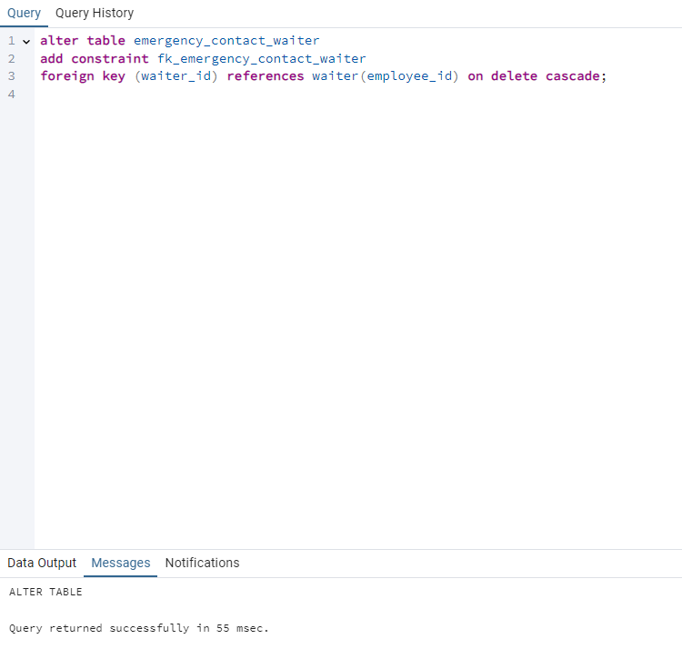

When deleting the primary key that the foreign key references, the foreign key will be deleted too.

### 11.3.16 FK_Emergency_Contact_Chef

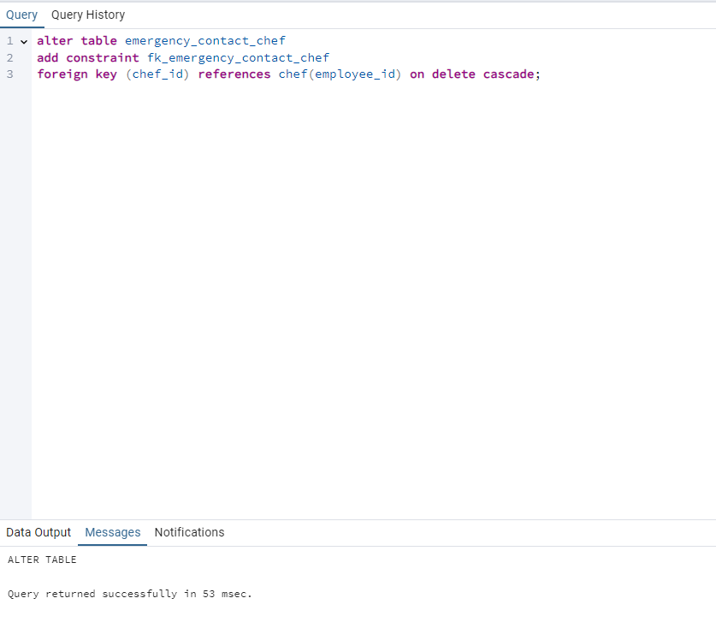

When deleting the primary key that the foreign key references, the foreign key will be deleted too.

### 11.3.17 FK_Emergency_Contact_Delivery_Driver

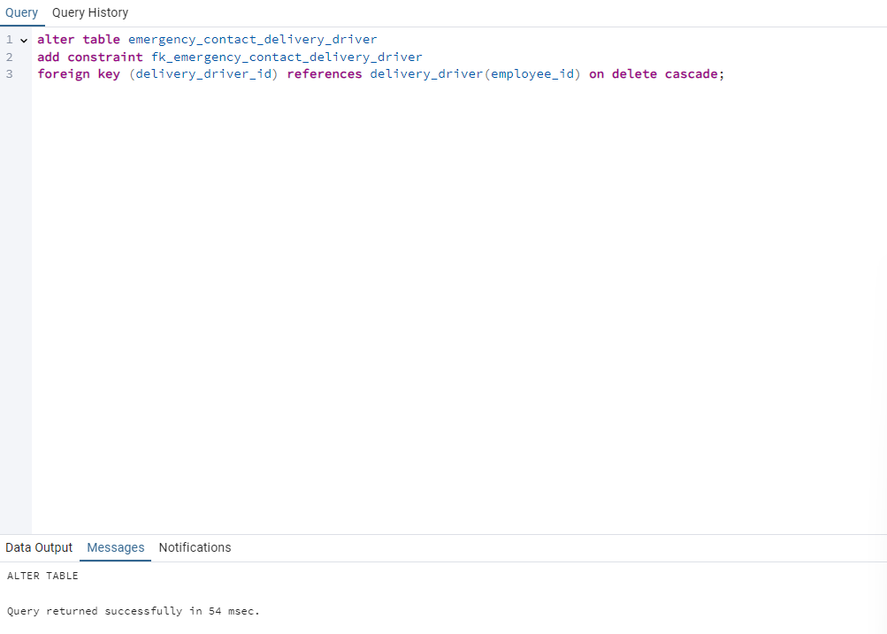

When deleting the primary key that the foreign key references, the foreign key will be deleted too.

## 11.4. Relationships

### 11.4.1 Creates

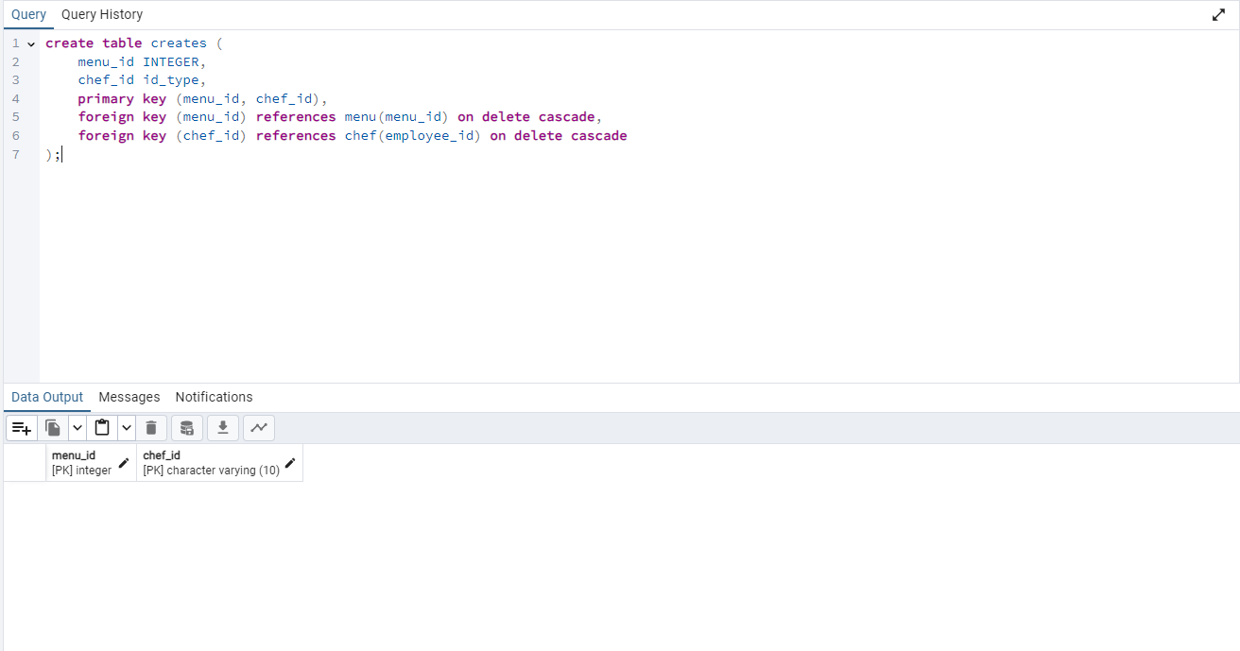

### 11.4.2 Cooks

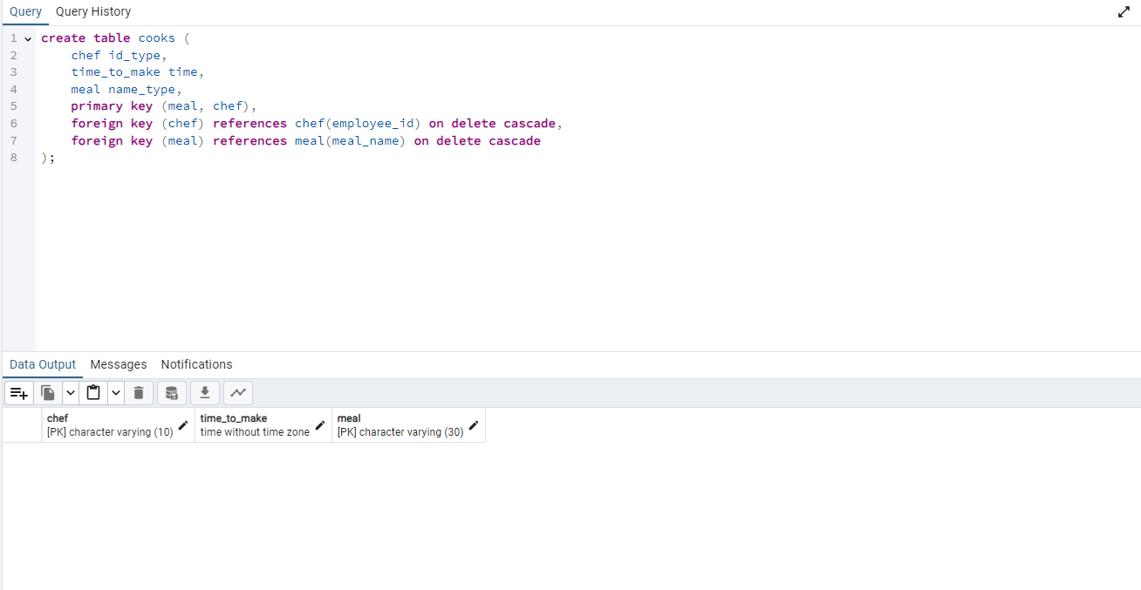

11.4.3 Composed_Of

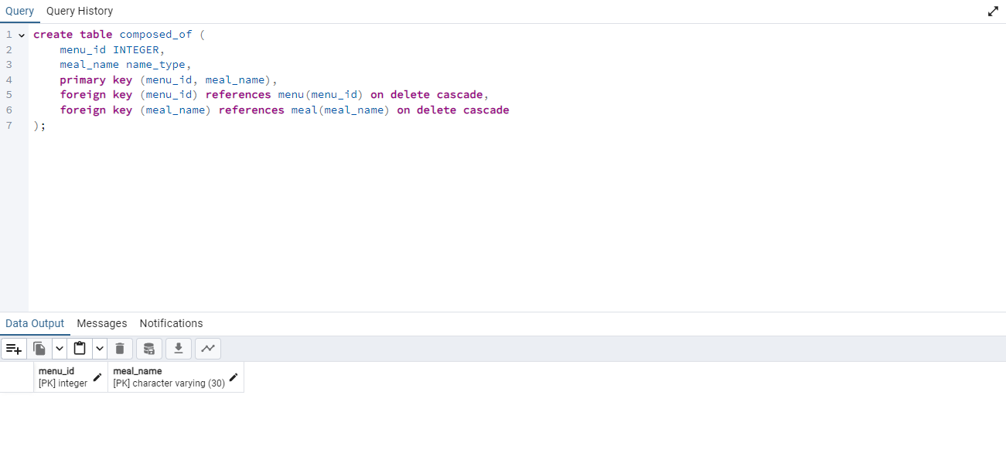

### 11.4.4 Supplies

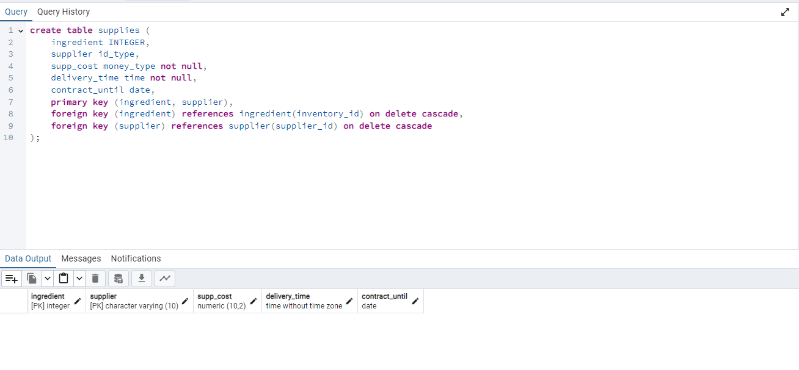

### 11.4.5 Chef_Shift

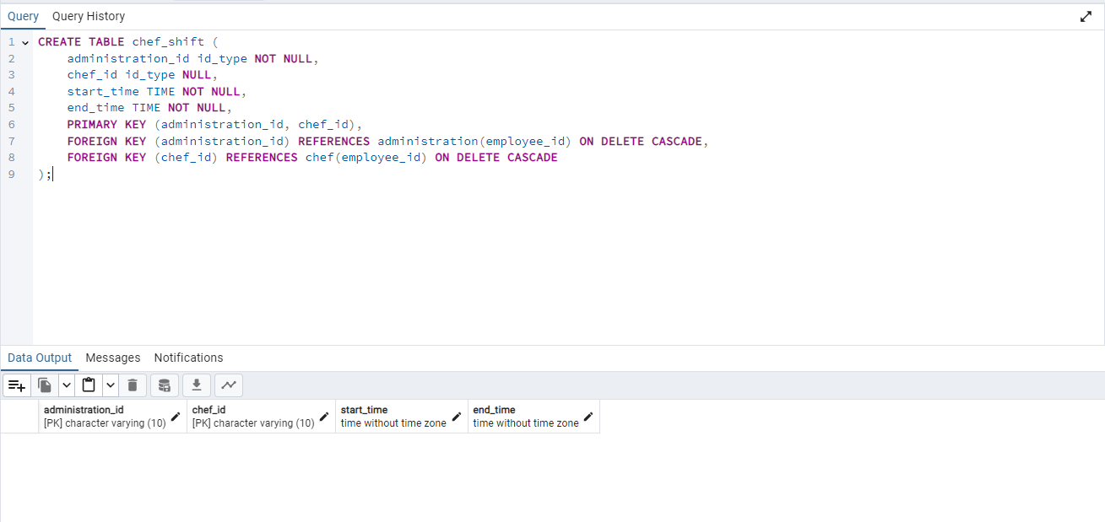

### 11.4.6 Waiter_Shift

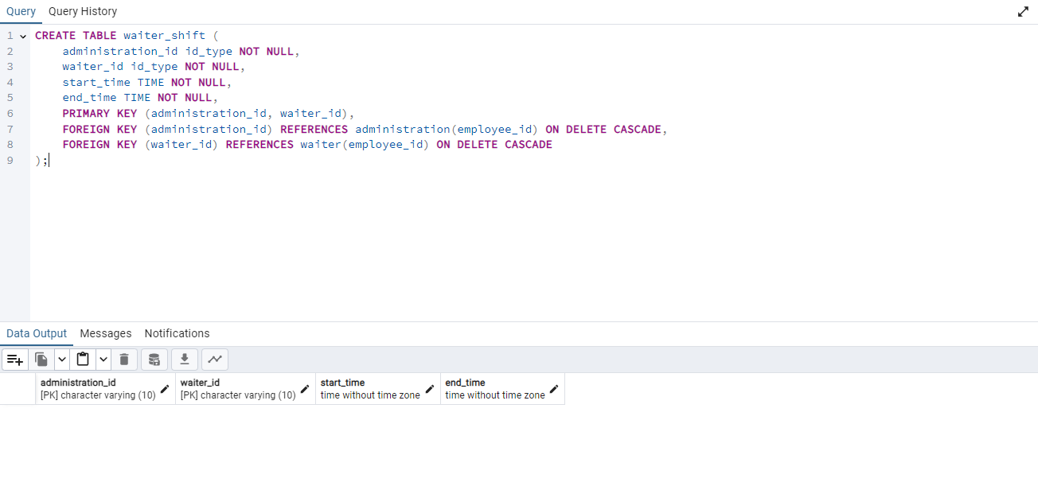

### 11.4.7 Hires_Waiter

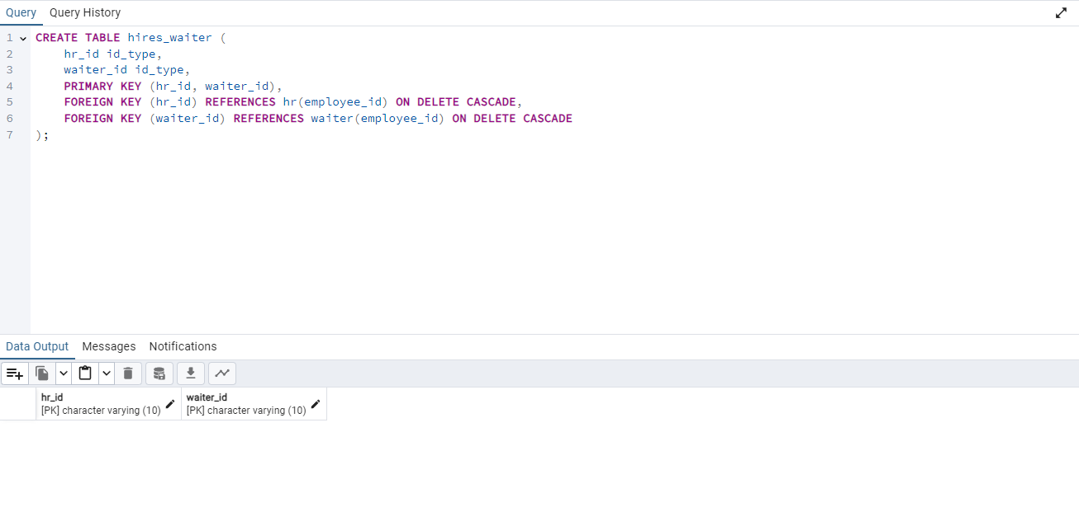

### 11.4.8 Hires_chef

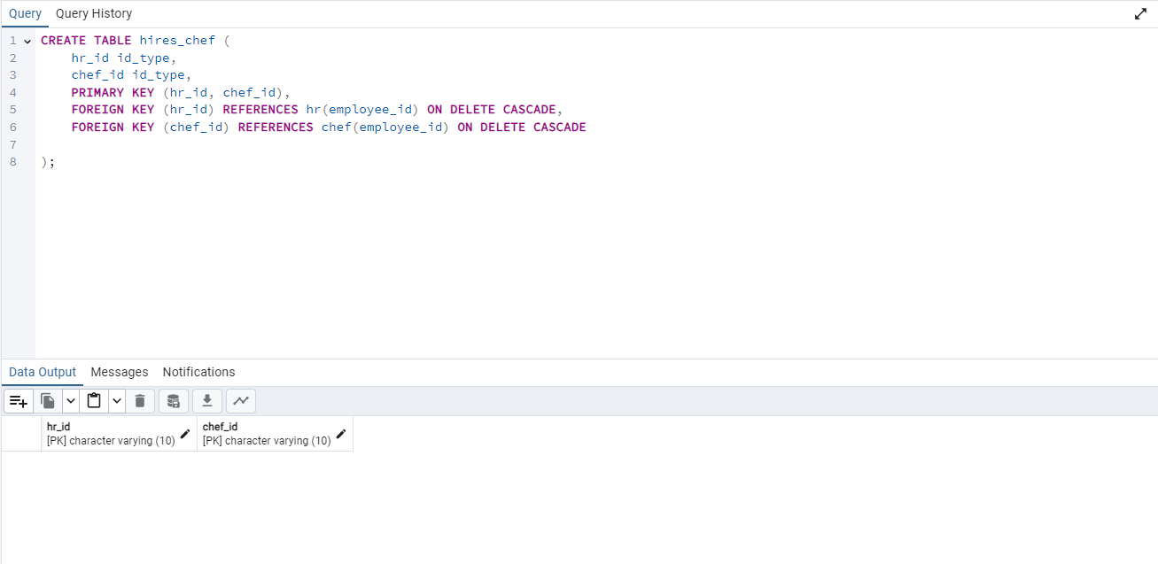

### 11.4.9 Is_made_of

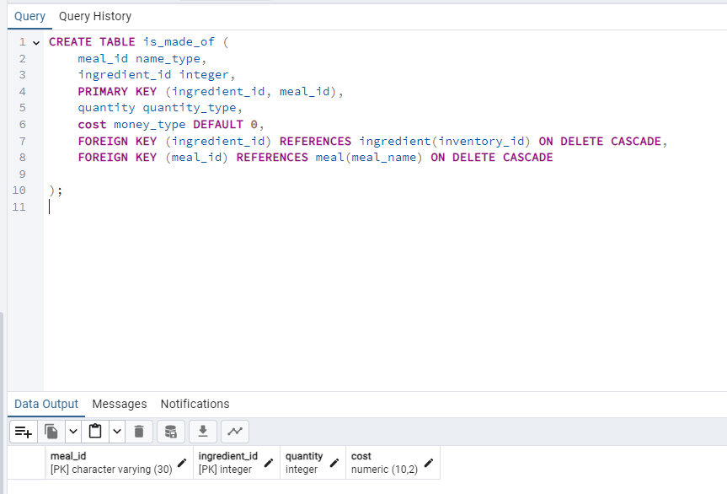

Notice cost is set to default 0 as it is a derived attribute that will be automatically calculated.

11.4.10 Hires_driver

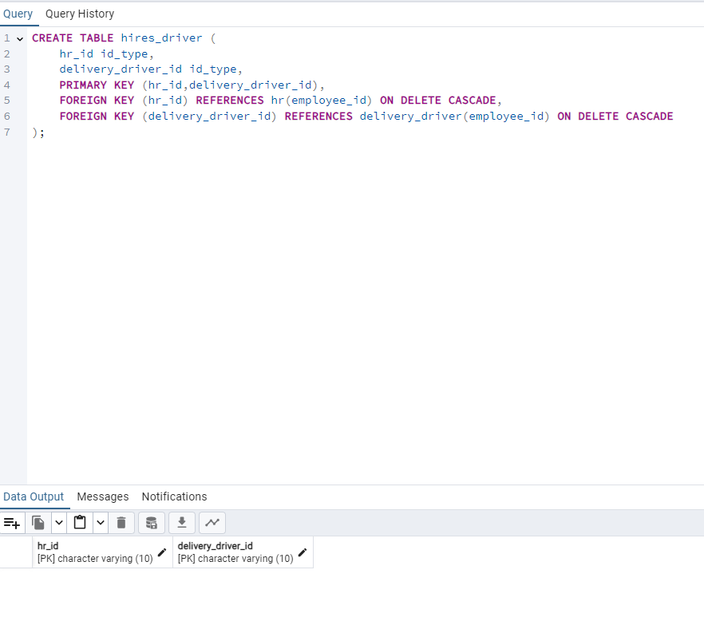

### 11.4.11 Contacts

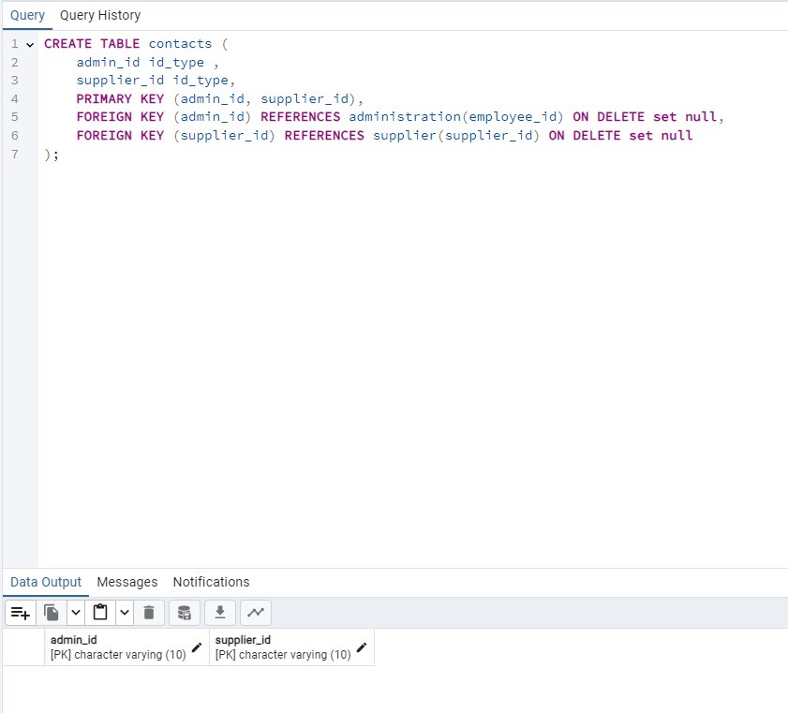

### 11.4.12 Contain

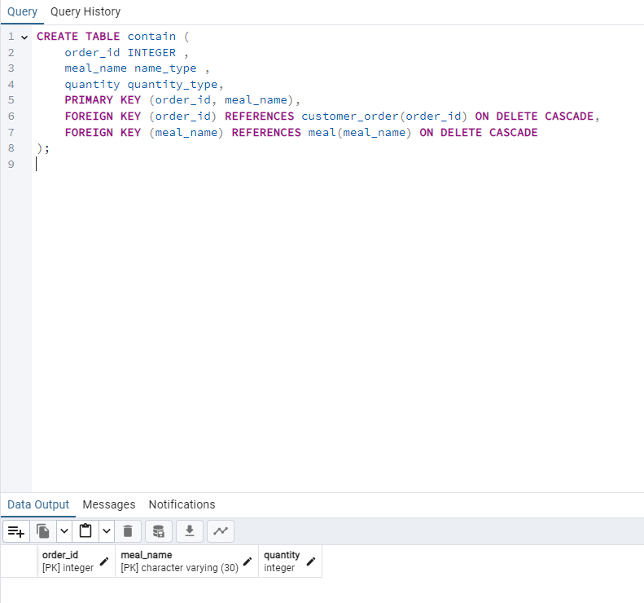

### 11.4.13 Places

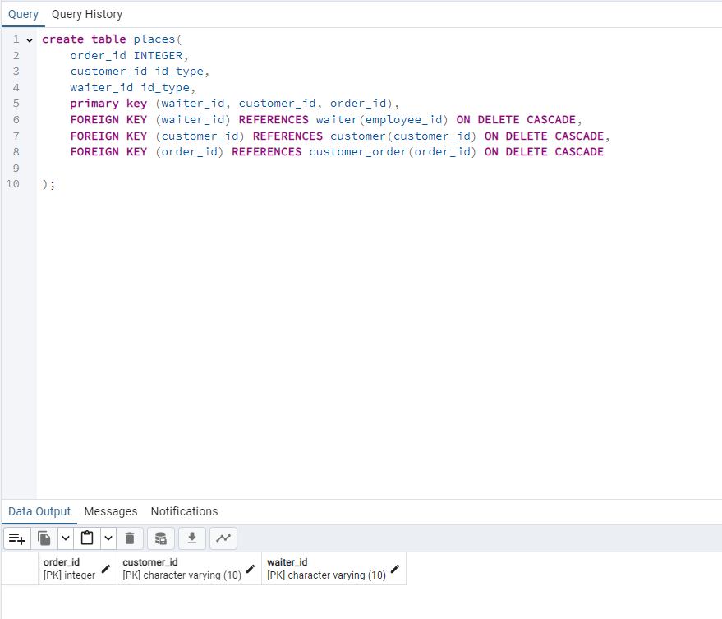

## 11.5. Populate Tables

### 11.5.1 Customer

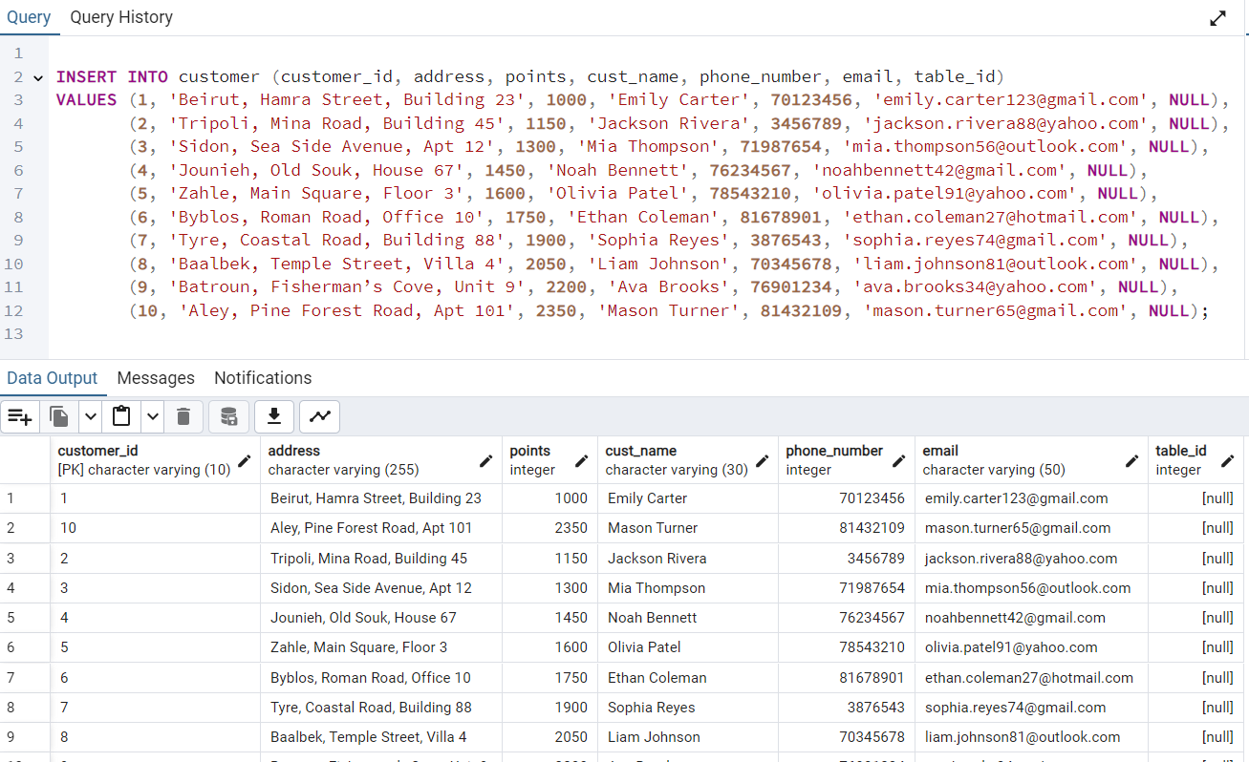

### 11.5.2 HR

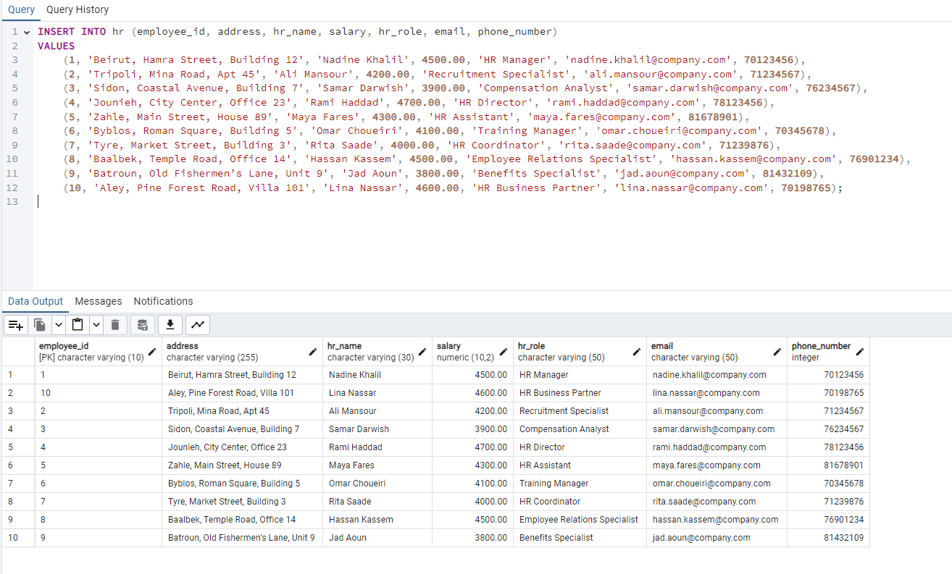

### 11.5.3 Payment_Method

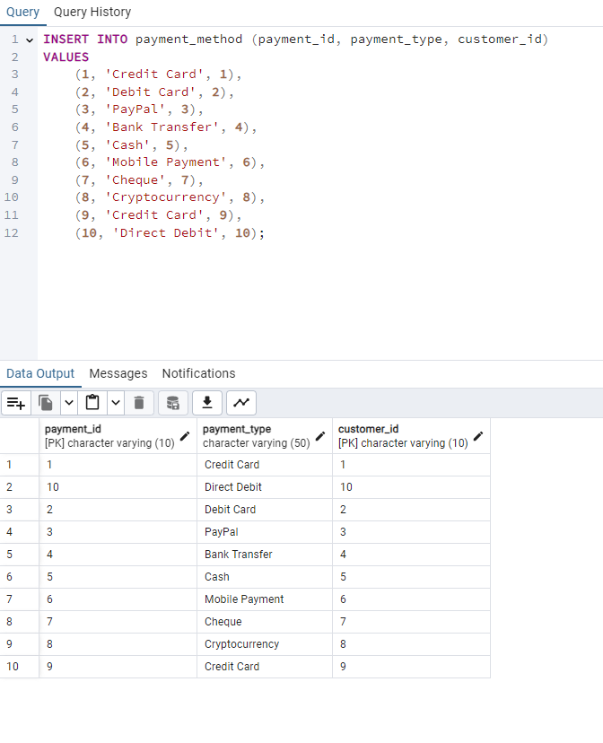

### 11.5.4 Review

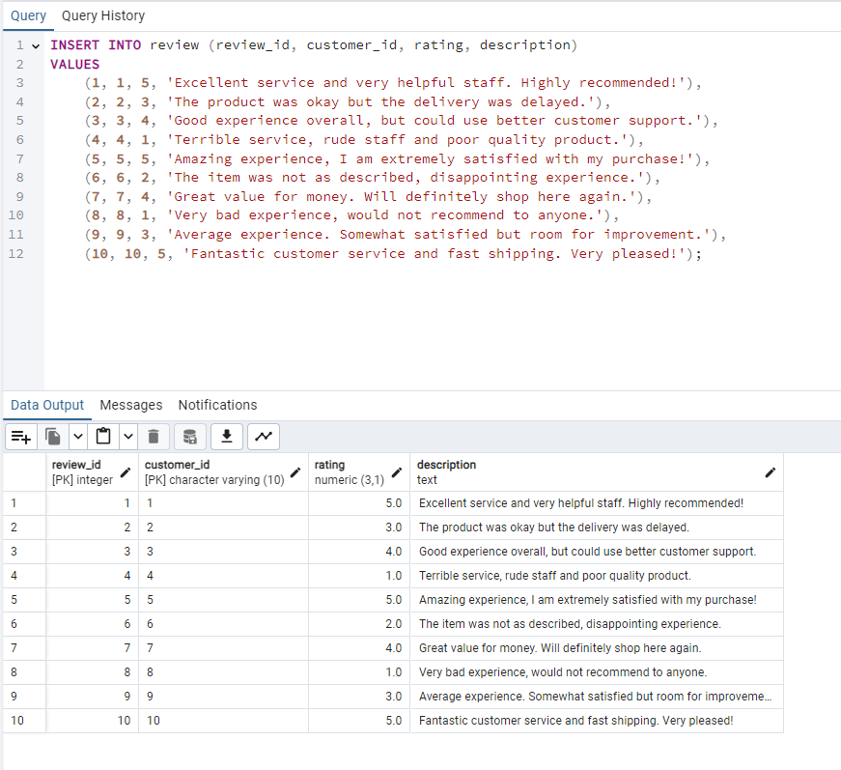

### 11.5.5 Image_Review

### 11.5.6 Ingredient

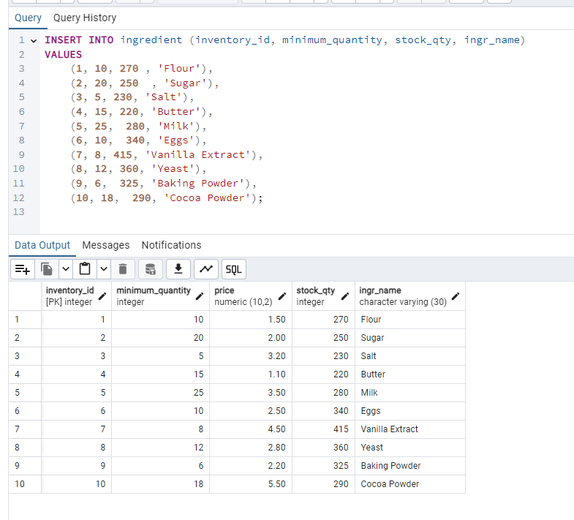

Notice that the price attribute was not included in the insert statement, it is filled by the trigger in section 11.6.1.2, the prices are updated automatically from the costs in the relationship “supplies”.

Notice the attributes cost_meal and price are not included in the insert query as they are set to be 0 by default. This is to then calculate them automatically using the triggers in 11.6.1

### 11.5.8 Image_Meal

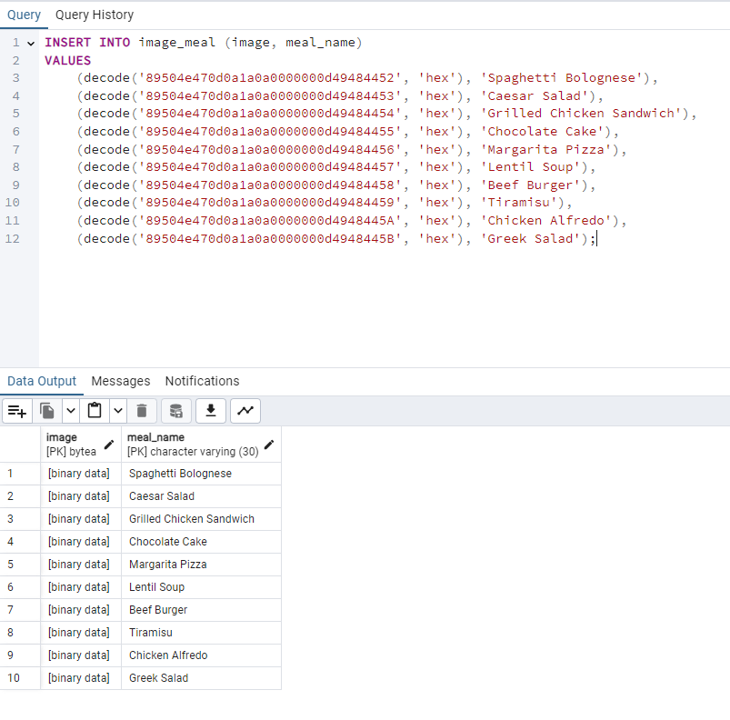

### 11.5.10 Tables

### 11.5.11 Menu

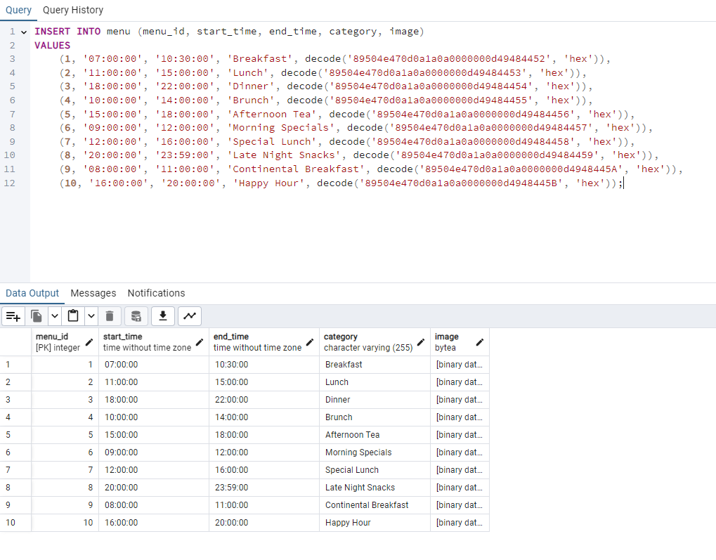

### 11.5.13 Kitchen_Station

For this data insertion, the number of chefs starts as 0 in a kitchen station. Whenever a row is added to the chef table, the number of chefs is incremented automatically in the correct kitchen station. And when a chef is removed from the chef table, the number of chefs is decremented automatically too. There are two triggers in section 11.6.1 that help achieve these changes.

### 11.5.14 Chef

### 11.5.15 Supplier

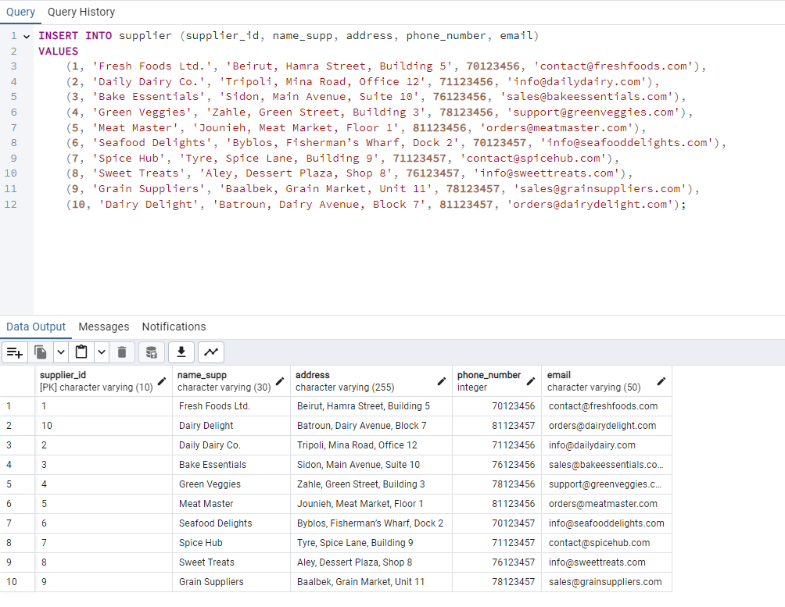

For this insertion, the price is derived, then when the contains relationship is modified with this order id, then the prices will be updated to whatever the customer has ordered.

We must note that our restaurant works like a food chain restaurant. You order all your items at once (in one order). Like in multiple big restaurants (McDonald’s , Burger King, ect…).

### 11.5.20 Administration

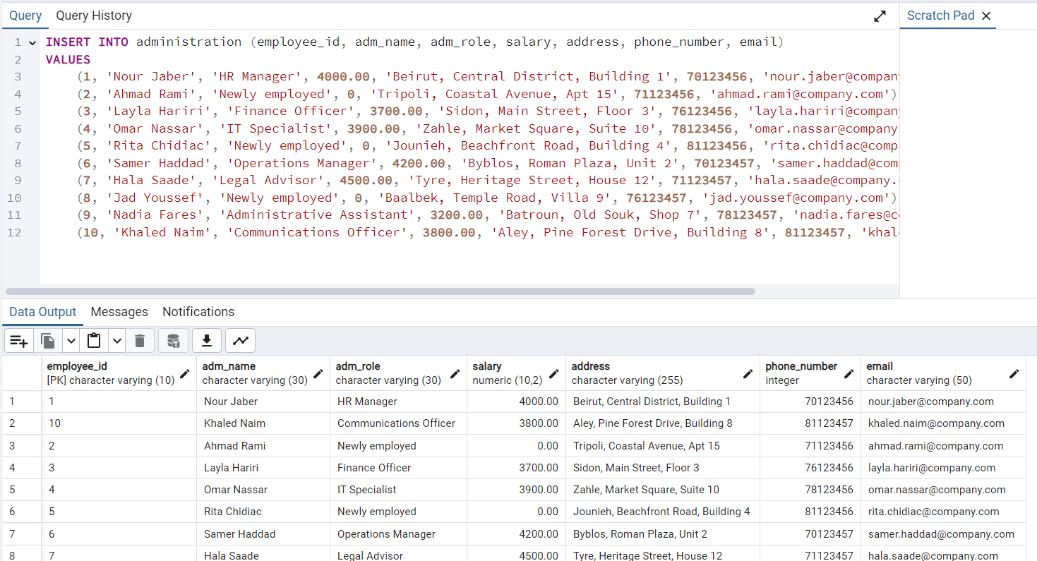

### 11.5.21 Emergency_Contact_Waiter

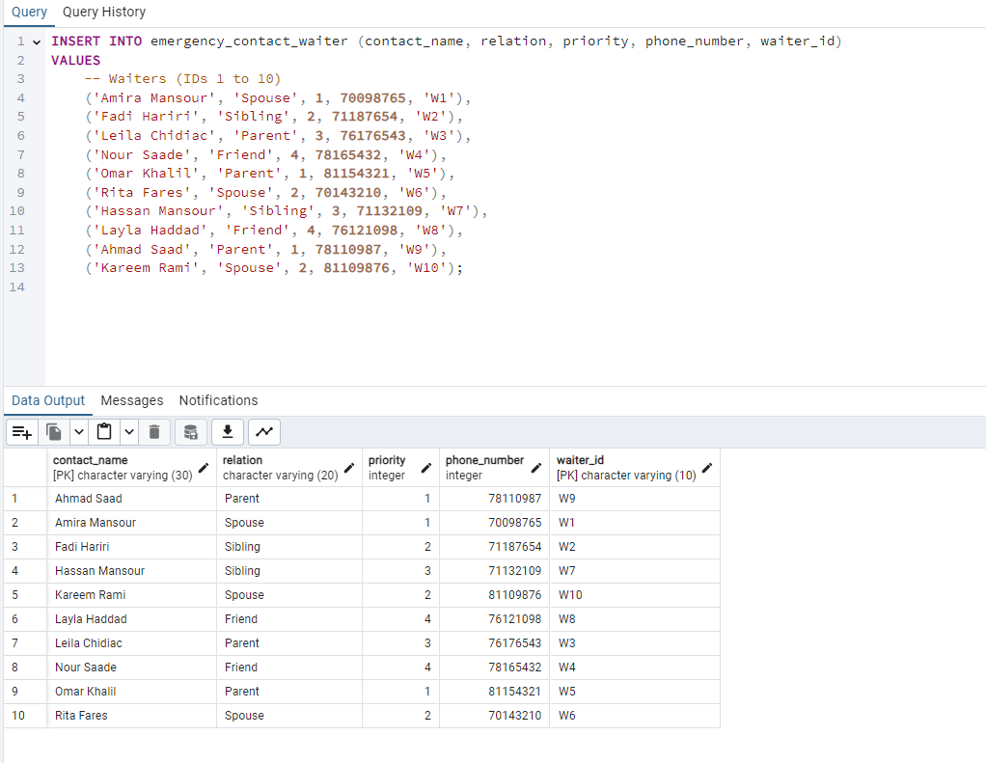

### 11.5.22 Emergency_Contact_Chef

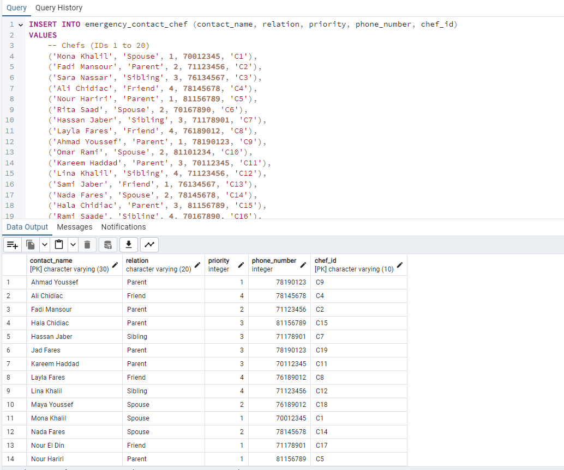

### 11.5.23 Emergency_Contact_Delivery_Driver

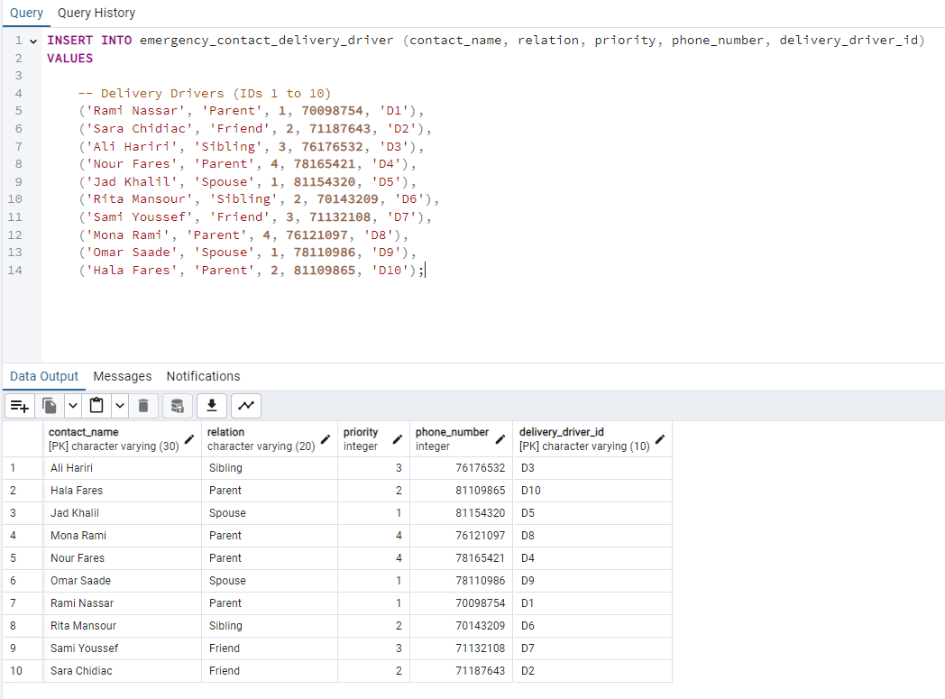

### 11.5.28 Chef_Shift

### 11.5.29 Waiter Shift

### 11.5.30 Hires_Waiter

### 11.5.32 Hires_Driver

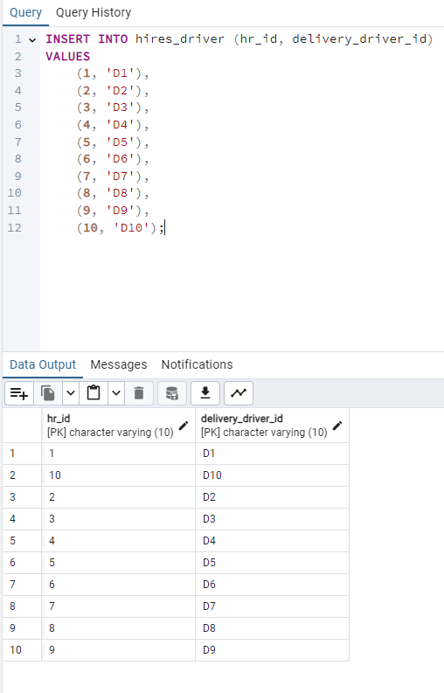

### 11.5.33 Contacts

Note that cost is not included in the insert statement; It’s set to 0 by default. This is to make sure the restaurant has all the costs for each ingredient first and their quantity needed per meal, then we can call the procedure on 11.6.2 which will update the costs on this table.

## 11.6. Triggers, Functions, Procedures and Views

### 11.6.1 Triggers & Functions

In this part we will explain our combinations of triggers and functions created. We must also note that in PostgreSQL we cannot write assertions. Instead, the assertions can be replaced by a Check or a combination of a Trigger and a Function.

#### 11.6.1.1 Increment Chef Count

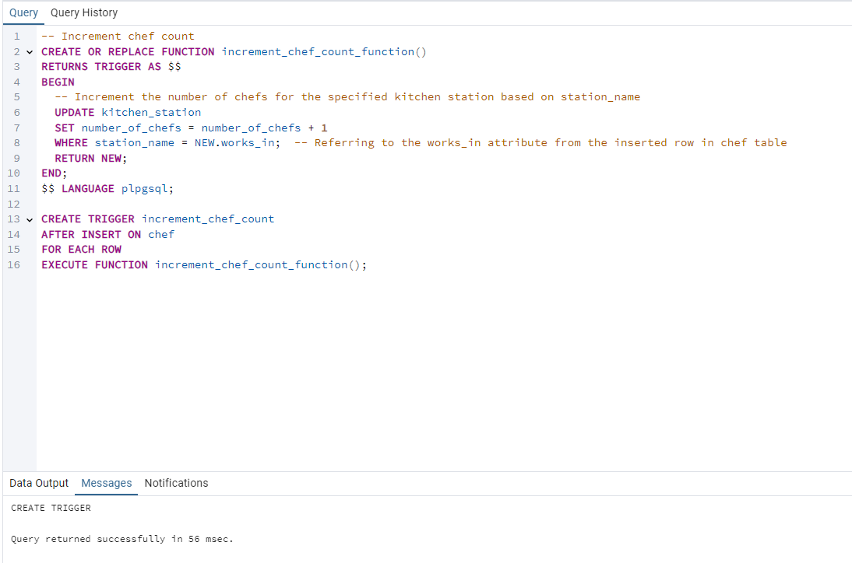

The trigger increment_chef_count with the function increment_chef_count_function() updates the number of chefs working in each kitchen station whenever a new chef is inserted in the database rather than having to manually update the number of chefs each time.

For example, when a new chef is hired and is assigned to a kitchen station, the number of chefs in this kitchen station is automatically updated, it is incremented by 1.

OUTPUT:

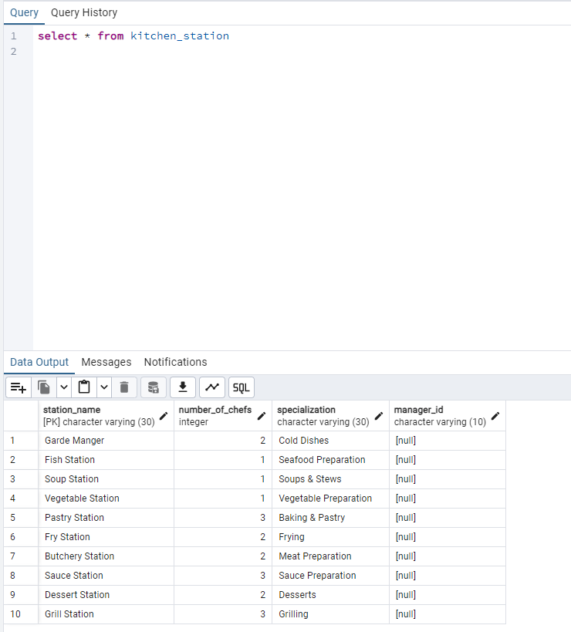

Notice that in the insert statement of kitchen station, we did not include any values for number_of_chefs as they were set to 0 by default, after populating the chef table the number_of_chefs in the kitchen_station table will be automatically incremented to represent the number of chefs working in each station!

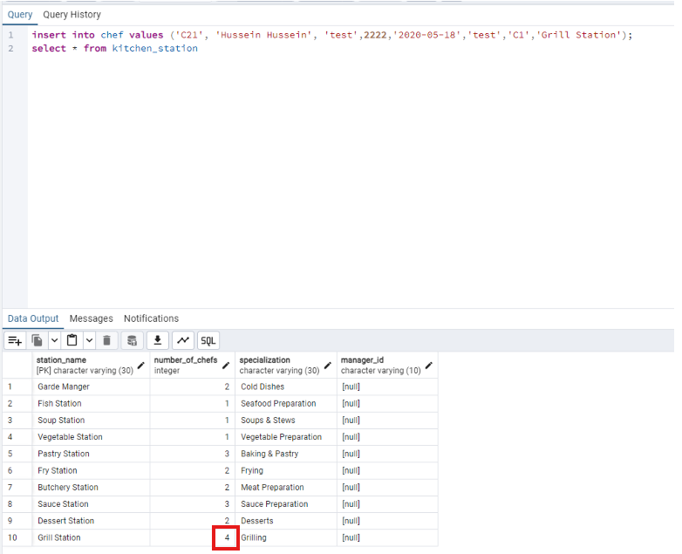

Inserting a new chef who works in the grill station will automatically increment the number_of_chefs attribute in kichen_station.

#### 

#### 11.6.1.2 Calculate Ingredient Price

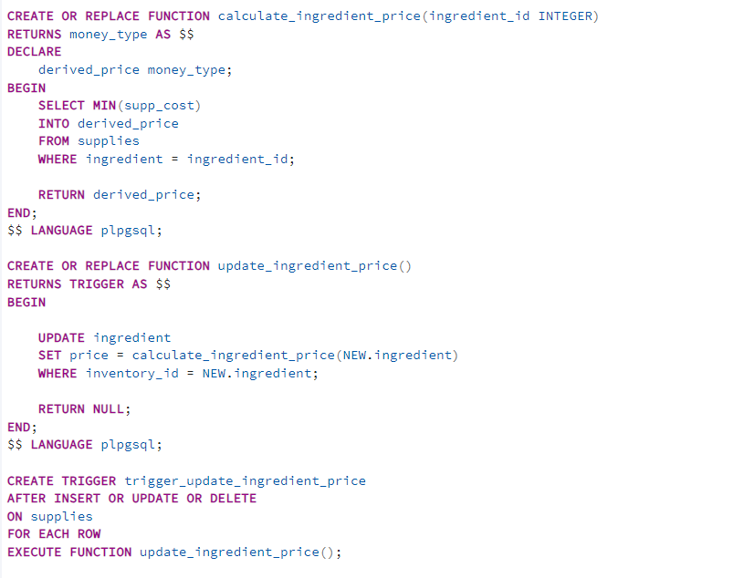

In the first part, The function calculates the derived price for an ingredient based on its supplier costs in the supplies table.

In the second part, The trigger ensures that the price in the ingredient table is updated whenever there are changes in the supplies table.

In the last part The trigger will fire whenever there is an INSERT, UPDATE, or DELETE in the supplies table, ensuring the derived price in the ingredient table remains up-to-date.

For example, when a new ingredient is supplied, and so the supplies table is modified, the trigger is activated in order to get the derived attribute Price.The screenshot below shows the price in the ingredient table:

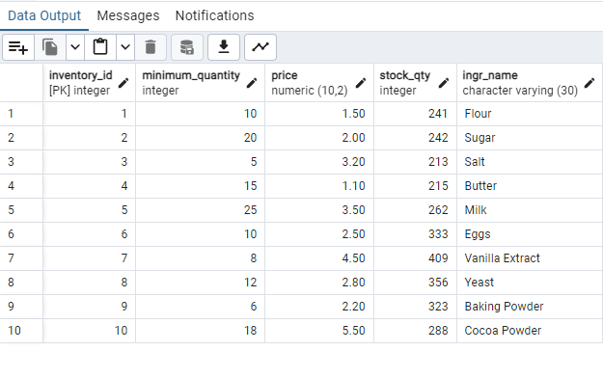

#### 11.6.1.3 Decrement Chef Count

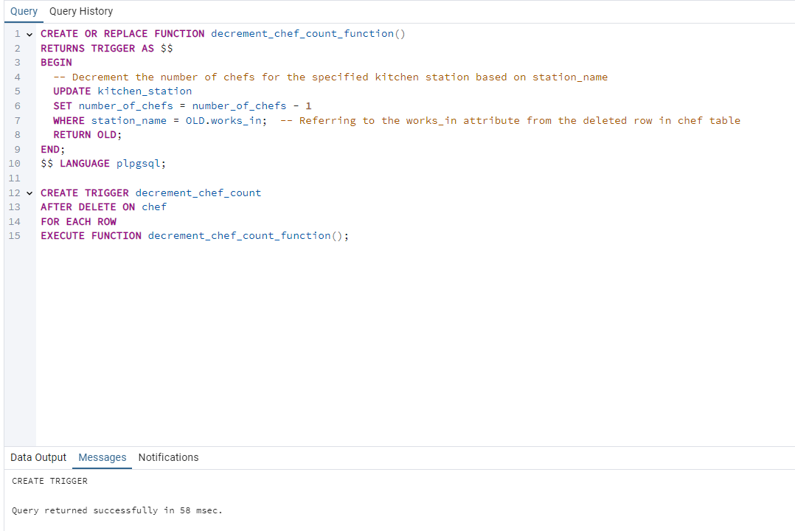

The trigger decrement_chef_count with the function decrement_chef_count_function() update the number of chefs working in each kitchen station whenever a chef is deleted from the database rather than having to manually update the number of chefs each time.

For example, if a chef was fired from the restaurant and so was deleted from the database, the number of chefs in the kitchen station that the chef used to work in is decremented by 1.

OUTPUT:

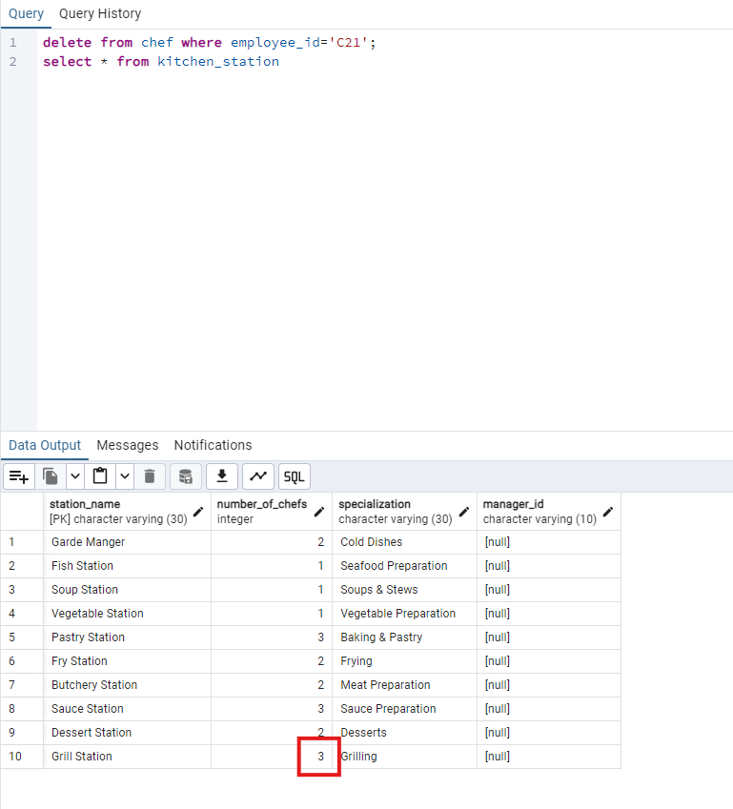

In the case where a chef is removed from the database, the number_of_chefs of the kitchen station where he is working will be automatically decremented!

#### 11.6.1.4 Calculate Order Price

In the first part, the function calculates the total price of an order based on the meals and their quantities.

In the second part, This trigger will automatically update the price in the customer_order table whenever a row is inserted, updated, or deleted in the contain table.

The last part ensures that the customer_order_price field is updated whenever a change occurs in the contain table.

For example, when a new order is made, and so the table contains is modified, the trigger is activated in order to get the derived attribute Price. The screenshot below shows the updated prices in customer_order:

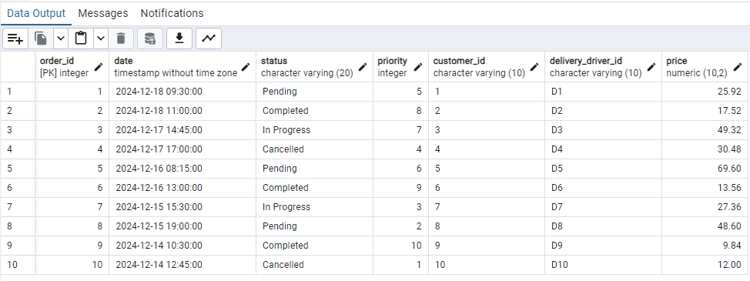

#### 11.6.1.5 Update Meal Cost:

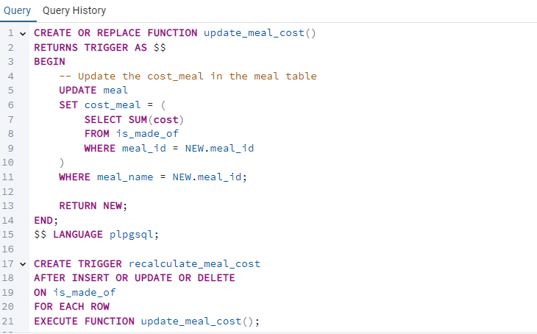

### The trigger recalculate_meal_cost uses the function update_meal_cost to compute the total cost it takes to prepare a meal based on the ingredients used in it. It adds up all prices of the ingredients calculated using the procedure 11.6.2.2 from is_made_of and sets them in the cost_meal column of the table meal

If for example we change the quantity of ingredients needed to prepare a certain meal, add or remove some ingredients etc.. This trigger will automatically recalculate the total cost of preparation of the meal.

#### OUTPUT:

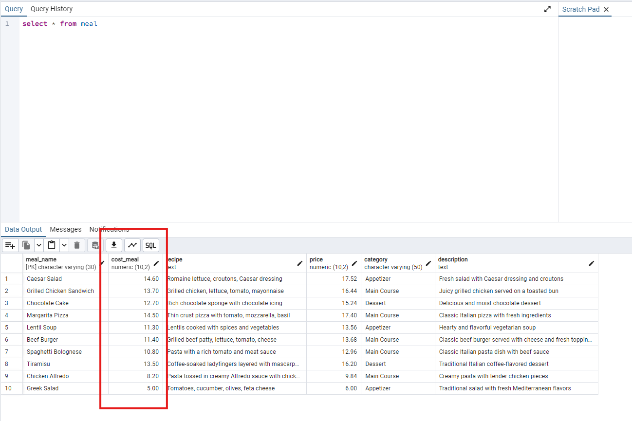

#### Notice the cost_meal attribute was not populated during the insertion process as it was set to 0 by default. This trigger calculates the total cost involved in creating a specific meal based on the price of the ingredients used and their quantity in the given meal.

#### 11.6.1.6 Update Meal Price:

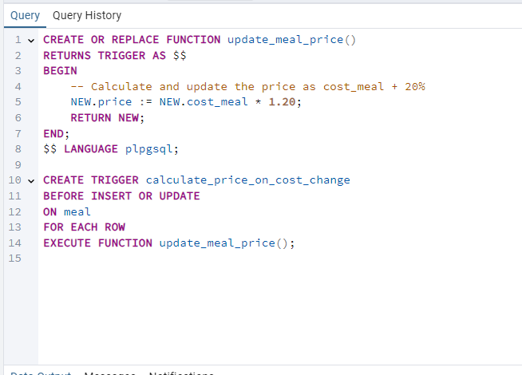

This trigger is executed whenever the column cost_meal is changed in the meal table. It calculates the price of the meals in the restaurant by multiplying the total cost of the meal by 1.2, basically adding 20% profit on the meal.

If for example we change the total cost to make a meal, this trigger will automatically change the price we charge our customers for it. It’s crucial as we can't manually go and update the prices each time.

OUTPUT:

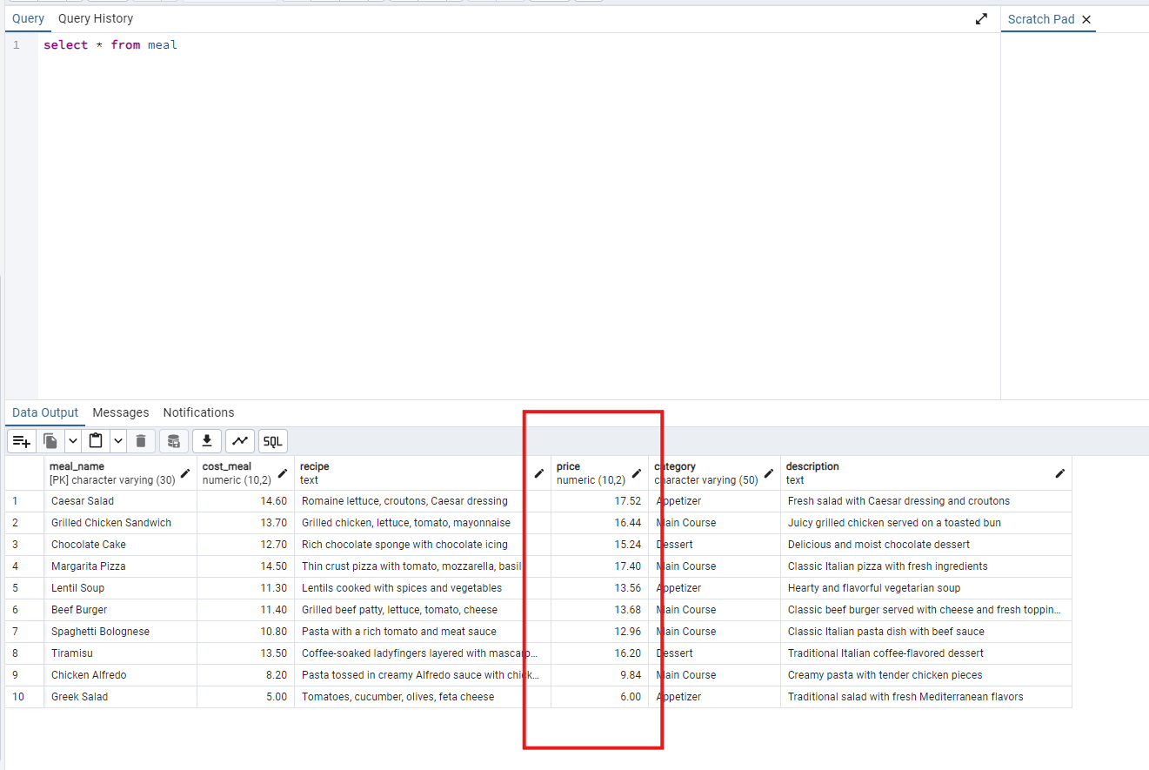

Notice the price attribute was not populated during the insertion process as it is set to be 0 by default. After the cost_meal is updated through the trigger 11.6.1.6, the price column will be itself automatically updated by multiplying the cost of the meal by 1.2 therefore adding 20% profit on each meal sold.

#### 11.6.1.7 Check Contract Until

#### 

This trigger doesn’t allow the contracts to be in the past. the date of the ending of a contract with a supplier to be in the past. It must be in the future (after the current date).

OUTPUT

#### 

In this example, we tried inserting a tuple (row) where the date of the contract ending is in 2021 (well before today’s date, 11/22/2024). This resulted in an error due to the assertion.

#### 11.6.1.8 Check Order Time

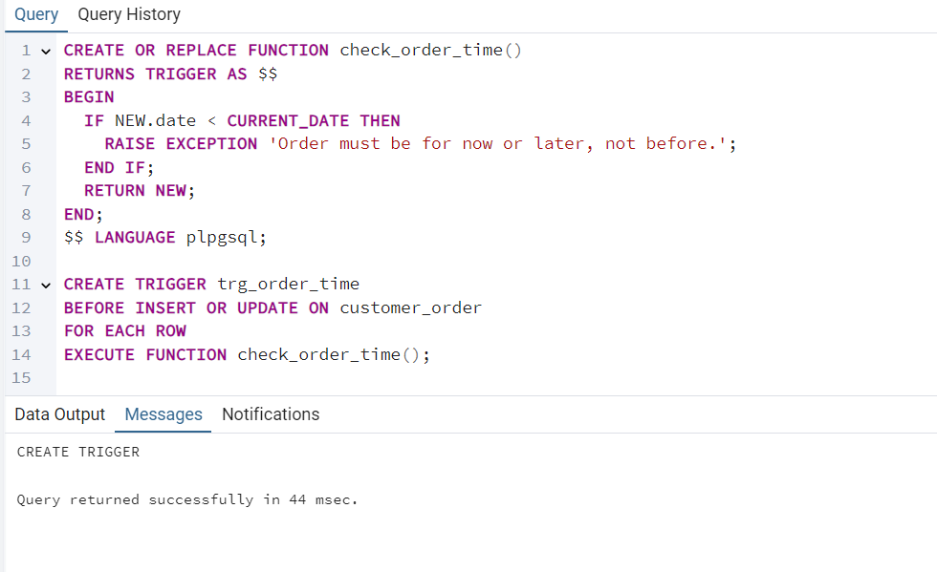

This trigger restricts the order date to be a date in the present or future, not in the past.

OUTPUT

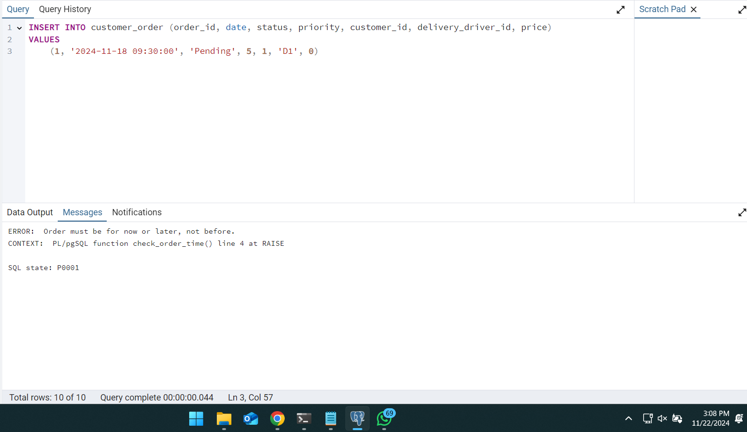

In this example, we can clearly see that the insertion of a tuple (row) with date being before today’s date (as seen in screenshot) did not go through due to the assertion.

#### 11.6.1.9 Notify_Stock

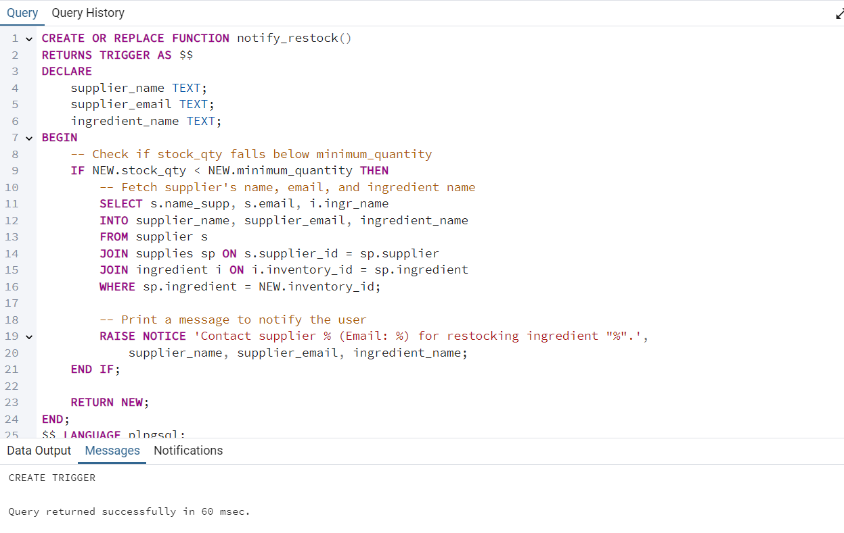

Whenever the stock quantity of an ingredient falls below the minimum quantity, a notice automatically is shown.

OUTPUT:

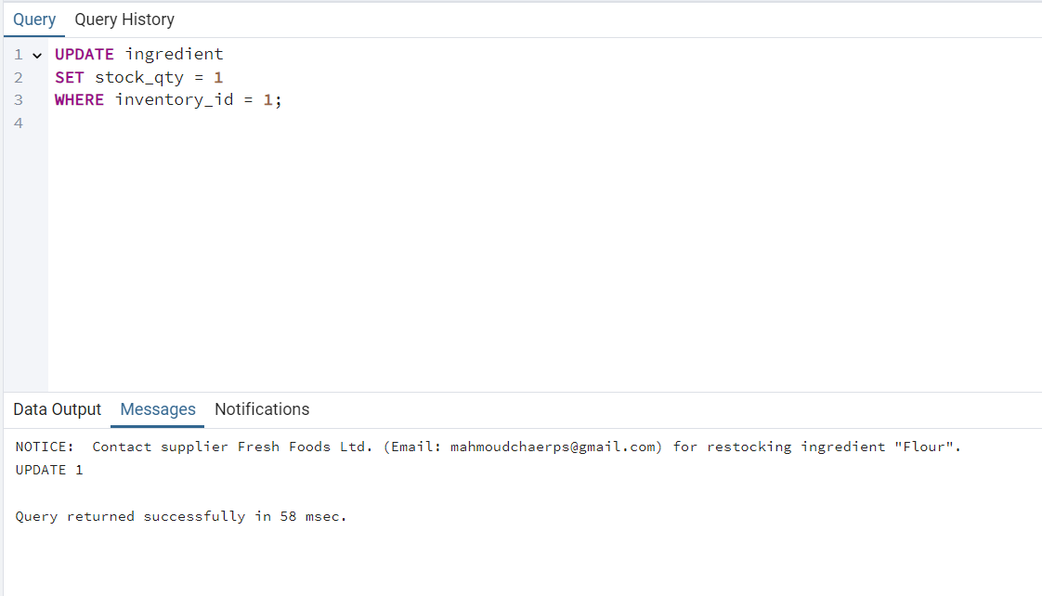

The stock fell below the minimum quantity. The notice told us what ingredient to restock and what supplier to contact.

#### 11.6.1.10 Decrement Stock On Order

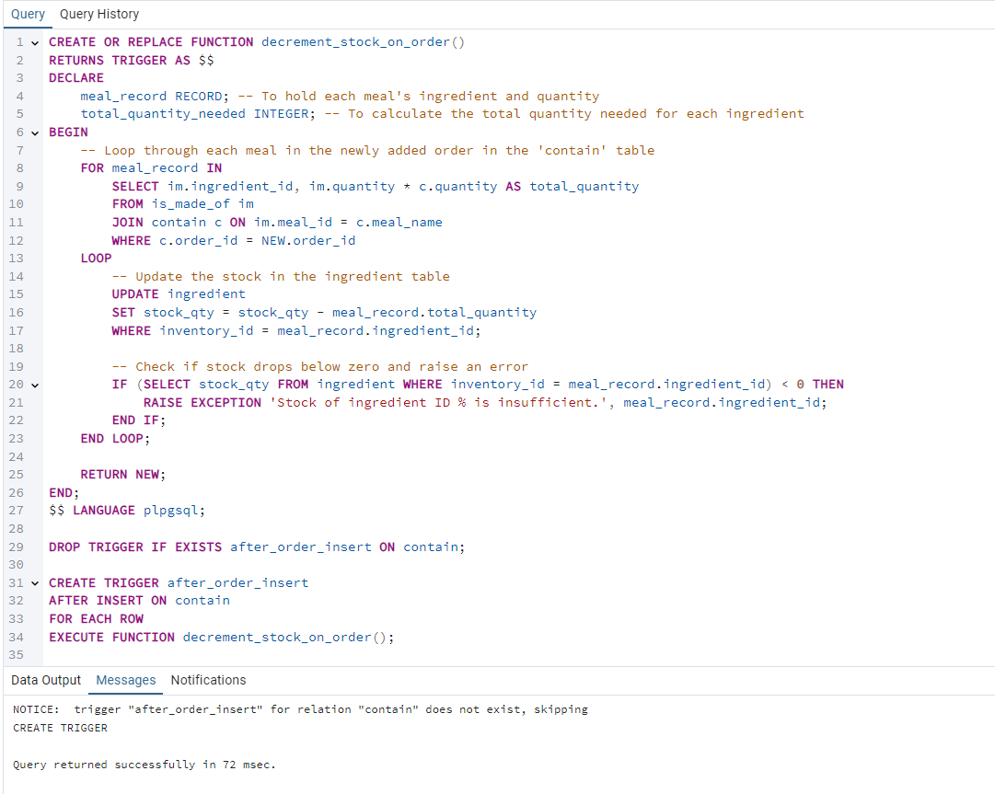

This trigger ensures the stock quantity in the table ingredient is correctly decremented whenever a new order is placed by checking what meals are in the order using the contain table then checking what ingredients are needed for each meal in the is_made_of table to then decrement the stock by this quantity!

That way we don’t have to keep manually updating our stock whenever an order is placed.

#### 11.6.1.11

#### 11.6.1.12

#### 11.6.1.13

#### 11.6.1.14

### 11.6.2 Procedures

#### 11.6.2.1 Apply Raise Individual Chef Salary:

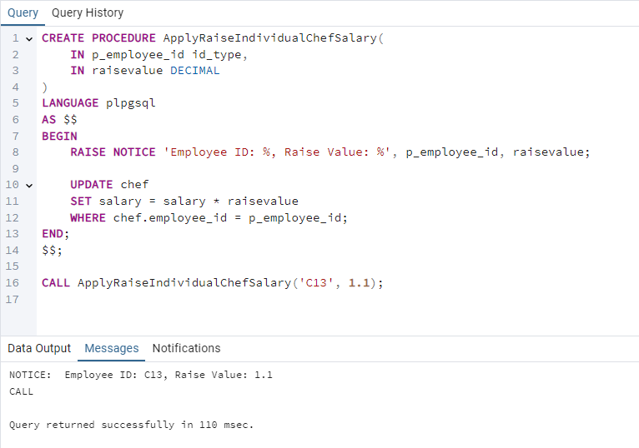

This procedure allows the user to apply a raise on the salary of a chef. The user calls the procedure with the employee id of the chef and the raise to apply. In this screenshot, we can see that we successfully applied a raise of 10% on the salary of the chef with employee id C13.

#### 11.6.2.2 Calculate Costs:

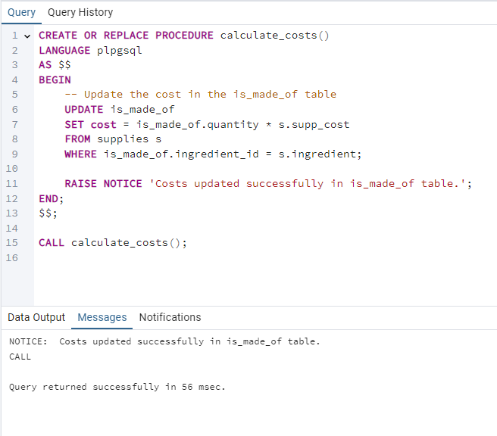

This procedure updates the costs of the ingredients in a meal in the “is made of’’ table by multiplying the quantity used by the price of 1 unit of this particular ingredient.

#### 11.6.2.3 Apply Raise General Chef Salary:

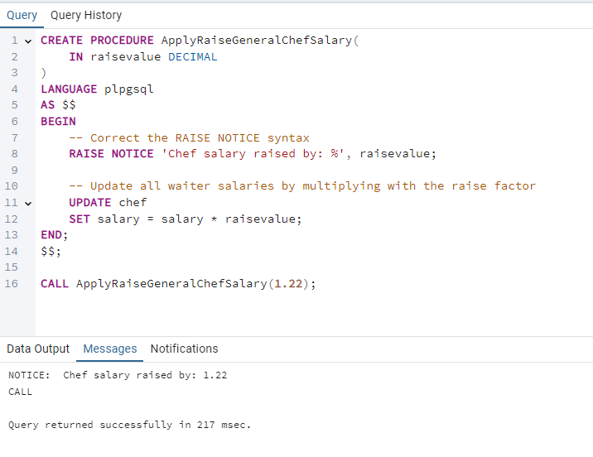

This procedure allows the user to apply a raise on the salary of all chefs. The user calls the procedure with the raise to apply. In this screenshot, we can see that we successfully applied a raise of 22% on the salary of all chefs.

#### 11.6.2.4 Apply Raise Individual Waiter Salary:

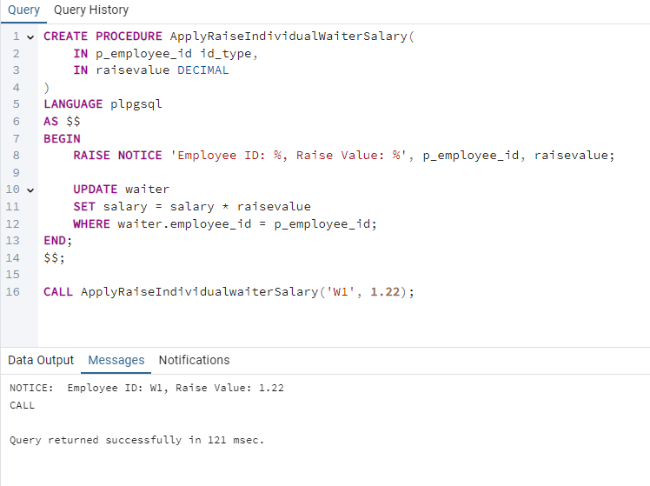

This procedure allows the user to apply a raise on the salary of a waiter. The user calls the procedure with the employee id of the waiter and the raise to apply. In this screenshot, we can see that we successfully applied a raise of 22% on the salary of the waiter with employee id W1.

#### 11.6.2.5 Apply Raise General Waiter Salary:

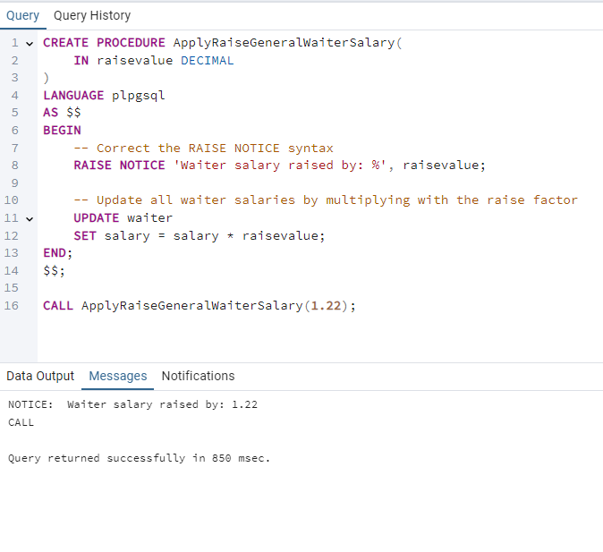

This procedure allows the user to apply a raise on the salary of all waiters. The user calls the procedure with the raise to apply. In this screenshot, we can see that we successfully applied a raise of 22% on the salary of all waiters.

#### 11.6.2.7

#### 11.6.2.8

#### 11.6.2.9

#### 11.6.2.10

#### 11.6.2.11

### 11.6.3 Views

#### 11.6.3.1 Employees

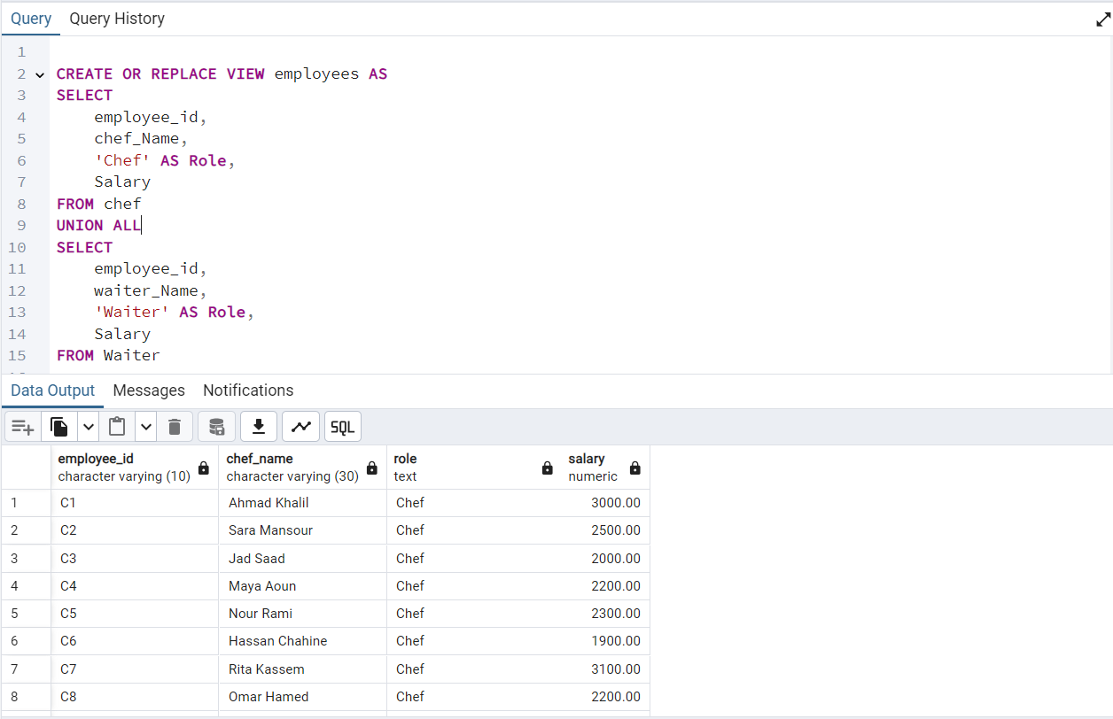

This is a view of all the employees in the restaurant with some relevant info like their salaries. This helps the restaurant see who is affiliated with their company. The delivery drivers have a salary of 0 as they are employed from outside companies, but it is crucial to include them.

## 11.7 Complex Queries

### 11.7.1 Highest Paid Role

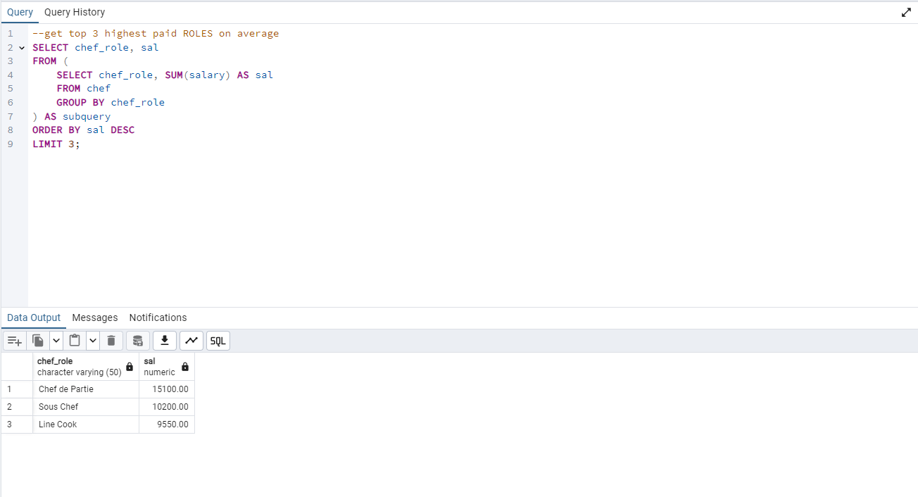

The query above displays the top 3 chef roles based on salary from high to low.

For example, in our case, the role that pays the most for a chef is chef de partie, then sous chef and finally Line cook

### 11.7.2 Most and Least Order Meals

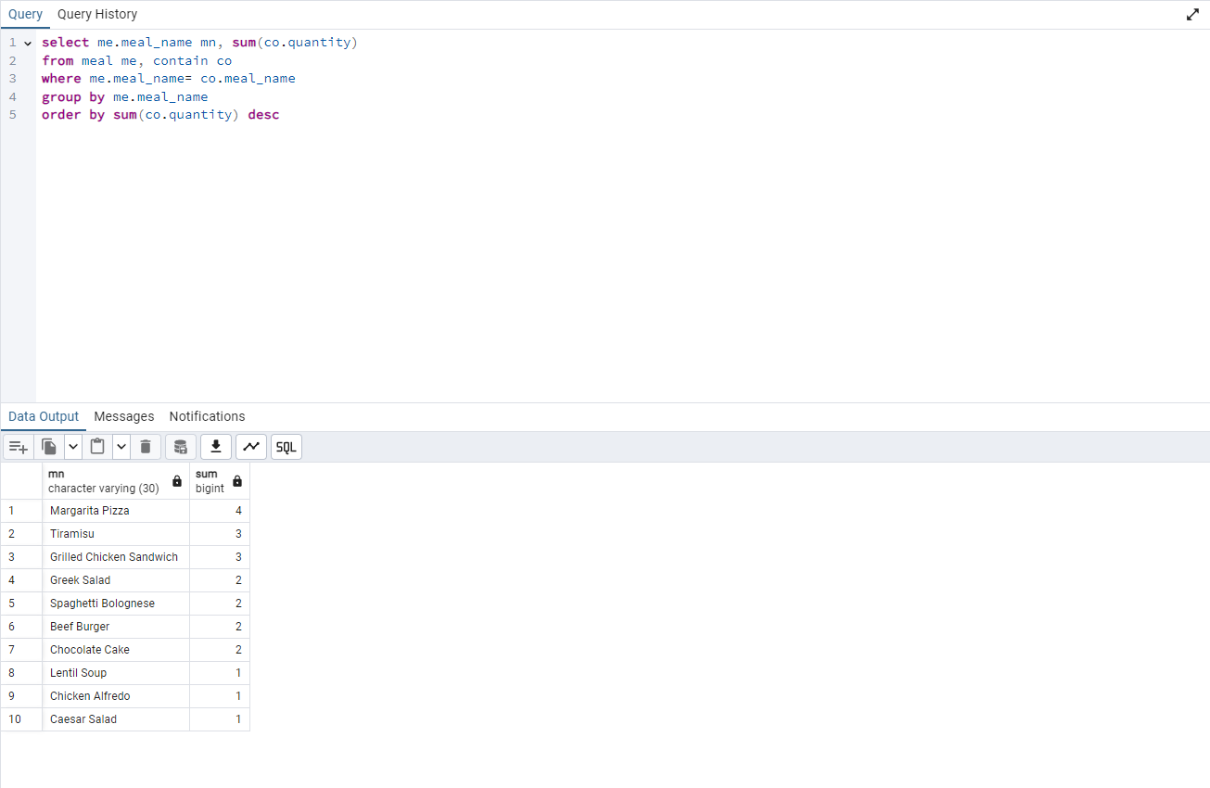

The query above displays the meals from most to least ordered, along with the number of times that it was ordered. For example in our case margaritta pizza is the most ordered meal (4 times), meanwhile caesar salad was the least ordered item (1 time).

### 11.7.3 Most Expensive 3 Products in the Inventory

The query above returns the 3 most costly products in our inventory. For example in our case the cocoa powder costs 5.50, and we have 50 in stock, then it costs 495.00$.

11.7.4 get revenue and profit for last 12 months from orders

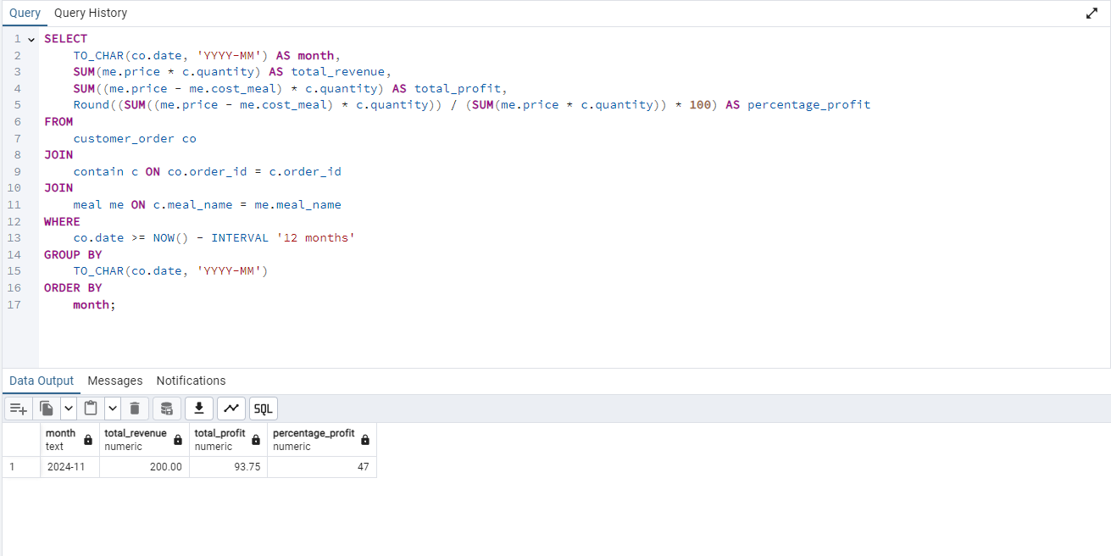

The query above returns the months of the year ranked based on profit made, from high to low.In our case, the restaurant opened just a few days ago, thats why we only have one month.

### 11.7.5 Profitability and salaries ranked by kitchen station

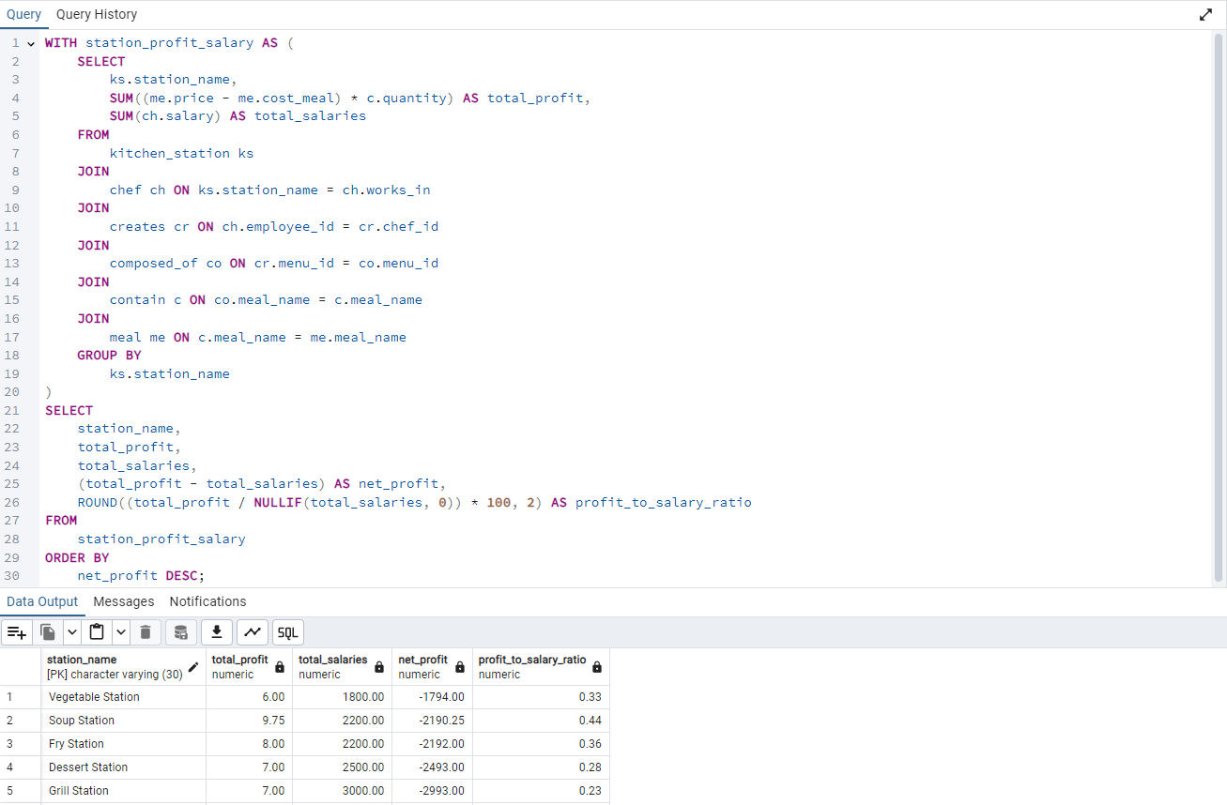

The query above ranks the kitchen station by profit made, from high to low, it also shows the salary earned by the station members.

### 11.7.6 Chef Ranking By Performance

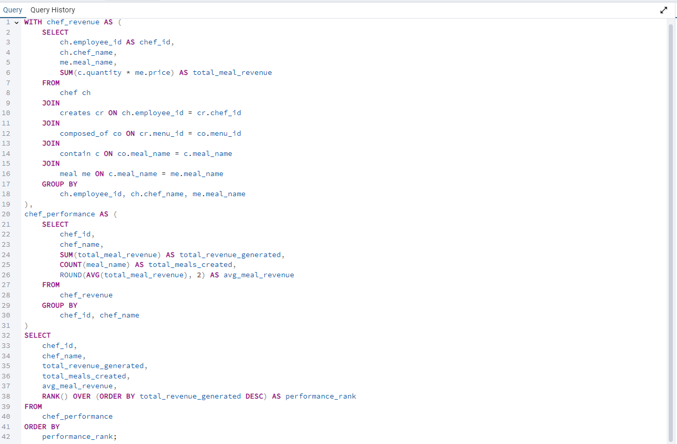

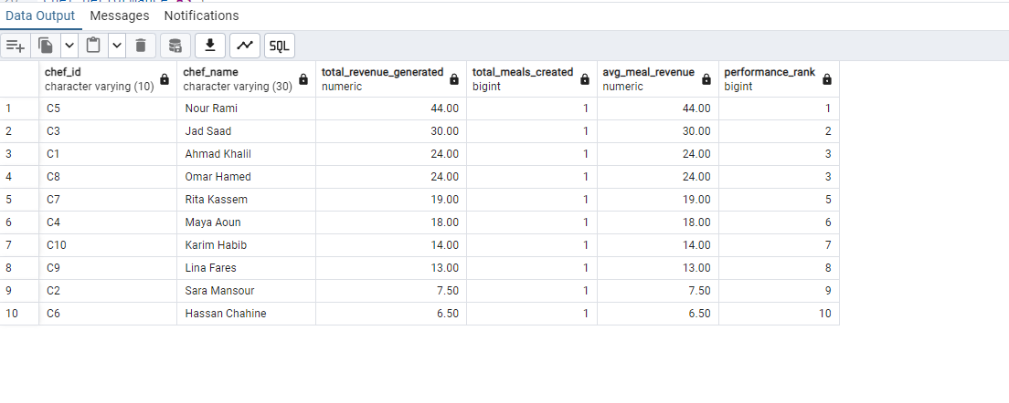

The query above ranks the chefs based on their generated revenue, from high to low.

### 11.7.7 Waiter_Supervisor (Recursive query)

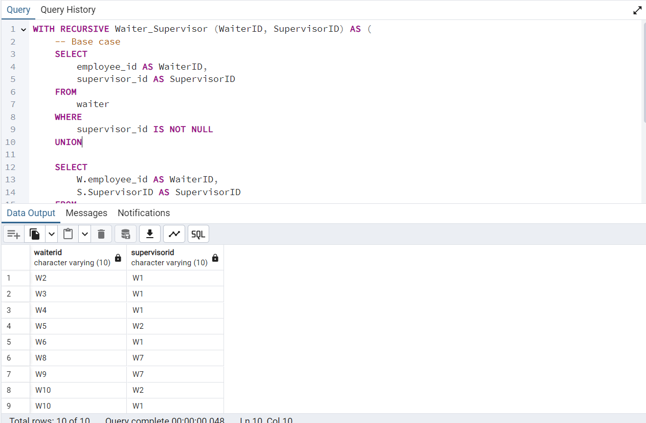

This recursive query provides a hierarchical structure of relationships between waiters and their supervisors, including both direct and indirect connections. It allows us to trace the chain of command from any waiter up through all levels of supervision.

### 11.7.8 Chef_Supervisor

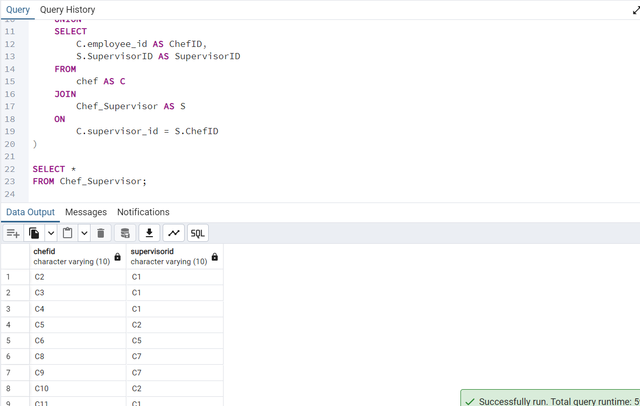

This recursive query provides a hierarchical structure of relationships between chefs and their supervisors, including both direct and indirect connections. It allows us to trace the chain of command from any chef up through all levels of supervision.

### 11.7.9 Top 3 payment methods

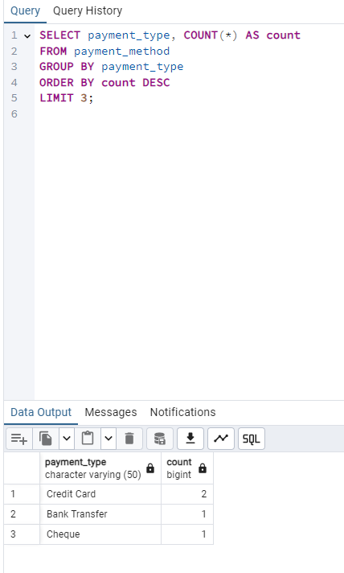

The above query displays the 3 most used payment methods by customers.

If for example, we want to check the most used payment methods to implement techniques to make them easier for customers to use we would need this query.

### 11.7.10 Revenue generated by waiters

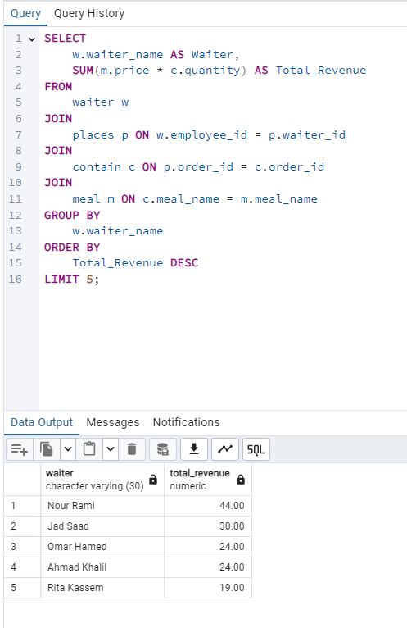

The query above displays the 5 waiters that generate the most revenue in descending order by checking how many orders they were responsible for.

If for example we want to reward our highest earning waiters we would use this query.

### 11.7.11 Highest paying customers.

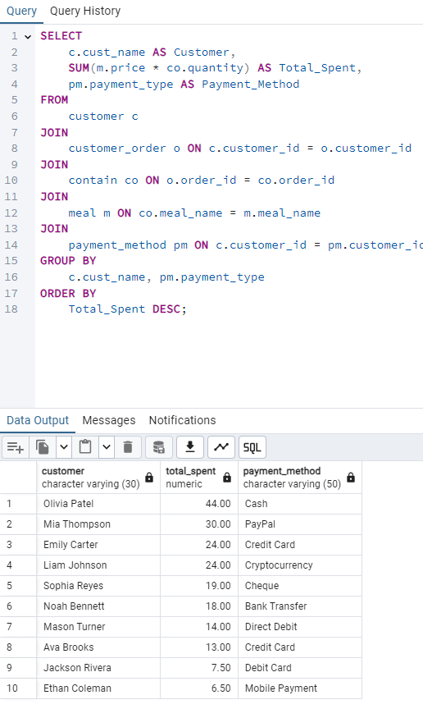

The query above displays customer payments in decreasing order by calculating all payments they made on orders.

If for example we want to reward our highest paying customers we would use this query.

### 11.7.12 Restocking ingredients

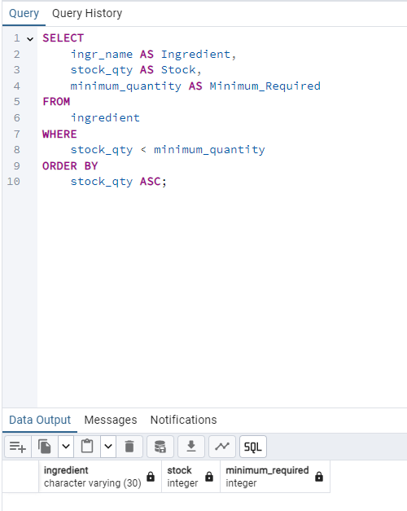

The query above displays which ingredients need to be restocked by checking the available stock and comparing it to the specified minimum quantity. Note that in this case no ingredient needs restocking as they are all above minimum quantity.

If for example we want to see what ingredient we need to restock we would use this query.

### 11.7.13 Shift Hours

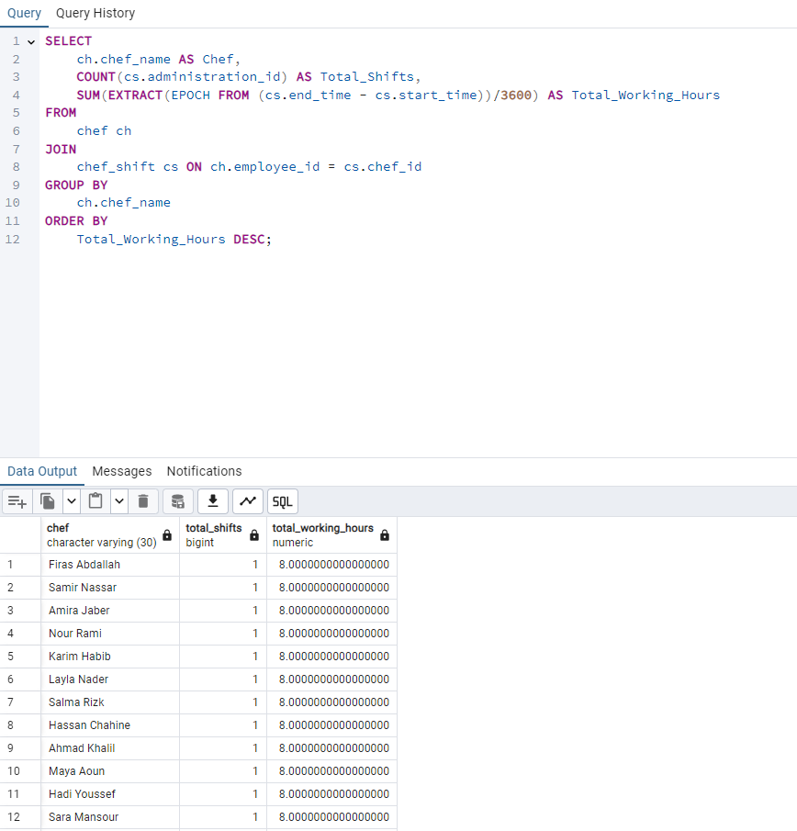

The query above displays the total shift hours of the chefs in descending order.

If for example we want to check which chef works the most hours to give them a raise we would use this query.

### 11.7.14 Popular meal categories

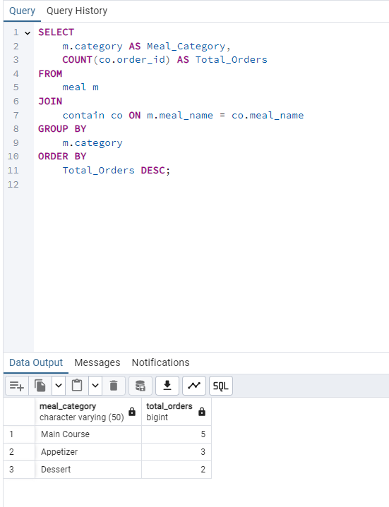

The query above displays the most popular meal categories in descending order. Each meal category is composed of specific meals, this query calculates the total number of meals ordered and groups them based on their category.

For example if we want to check which category is the most popular we would use this query.

### 11.7.15 Customer review

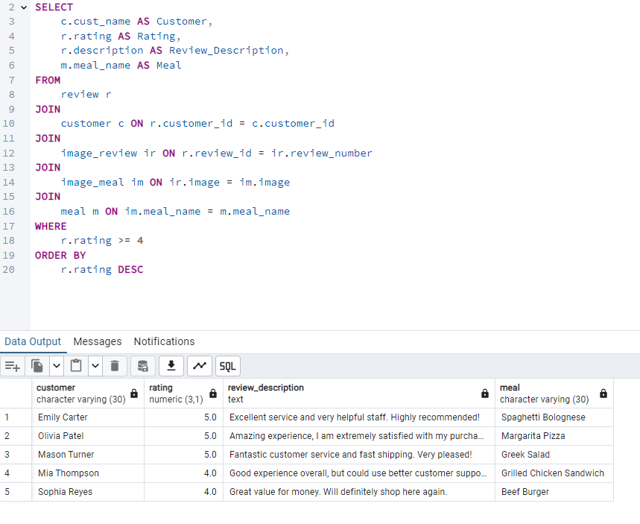

The query above displays the reviews of the customers in decreasing order based on the provided rating as well as the name of the meal they reviewed.

For example if we would like to see the general customer opinion and check the highest reviewed meals in the restaurant he would use this query.

## 11.8. (BONUS) Security

Database security is an essential feature because databases store sensitive, critical, and often confidential information. Without proper security measures, this data can be vulnerable to breaches, misuse, and unauthorized access, leading to severe consequences.

Our security measures are designed to restrict access to specific parts of the database, ensuring that different users can only access predetermined sections. Additionally, these measures enforce query-level permissions, allowing users to perform only the operations that align with their roles and responsibilities.

11.8.1 HR role

HR employees are only allowed to access the tables: chef, waiter and delivery_driver as they are responsible for their hiring process and following up with their performance. They are also allowed all types of queries on these specific tables, but are restricted from all other tables.

We first create the hr_role and grant/revoke access to specific queries/tables.

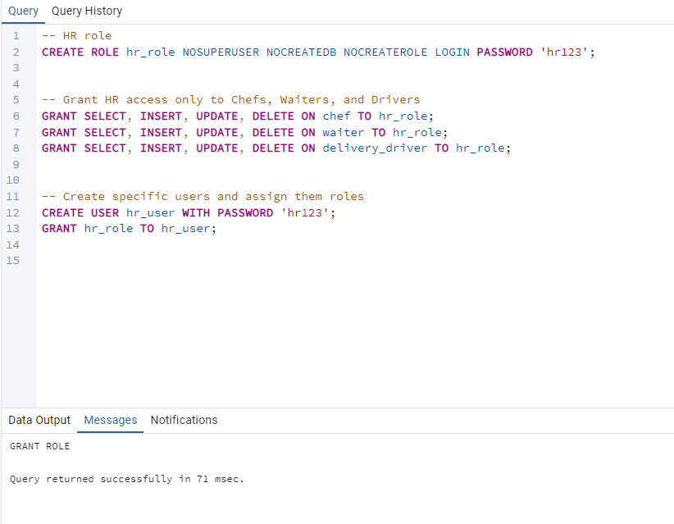

We then create a new server HR_connection.

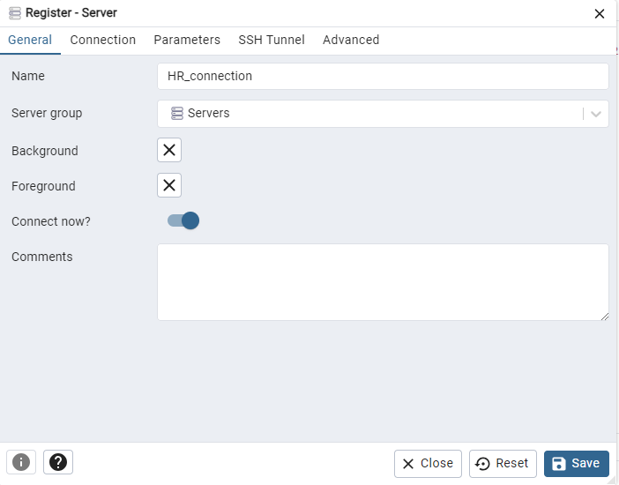

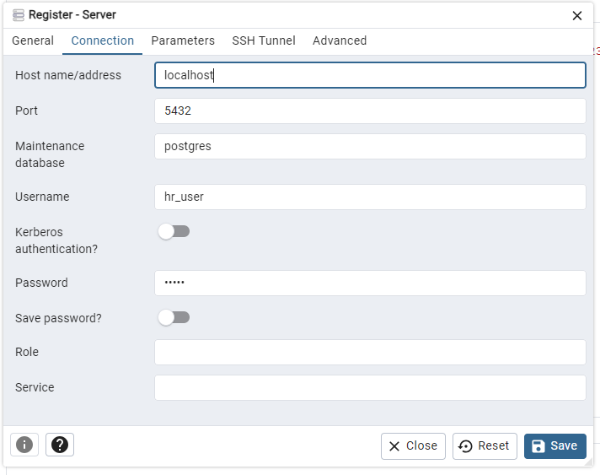

We then access the database through the HR_connection server and login using the specified username and password.

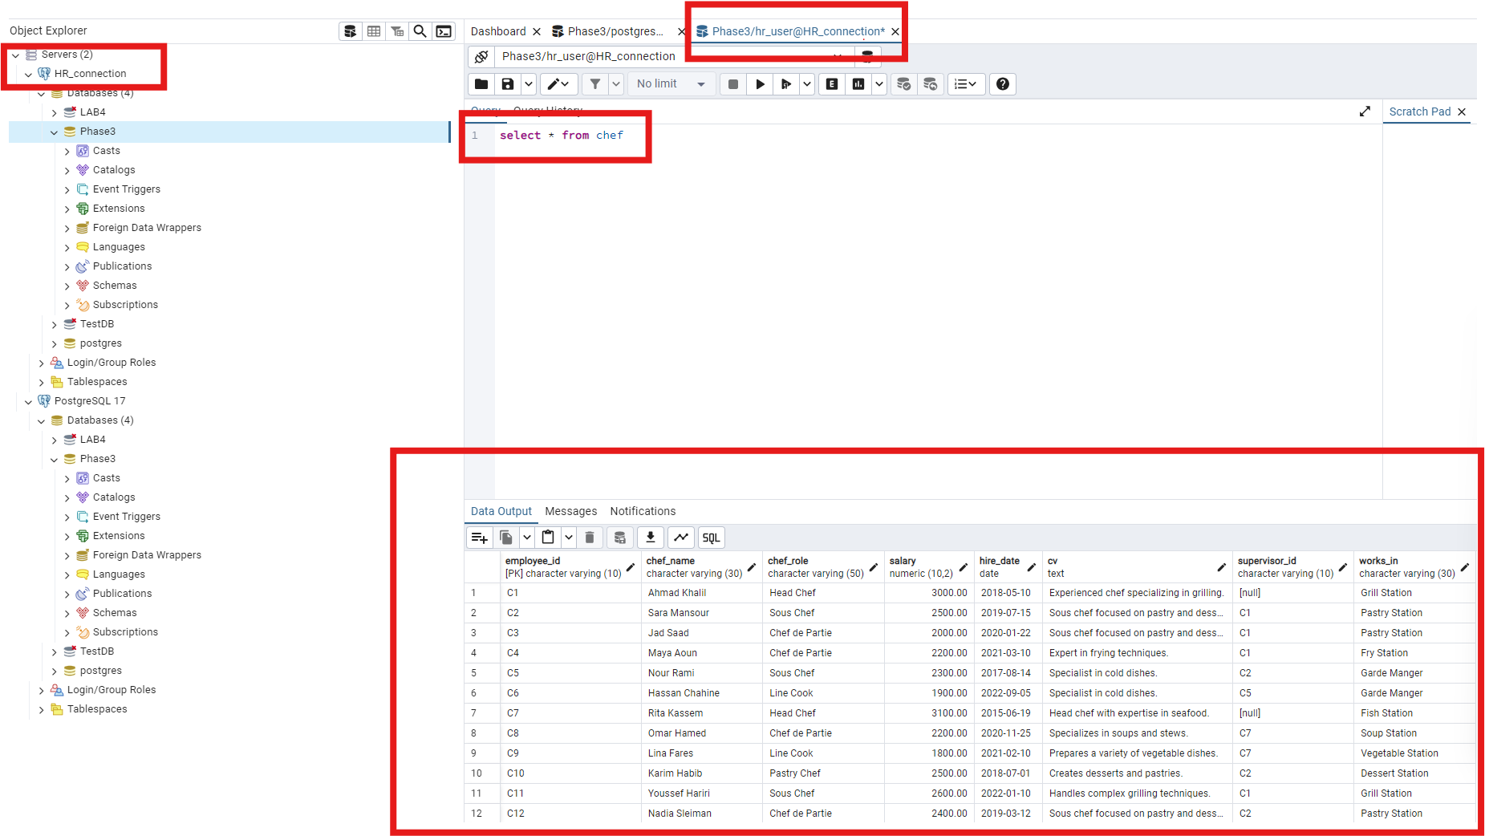

All queries are available for the hr_user on tables waiter, chef and delivery_driver as specified.

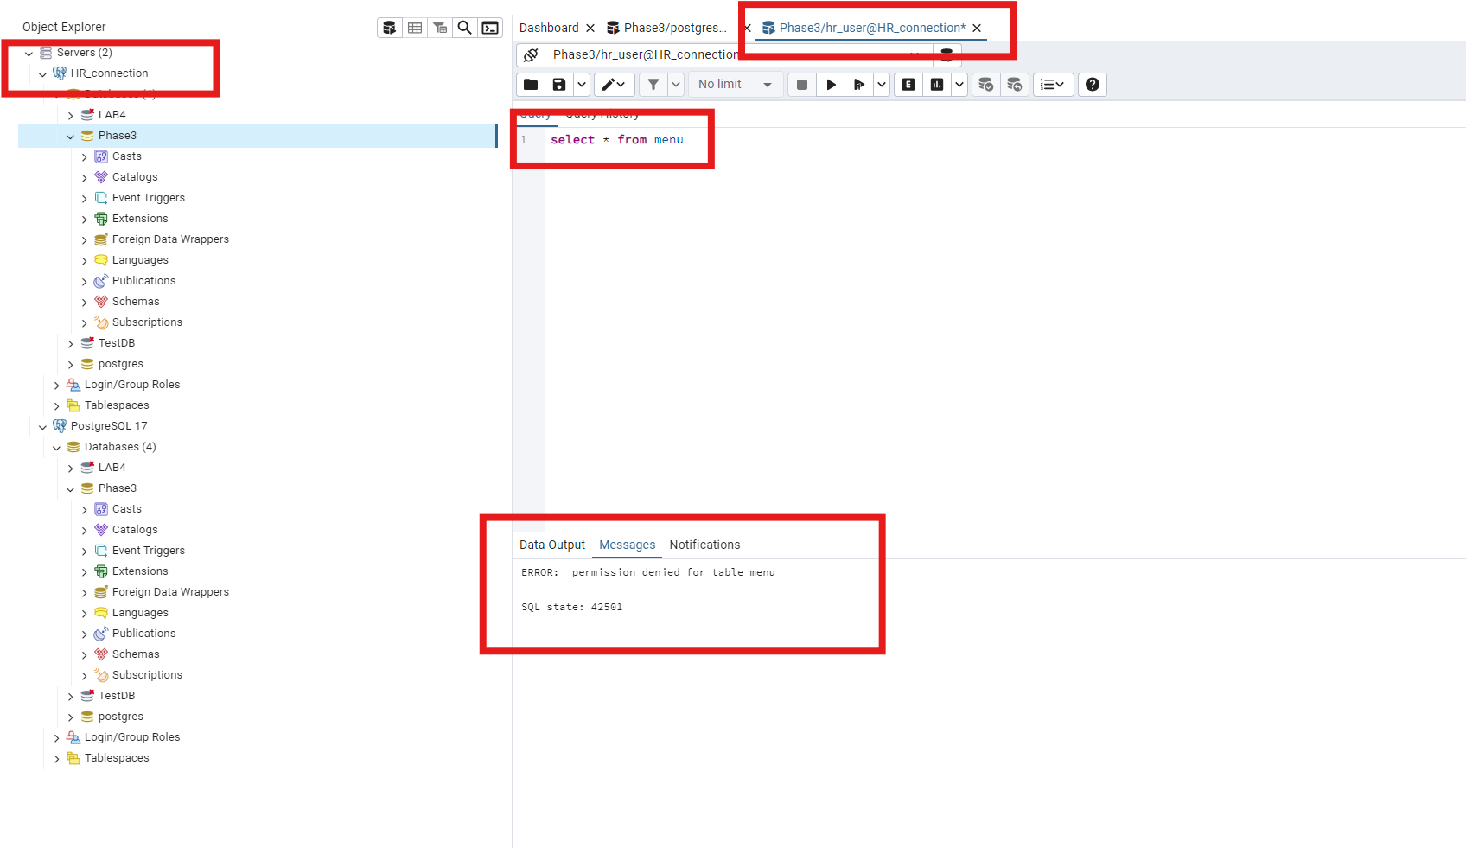

Any attempt from hr_user to access some other tables will be denied.

11.8.2 Admin role

Admin users are granted access to all parts of the database as well as all query rights. Admin users need such freedom of access to monitor all aspects of the restaurant from stocks to customer satisfactions to employee performances etc…

We first create the manager_role and grant access to all tables of the DB

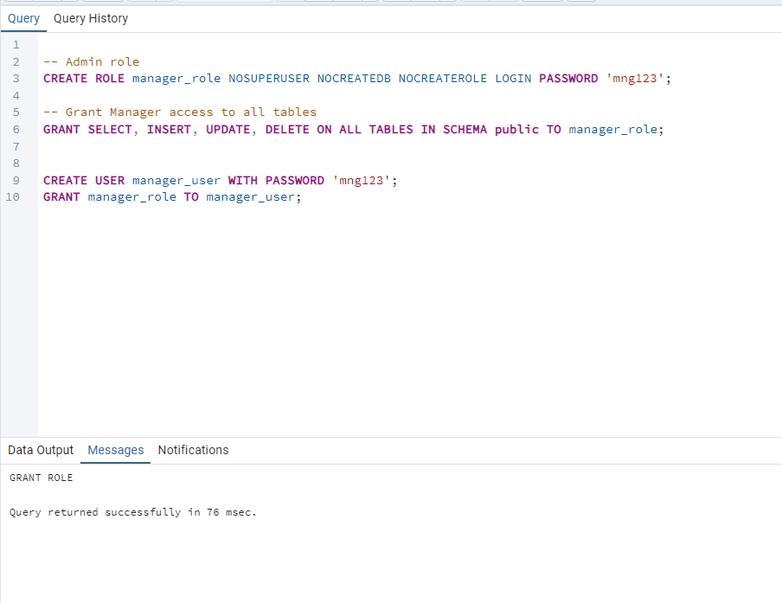

We then create a new server Admin_connection.

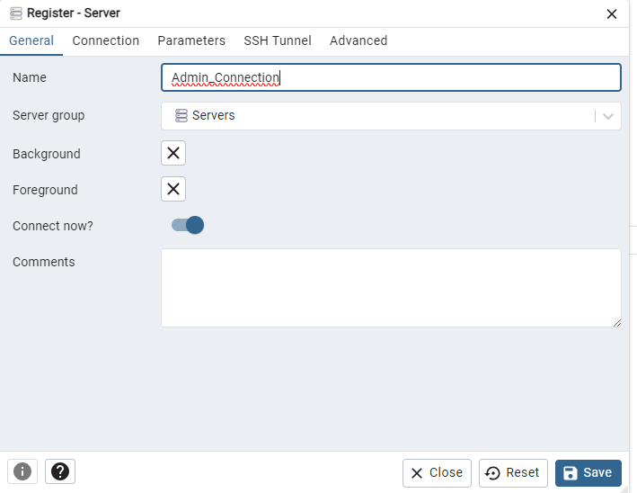

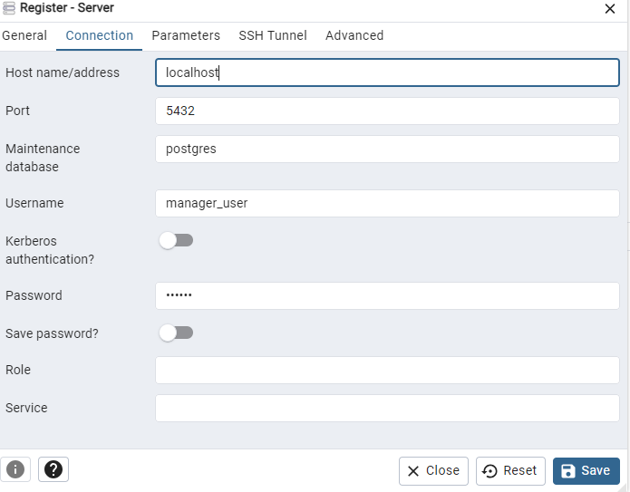

We then access the database through the Admin_connection server and login using the specified username and password.

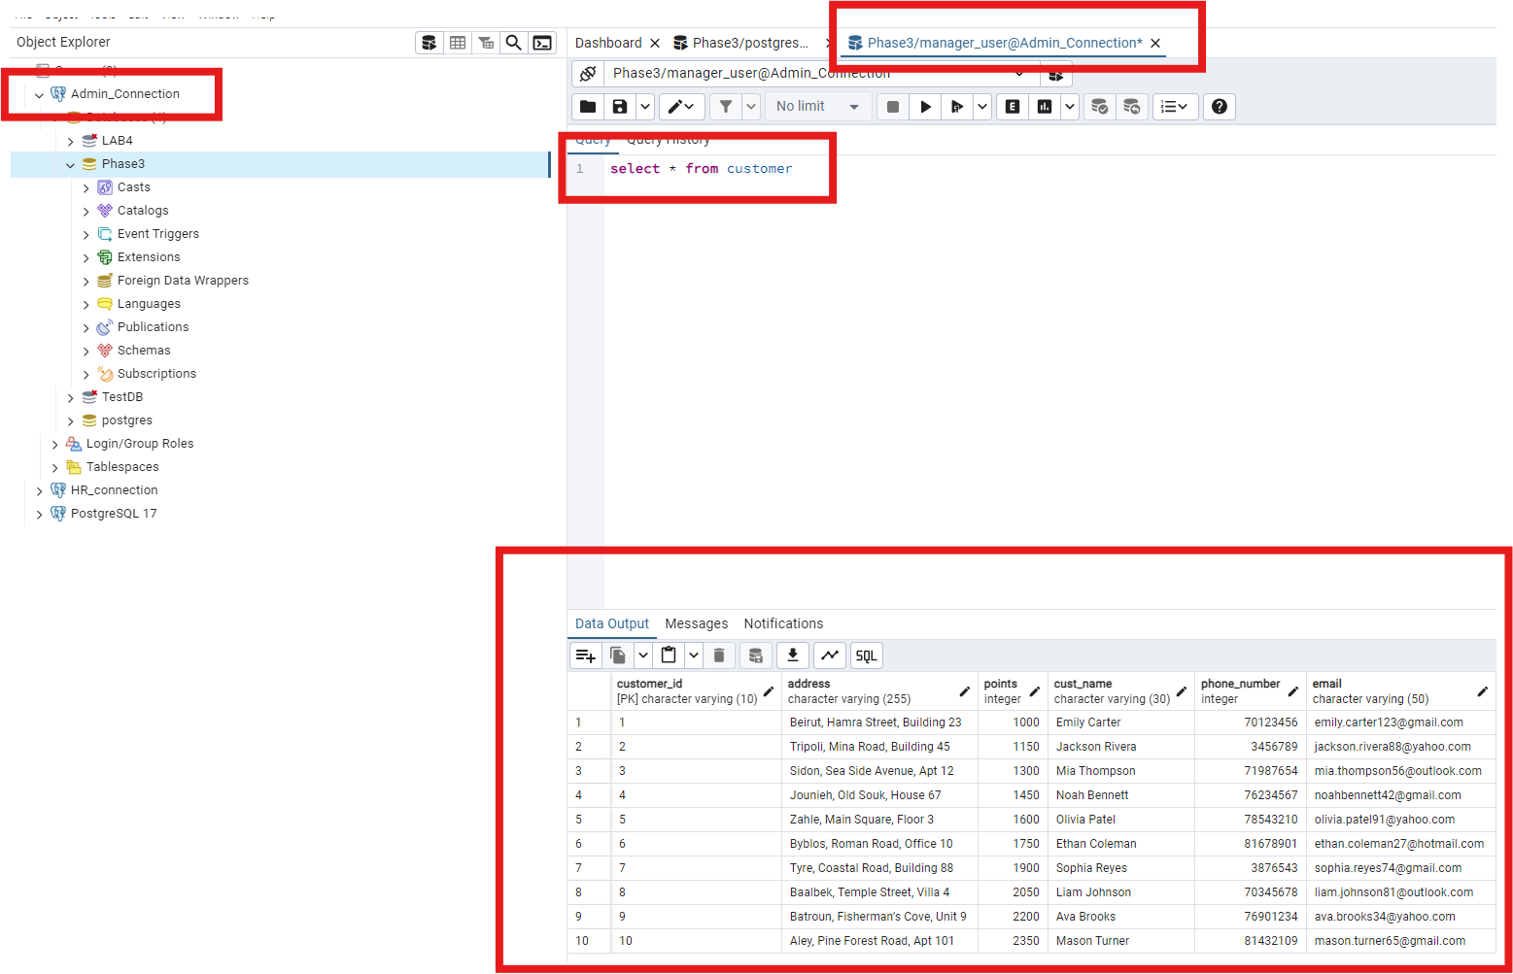

manager_user has access to all tables in the database and can perform all queries as specified.

# Conclusion

As a conclusion, the proposed model for the Bakri’s Big Burger restaurant management system is designed to meet all necessary requirements to promote excellent functioning of every fraction of the restaurant. It optimizes key operational areas including but not limited to customer service, staff, management and inventory control. This system aims to enhance performance, improve workflow and facilitate decision making whether at the staff or administration level, ultimately contributing to a more efficient and well-managed restaurant environment for all stakeholders.

# Instructor’s Feedback